**Applied Project Report**

**Analysis of Real-life Business Cases**

By

Kalluru Srimannarayana Sharat Gupta

**A Master’s Project Report submitted to Scaler Neovarsity - Woolf in partial fulfillment of the requirements for the degree of Master of Science in Computer Science**

February, 2025



**Scaler Mentee Email ID :** kallurugupta@gmail.com

**Thesis Supervisor :** Shivank Agarwal

**Date of Submission :** 05/01/2025

**Certification**

I confirm that I have overseen / reviewed this applied project and, in my judgment, it adheres to the appropriate standards of academic presentation. I believe it satisfactorily meets the criteria, in terms of both quality and breadth, to serve as an applied project report for the attainment of Master of Science in Computer Science degree. This applied project report has been submitted to Woolf and is deemed sufficient to fulfill the prerequisites for the Master of Science in Computer Science degree.

Shivank Agarwal

…………………

Project Guide / Supervisor

**DECLARATION**

I confirm that this project report, submitted to fulfill the requirements for the Master of Science in Computer Science degree, completed by me from 20/02/2023 to 05/01/2025 is the result of my own individual endeavor. The Project has been made on my own under the guidance of my supervisor with proper acknowledgement and without plagiarism. Any contributions from external sources or individuals, including the use of AI tools, are appropriately acknowledged through citation. By making this declaration, I acknowledge that any violation of this statement constitutes academic misconduct. I understand that such misconduct may lead to expulsion from the program and/or disqualification from receiving the degree.

**Kalluru Srimannarayana Sharat Gupta**

** Date: 05 January 2025**

**ACKNOWLEDGMENT**

*I would like to express my profound gratitude to all my Instructors & Teaching Assistants for their constant Support in the New Computer Science Journey.*

*A Big Shoutout to Scaler Team for Seamless integration of Leaning Programs and Creation of Wonderful platform for Enthusiastic Working Professional.*

*I would like to Thank all my batchmates who have made my learning into a wholesome Experience with their active participation and increasing enlightening by sharing Different Viewpoints with respect to their professional experience.*

*I would like to express my special thanks to my family for Support and efforts they provided throughout this Course. I am eternally grateful to them.*

*I would like to acknowledge that this project was completed entirely by me and not by someone else.*

*Kalluru Srimannarayana Sharat Gupta*

**Table of Contents**

Contents

List of Tables 8

List of Figures 8

Applied Real-life Business Cases 9

ABSTRACT 9

Chapter 1 : Business Case Study 1 10

Problem Description 10

Problem: 10

DataSet: 11

Libraries Used: 11

Outcome of Analysis: 12

Business Questions to be answered from Analysis: 12

Analysis 13

Data Cleaning: 13

Feature Engineering 1: 22

Statistical Analysis, Graphical Visualization & Insights 25

Feature Engineering 2: 30

Business Insights 34

Recommendations: 34

Chapter 2 : Business Case Study 2 35

Problem Description 35

About Company 35

Problem: 35

Dataset: 35

Libraries Used: 35

Outcome of Analysis: 36

Analysis: 36

Univariate, Bivariate Analysis Set up 37

Hypothesis Testing setup: 37

Impact of Datetime on User Count 37

Impact of Season on User Count 39

Impact of Weather on User Count 40

Dependency of Weather and Season 42

Impact of Holiday on User Count: 44

Impact of Workingday on User Count: 45

Impact of Temp on User Count: 47

Impact of Humidity on User Count: 48

Impact of Windspeed on User Count 50

Correlation matrix: 51

Business Insights 53

Overall Summary: 53

Seasons: 53

Weather: 53

Holiday: 53

Workingday: 54

Humidity: 54

Windspeed: 54

Recommendations 54

Chapter 3 : Business Case Study 3 55

Problem Description: 55

About Company 55

Problem: 55

Dataset: 55

Libraries Used: 55

Outcome of Analysis: 56

Analysis: 56

Statistical Analysis, Graphical Visualization: 56

Hypothesis Testing: 63

Data Preparation for Modelling: 64

Model Building - Linear Regression[OLS] 66

Linear Regression Assumptions 70

Model Building - Linear Regression [Lasso] 75

Model Building - Linear Regression [Ridge] 76

Model Building - Polynomial Regression 78

Business Insights: 81

Recommendations: 81

Chapter 4 : Business Case Study 4 82

Problem Description 82

About Company 82

Problem: 82

Dataset: 82

Libraries Used: 82

Outcome of Analysis: 83

Analysis 84

Data Cleaning 85

Row Merging for Each Driver_ID 86

Feature Engineering 1 87

Univariate & Bivariate Analysis 88

Feature Engineering 2 98

Data Prep for Modelling 101

Model Training - Random Forest [Ensemble - Bagging] 102

Model Training - Gradient Boosting DT [Ensemble - Boosting] 111

Business Insights 118

Recommendations 119

Chapter 5 : Business Case Study 5 120

CONCLUSION 121

References 122

## List of Tables

**(To be written sequentially as they appear in the text)**

|  |  |  |
| --- | --- | --- |
| **Table No.** | **Title** | **Page No.** |
| **1** |  |  |
| **2** |  |  |

## List of Figures

**(List of Images, Graphs, Charts sequentially as they appear in the text)**

Figure 1:Logistic Trip Record Dataset 10

|  |  |  |
| --- | --- | --- |
| **Figure No.** | **Title** | **Page No.** |
| **1** |  |  |
| **2** |  |  |

## Applied Real-life Business Cases

### ABSTRACT

Data science is the activity of analyzing vast amounts of unorganized and organized raw data to find patterns and draw conclusions that can be put to use. Data science is an interdisciplinary field, and the foundations include, inference, computer science, predictive analytics, the creation of machine learning techniques, and new tools for extracting information from large data sets.

With Increase in Digitalization, Each Business is generating huge amounts of Data, But Just generating Data does not benefit the Business. A Deep Analysis and Inference Extraction is Required to Support in Business Decisions and Machine Learning Model Development to Realize the Long-term Strategies with past Working Data

So Deep Analysis and Machine Learning Model Development, we need to Prepare the Data in systematic way else it will lead to Chaos.

Steps to be Followed:

1. Data Cleaning: it ensures the accuracy and consistency of your dataset, allowing for reliable results from any analysis you perform by removing errors, inconsistencies, and irrelevant data points, ultimately leading to more meaningful insights and better decision-making based on your findings.

Ex: Removing Unknown Columns, Datatype Conversion, Duplicate Values Removal, Outlier Removing, Dealing Missing Values

1. Feature Engineering: it is process of transforming raw data into Meaningful features that can be used to train models.

Ex: Extracting Day, week, month, from Date Data Type, Creating BMI from Weight and Height Features Etc

1. Exploratory Data Analysis: it is a method for analyzing data to identify patterns and relationships. It involves using visualizations, transformations, and models to understand the data.
2. Hypothesis Testing: It is a Statistical procedure to determine if there is enough evidence to support a claim about a population and find most effective Features for Model Building
3. Data Preparation: it is the Process where we fix our Data for Model Building
   1. by Splitting whole data into Training, validation and Testing Sets
   2. by Normalizing /Standardizing & Feature Encoding to Transform Categorical to Numerical
4. Model Building & Assumptions Checking: it the process where we
   1. Start Building our Models as per the Output Requirement like Continuous [Real Value] or Categorical [Probability] Output.
   2. After Building Model We need to Check if Data use meets the Assumptions for Selected model

Ex: Linearity, No Multicollinearity, Homoscedasticity, Residuals Normality, No Auto Correlation to be verified for Regression Model

1. Validation & Testing: Once the Training is Done
   1. Validation Dataset is Used to Tune the Hyperparameter of the Model to Achieve the Best Model Performance Metric
   2. While Testing Data Set is used only once & That after Finalization of all parameter’s ad Hyperparameters
2. Deployment & Monitoring: Once the Model is Ready
   1. We Containerize the Trained Model, Required Libraries and OS into a Container to make it run independent of it Deployed Environment and uniformity.
   2. Once Deployed we have Continuously monitor Model Performance for Data Shifting & Whenever need we have to Retrain, Redeploy to meet Required Goal

The abstract for an applied project should succinctly summarize its title, purpose, methods, results, and conclusions. You are expected to write a chapter on any 5 of the Business Cases which you have completed as part of your DSML course.

**NOTE - To ensure confidentiality, do not refer to actual company names. For example, to refer to “Target”, say, “Retailer”, to refer to “Netflix”, say, “Streaming Services Provider”, or simply ‘Company A’ etc…**

Since it is going to be a group of five Business Case Studies, the focus should be how DSML and its associated tools as a field of study can be beneficial to the field of business or how such tools can be applied to maximize profit or modify existing processes for better outcomes.

Aim for conciseness, usually limiting it to under 250-300 words, to effectively convey the project's essence.

### Chapter 1 : Business Case Study 1

#### Problem Description

About Company

A Logistics and Supply Chain Company which is largest and fastest-growing fully integrated player in India by revenue in Fiscal 2021 aims to build the operating system for commerce, through a combination of world-class infrastructure, logistics operations of the highest quality, and cutting-edge engineering and technology capabilities.

The Data team builds intelligence and capabilities using this data that helps them to widen the gap between the quality, efficiency, and profitability of their business versus their competitors.

##### Problem:

A Logistics and Supply Chain Company wants to understand and process the data coming out of data engineering pipelines:

• Clean, sanitize and manipulate data to get useful features out of raw fields

• Make sense out of the raw data and help the data science team to build forecasting models on it

##### DataSet:

* data - tells whether the data is testing or training data
* trip_creation_time – Timestamp of trip creation
* route_schedule_uuid – Unique Id for a particular route schedule
* route_type – Transportation type
* FTL – Full Truck Load: FTL shipments get to the destination sooner, as the truck is making no other pickups or drop-offs along the wayCarting: Handling system consisting of small vehicles (carts)
* trip_uuid - Unique ID given to a particular trip (A trip may include different source and destination centers)
* source_center - Source ID of trip origin
* source_name - Source Name of trip origin
* destination_cente – Destination ID
* destination_name – Destination Name
* od_start_time – Trip start time
* od_end_time – Trip end time
* start_scan_to_end_scan – Time taken to deliver from source to destination
* is_cutoff – Unknown field
* cutoff_factor – Unknown field
* cutoff_timestamp – Unknown field
* actual_distance_to_destination – Distance in Kms between source and destination warehouse
* actual_time – Actual time taken to complete the delivery (Cumulative) (Also Include Human Operation time between tranfer from one segment to other)
* osrm_time – An open-source routing engine time calculator which computes the shortest path between points in a given map (Includes usual traffic, distance through major and minor roads) and gives the time (Cumulative)
* osrm_distance – An open-source routing engine which computes the shortest path between points in a given map (Includes usual traffic, distance through major and minor roads) (Cumulative)
* factor – Unknown field
* segment_actual_time – This is a segment time. Time taken by the subset of the package delivery (Only time for that segmentg, No human operation time involved)

##### Libraries Used:

import numpy as np

import pandas as pd

import matplotlib.pyplot as plt

import seaborn as sns

from scipy.stats import  ttest_ind

from scipy.stats import shapiro,levene

from statsmodels.graphics.gofplots import qqplot

from scipy.stats import mannwhitneyu

!pip install category_encoders

from category_encoders import TargetEncoder

!pip install sklearn

from sklearn.preprocessing import LabelEncoder,OneHotEncoder, StandardScaler, MinMaxScaler

##### Outcome of Analysis:

Basic data cleaning and exploration:

** Handle missing values in the data.

** Analyze the structure of the data.

** Try merging the rows using the hint mentioned above.

Build some features to prepare the data for actual analysis. Extract features from the below fields:

** Destination Name: Split and extract features out of destination. City-place-code (State)

** Source Name: Split and extract features out of destination. City-place-code (State)

** Trip_creation_time: Extract features like month, year and day etc

In-depth analysis and feature engineering

** Calculate the time taken between od_start_time and od_end_time and keep it as a feature. Drop the original columns, if required

** Compare the difference between Point a. and start_scan_to_end_scan. Do hypothesis testing/ Visual analysis to check.

** Do hypothesis testing/ visual analysis between actual_time aggregated value and OSRM time aggregated value (aggregated values are the values you’ll get after merging the rows on the basis of trip_uuid)

** Do hypothesis testing/ visual analysis between actual_time aggregated value and segment actual time aggregated value (aggregated values are the values you’ll get after merging the rows on the basis of trip_uuid)

** Do hypothesis testing/ visual analysis between osrm distance aggregated value and segment osrm distance aggregated value (aggregated values are the values you’ll get after merging the rows on the basis of trip_uuid)

** Do hypothesis testing/ visual analysis between osrm time aggregated value and segment osrm time aggregated value (aggregated values are the values you’ll get after merging the rows on the basis of trip_uuid)

** Find outliers in the numerical variables (you might find outliers in almost all the variables), and check it using visual analysis

** Handle the outliers using the IQR method.

** Do one-hot encoding of categorical variables (like route_type)

Normalize/ Standardize the numerical features using MinMaxScaler or StandardScaler

##### Business Questions to be answered from Analysis:

• Clean, sanitize and manipulate data to get useful features out of raw fields

• Make sense out of the raw data and help the data science team to build forecasting models on it

As Explained, Clean and effective Data is most important Inputs for Building best Model

If we do not clean data it build good Models and Also if we do not extract meaningful feature that impact the Output of Model, that model performance will not be as effective as it should be

So we will deeply Analyze the Data, Clean it & Extract Meaningful Features for Data Science team to build models on in this case study

#### Analysis

Let Import Data and Check the Basic Data Structure





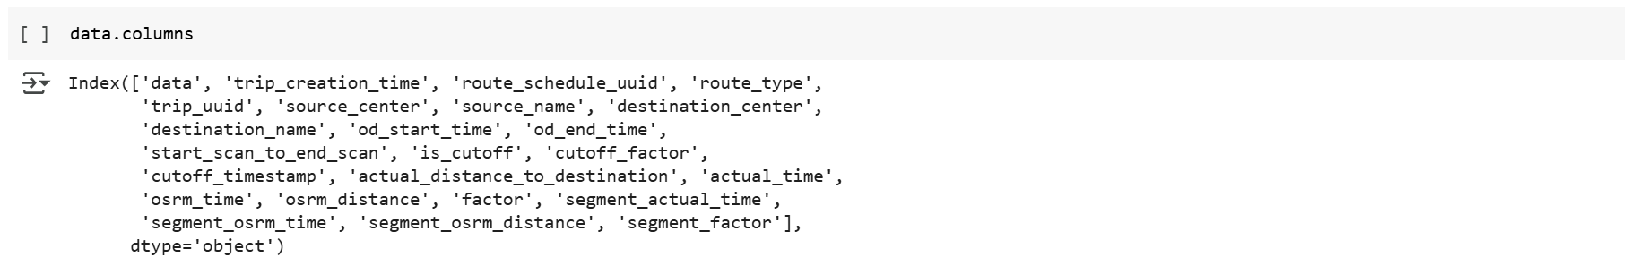

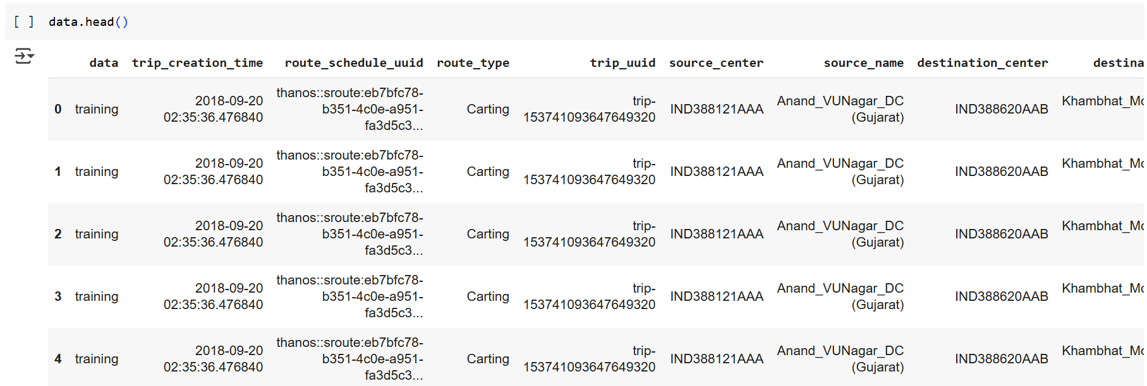

Figure 1:Logistic Trip Record Dataset

##### Data Cleaning:

Let’s Clean the Dataset by Removing Unknown Columns:

* is_cutoff – Unknown field,
* cutoff_factor – Unknown field,
* cutoff_timestamp – Unknown field
* factor – Unknown field
* segment_factor – Unknown field

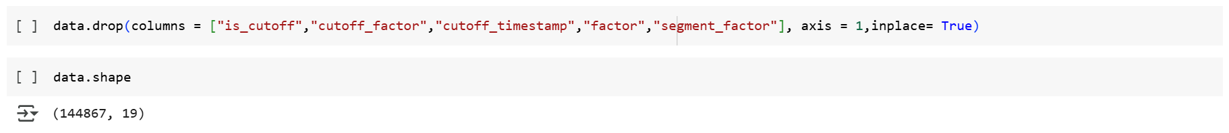

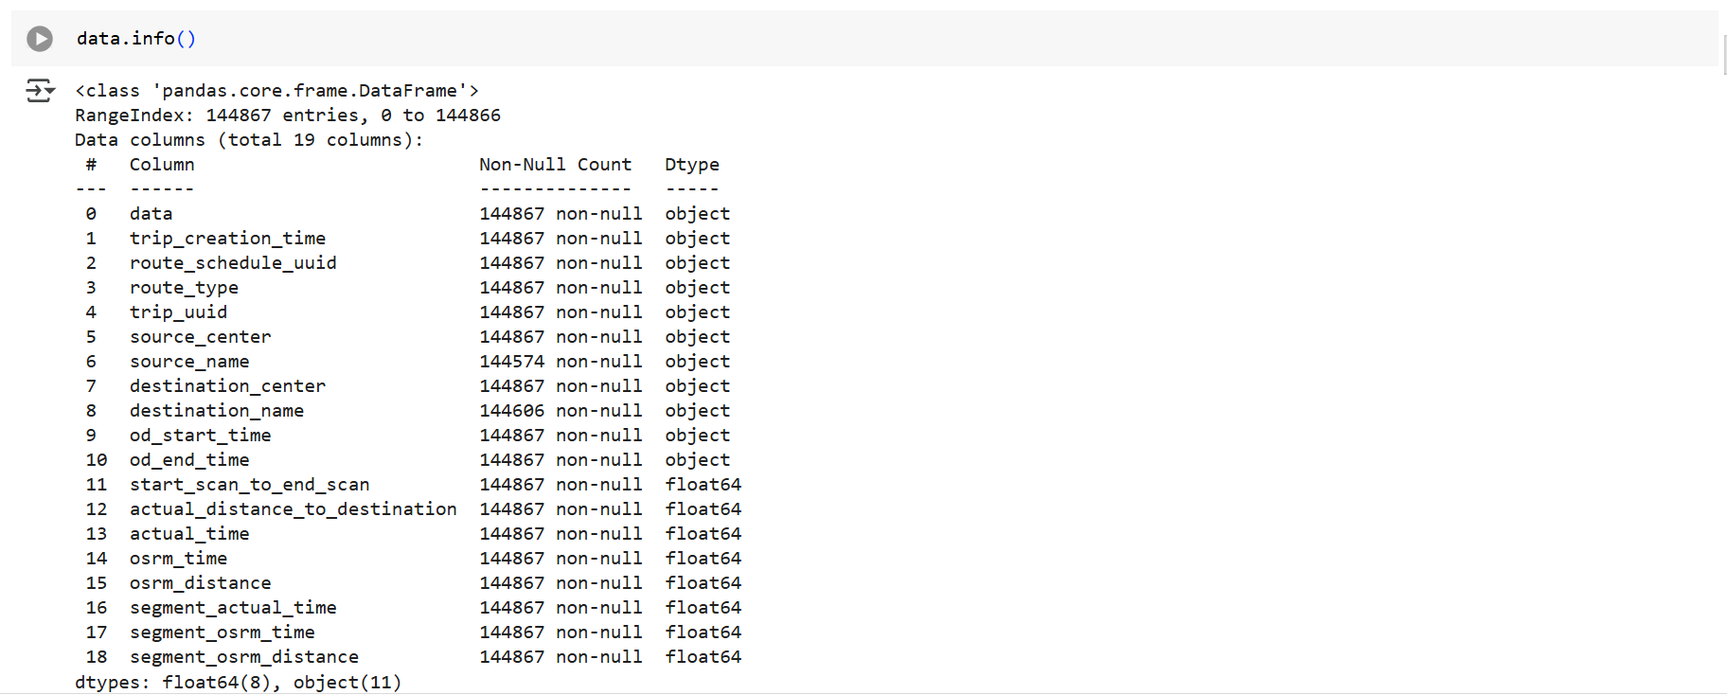

Unknown Columns have been Dropped.

Let’s Convert the Datatype of Features as per data:

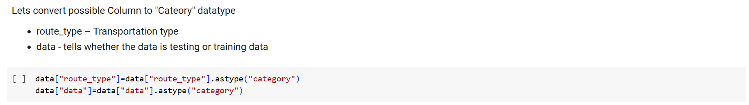

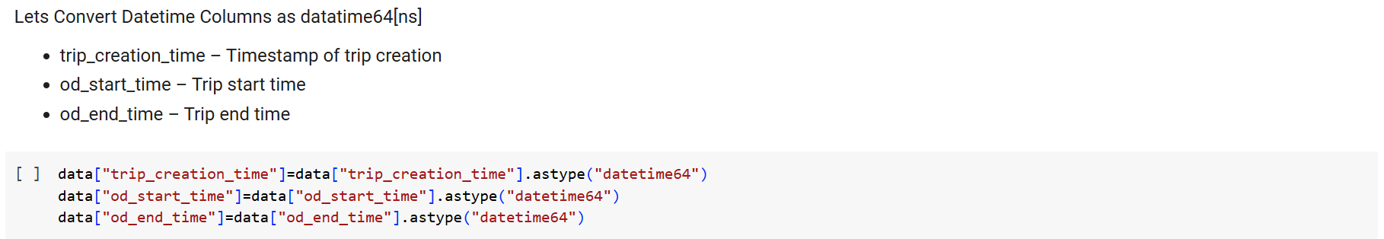

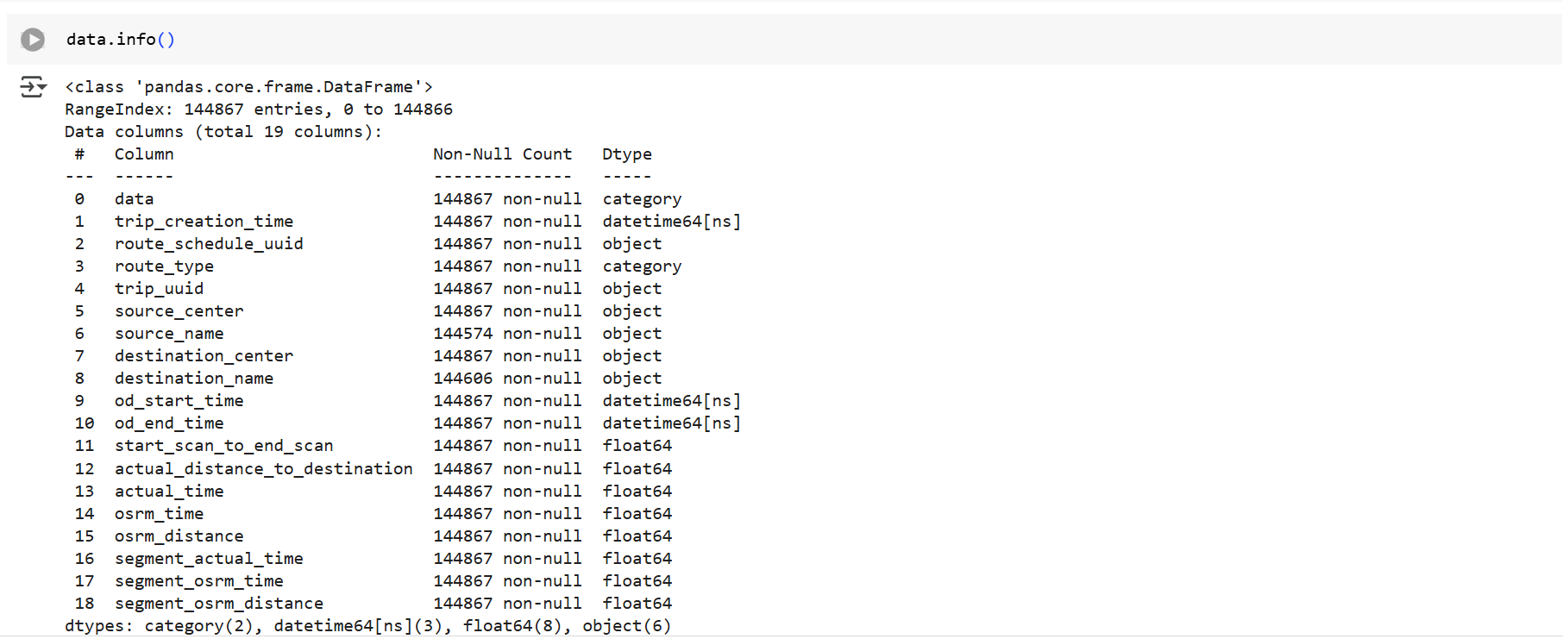

Data type of 5 Features have been changed.

Let’s Check the Duplicates Rows and Treat them:

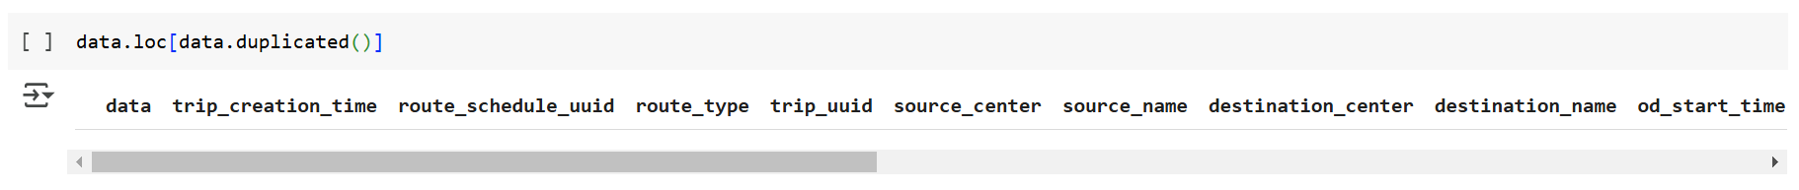

No Duplicate row Found

Let’s Check the Missing Values and Treat them:

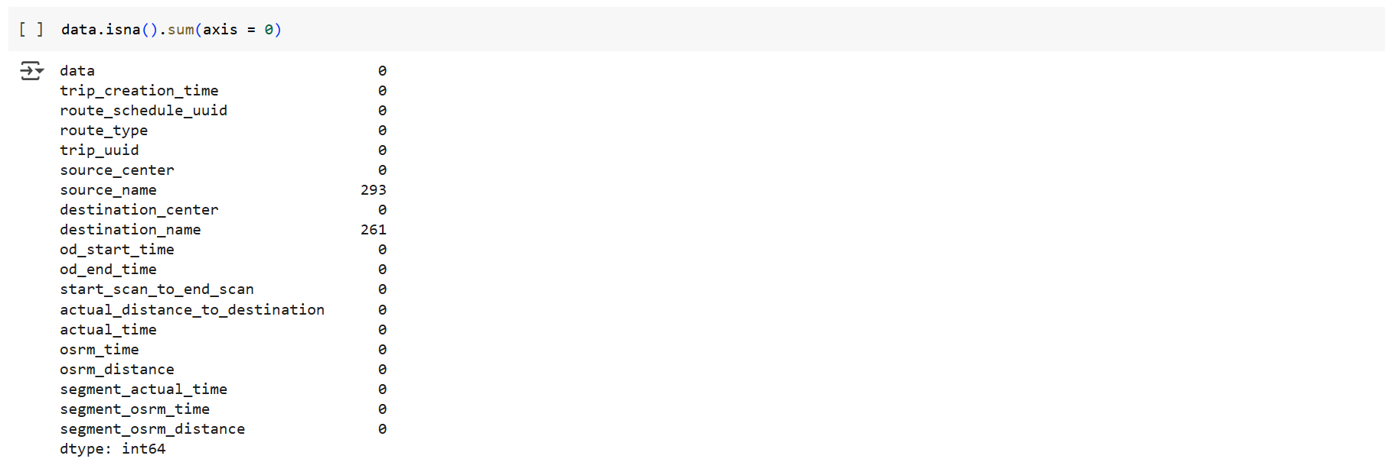

* Missing Values are present only in source_name & Destination_name
* As there are not missing values in source_centre & destination_centre, we can check if Source_name & Destination_name existing in any of the rows

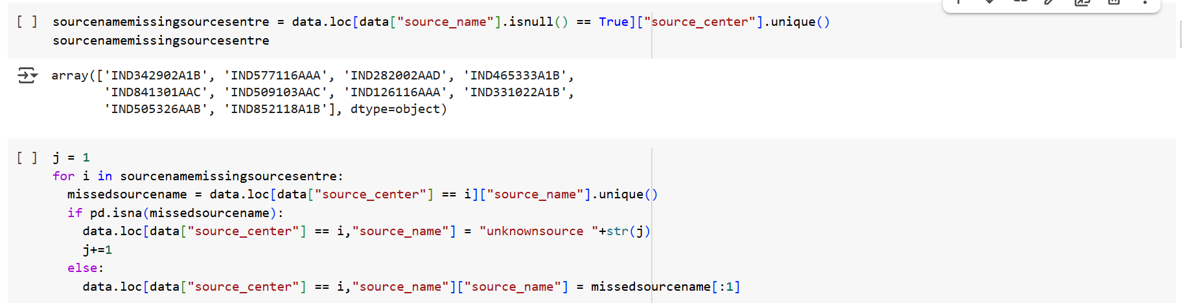

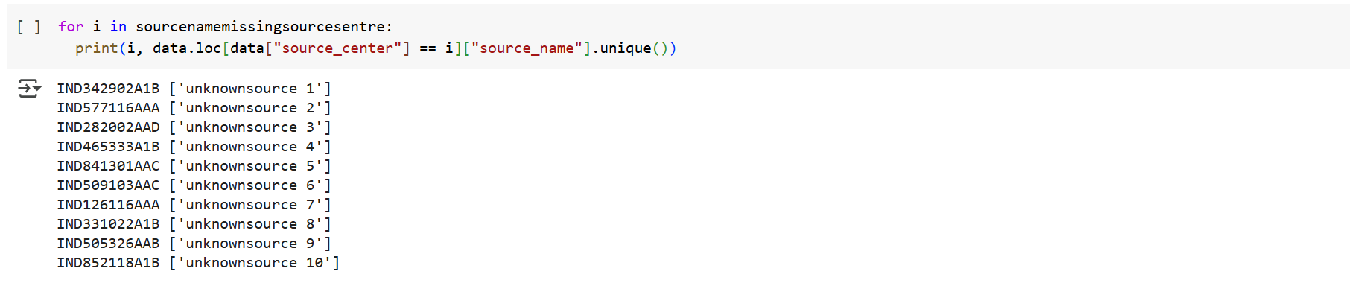

We Identified and labelled the Unknown Source Name to utilize the Data points, Now lets do the same for Unknown Destination names

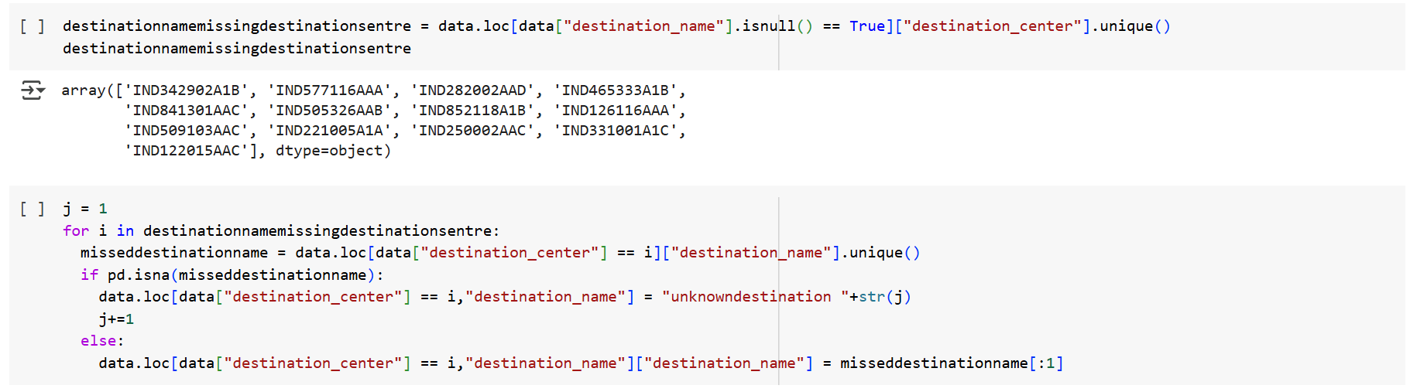

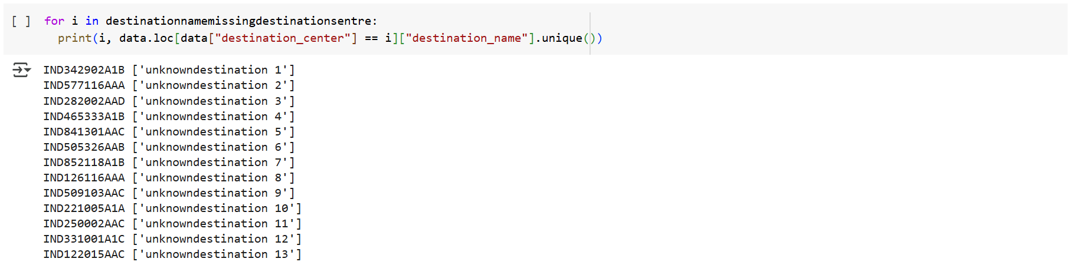

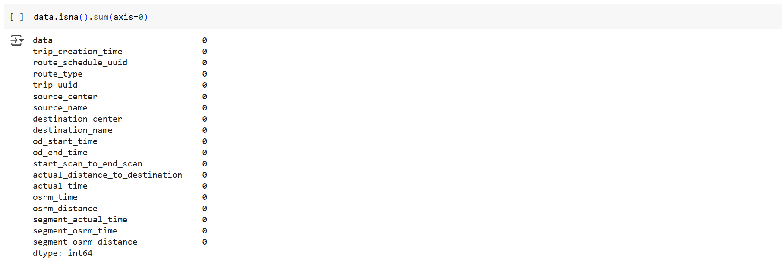

All the Missing values have been Resolved.

Let’s Analyze Row Wise Data to See if Rows can be merged .

As can be seen from data row, there are multiple row for each “trip_uuid”, we have to Merge multiple rows to get consolidated “od_start_time”, “od_end_time”, Source & Destination details with summed up Distance and time value

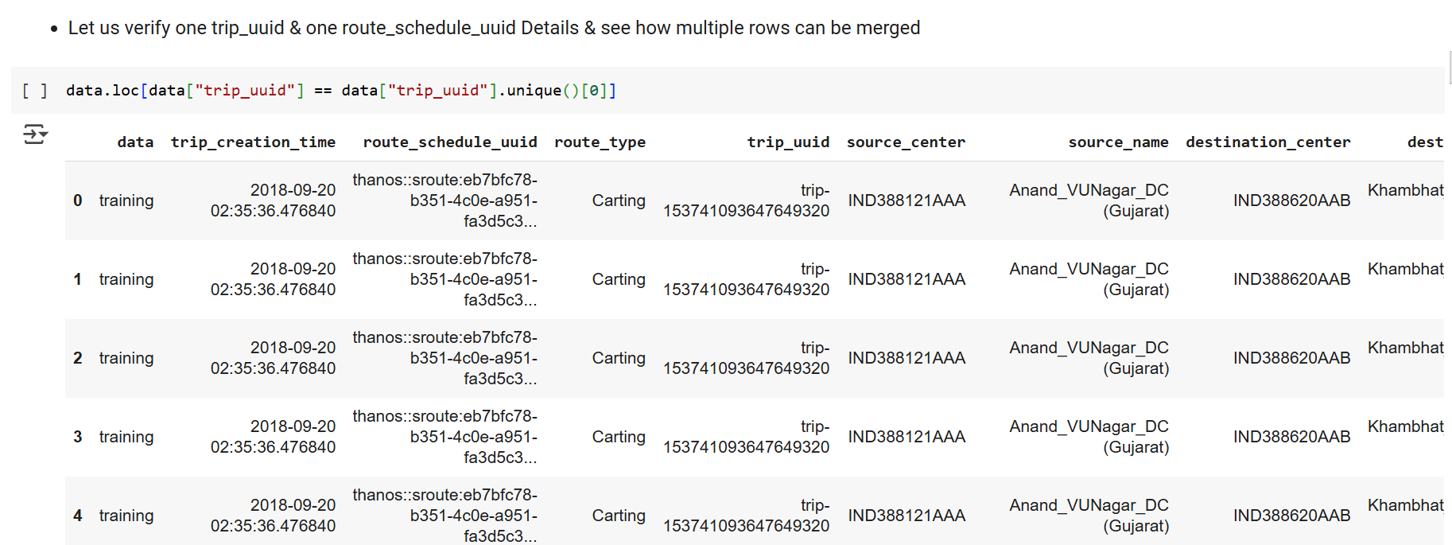

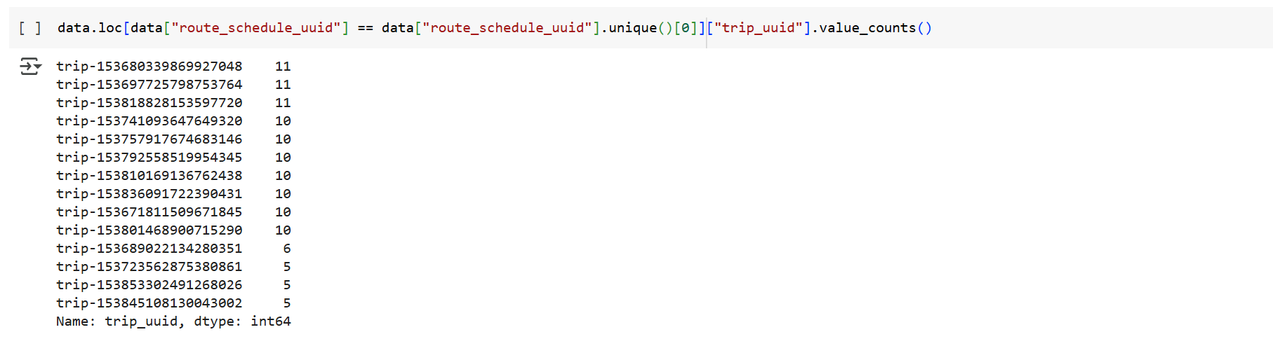

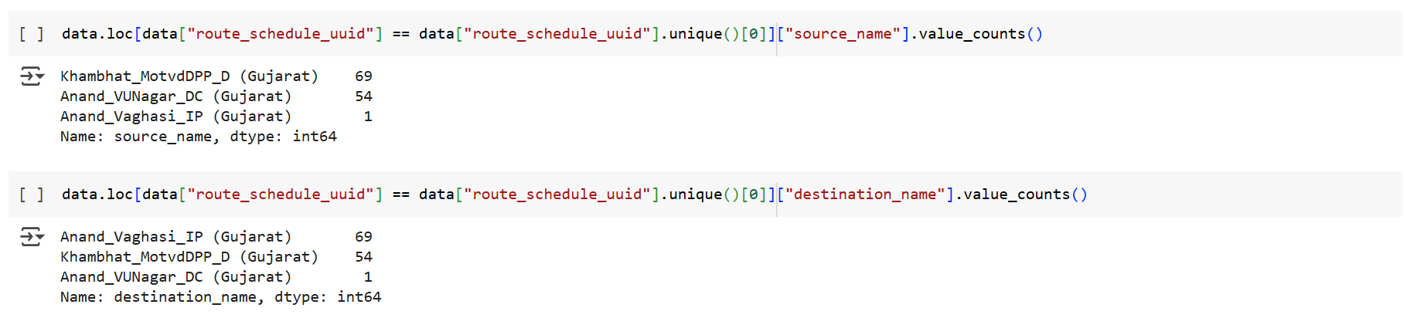

* From above 4 cell we can say that "route_schedule_uuid" futher consists of many "trip_uuid"
* Further each "trip_uuid has many destination & sources -- Because of this we cannot directly "groupby" on "trip_uuid"
* First we will use "groupby" on 3 columns - ['trip_uuid','source_center','destination_center'] and use aggregations as needed for each feature & again then we will "groupby"" on 1 column "trip_uuid

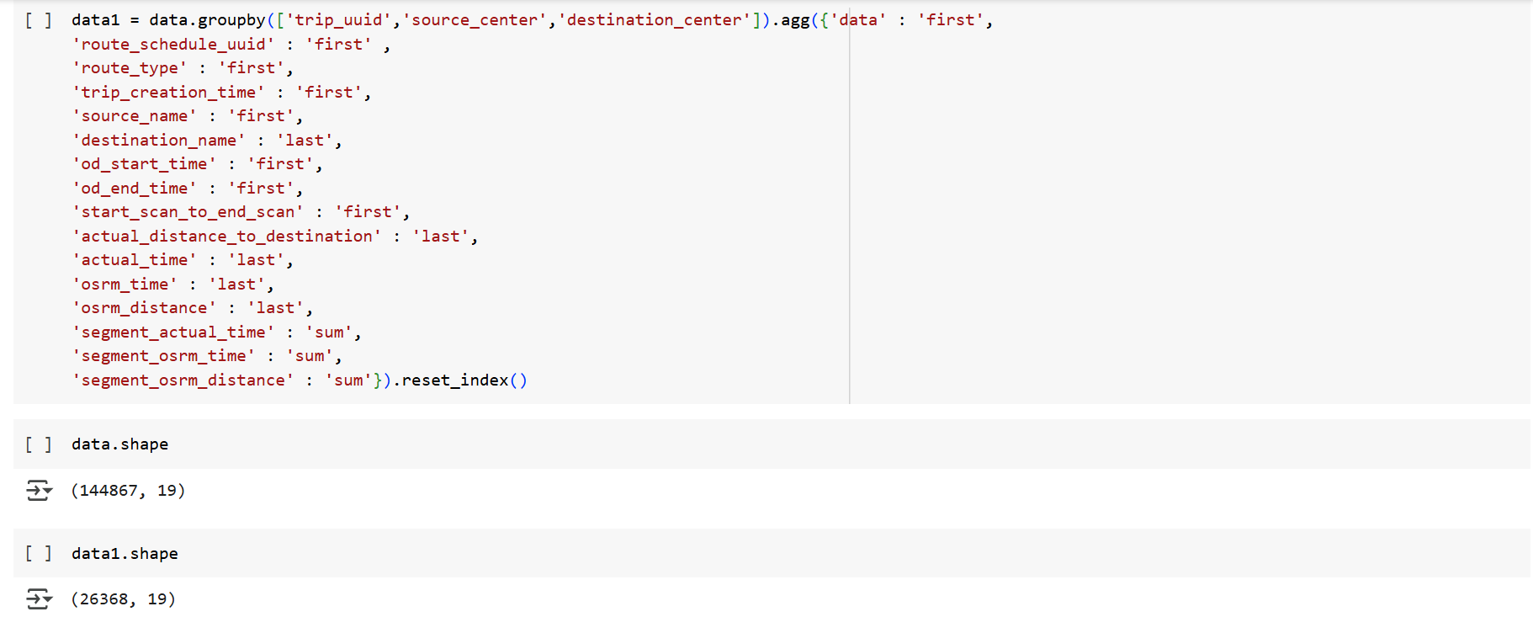

* Now lets do second groupby with only "trip_uuid"
* Here we have to sort any of "od-start_time" or "od_end_time" for each "trip_uuid" to ensure we get correct initial source & final destination for each trip_uuid

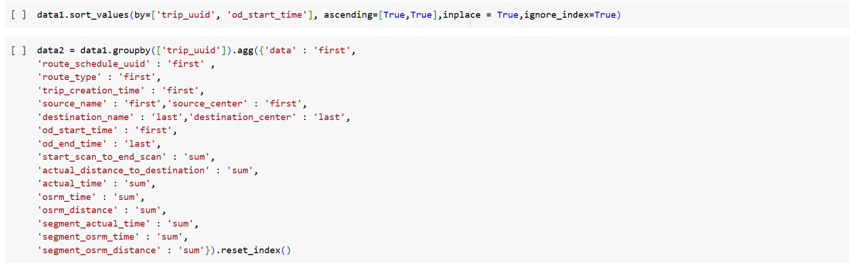

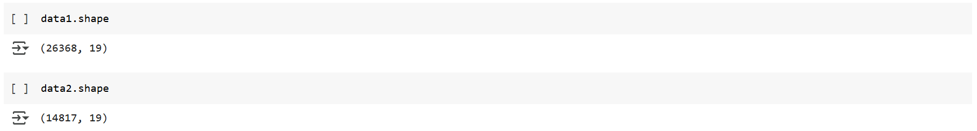

So After Merging Row we were able to Consolidate all information of 144867 rows 🡪 14817 rows

Now Lets cross check if we have achieved a Single Consolidate row for each “trip_uuid”

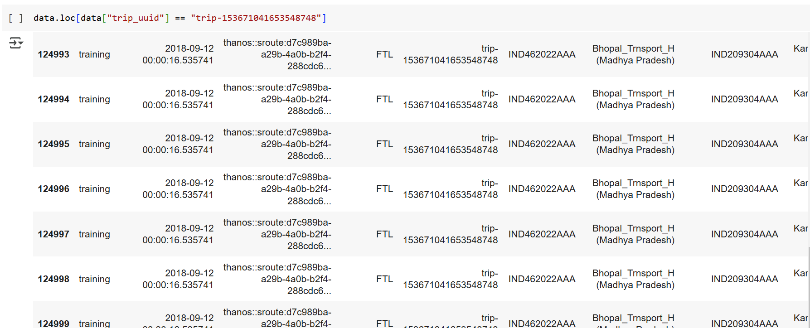

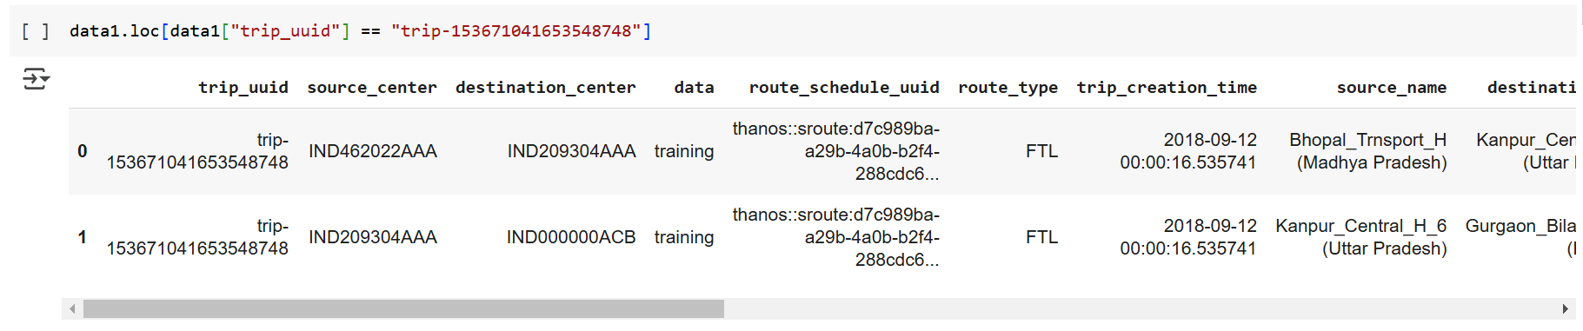

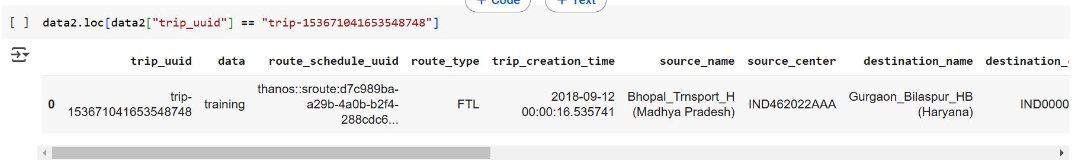

* As can be seen from above 3 cells now we can single row for each "trip_uuid" with proper od_start_time, od_end_time, Source & Destination details with summed up Distance and time value

###### Outlier Treatment:

Outlier Treatment Can be done only for Numerical features, so we will consolidate all Numerical features in one list for easy reference



We will create a new Dataframe " outlier" which store Boolean value of IQR Analysis Result for each reading of all numerical feature columns

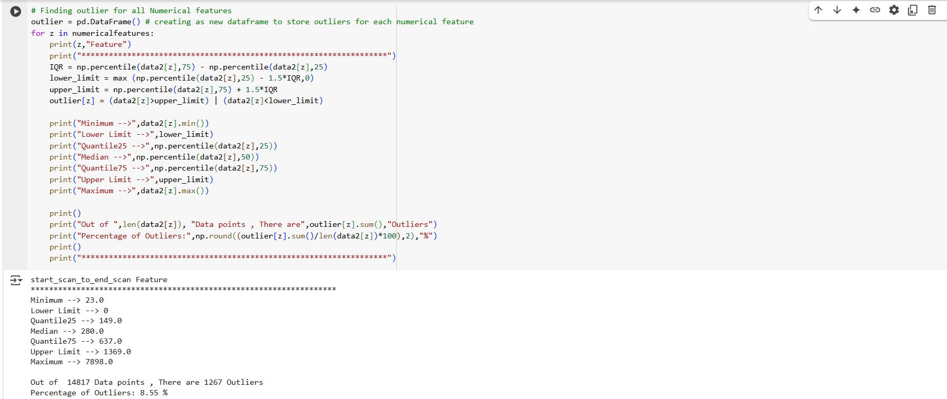

Let us visualize the outliers with Box plot

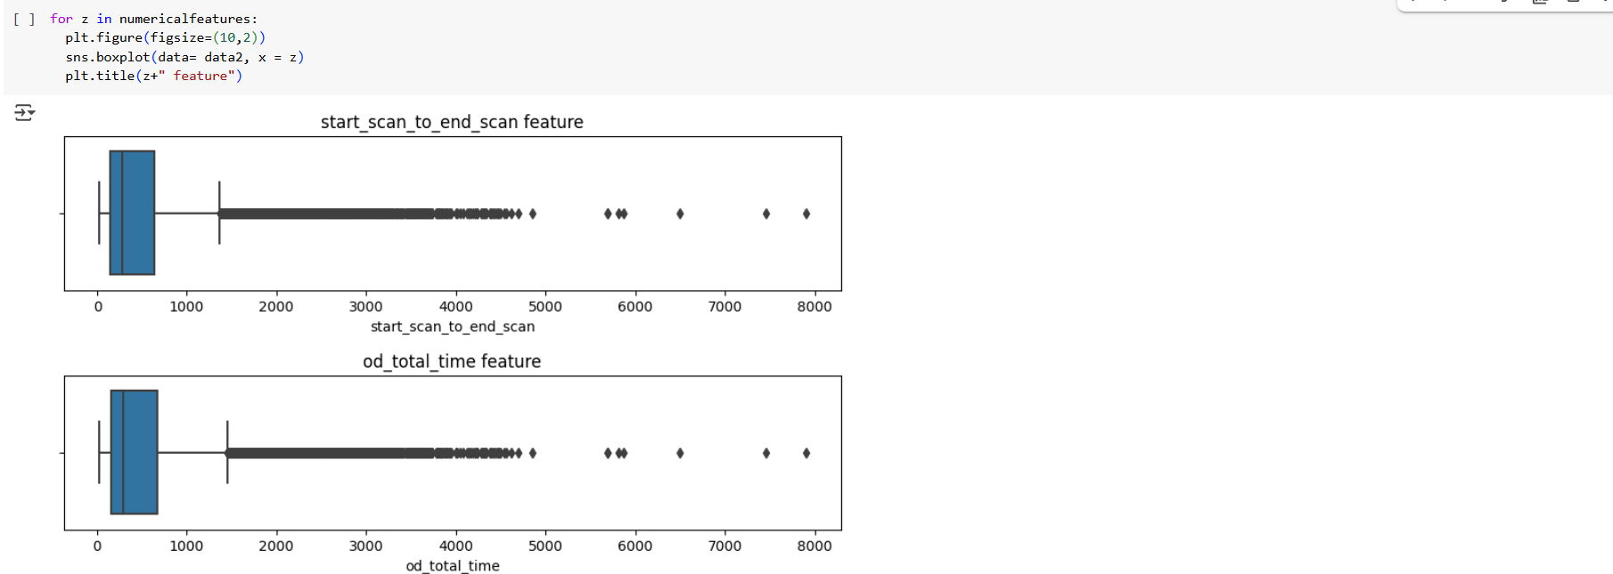

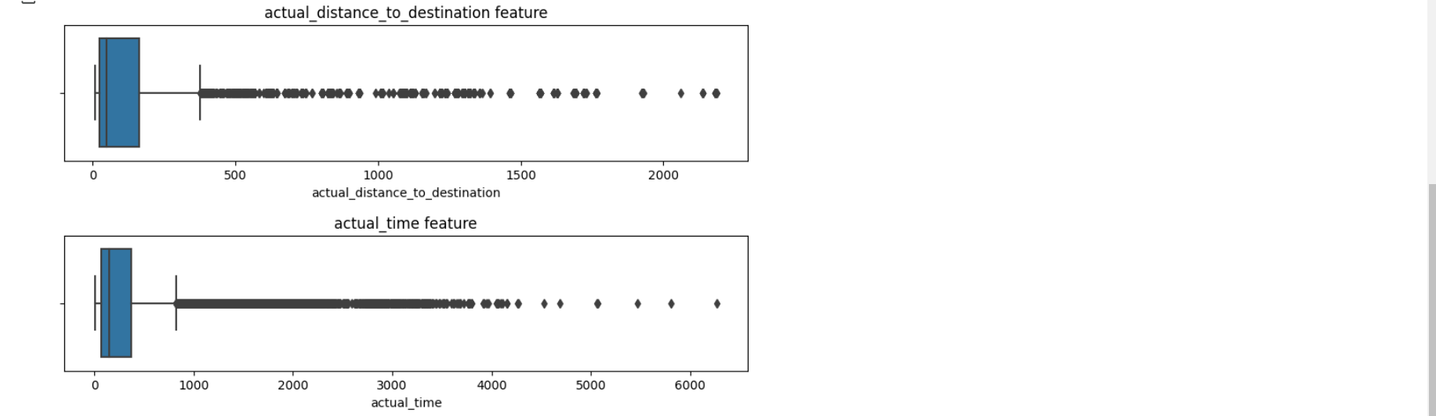

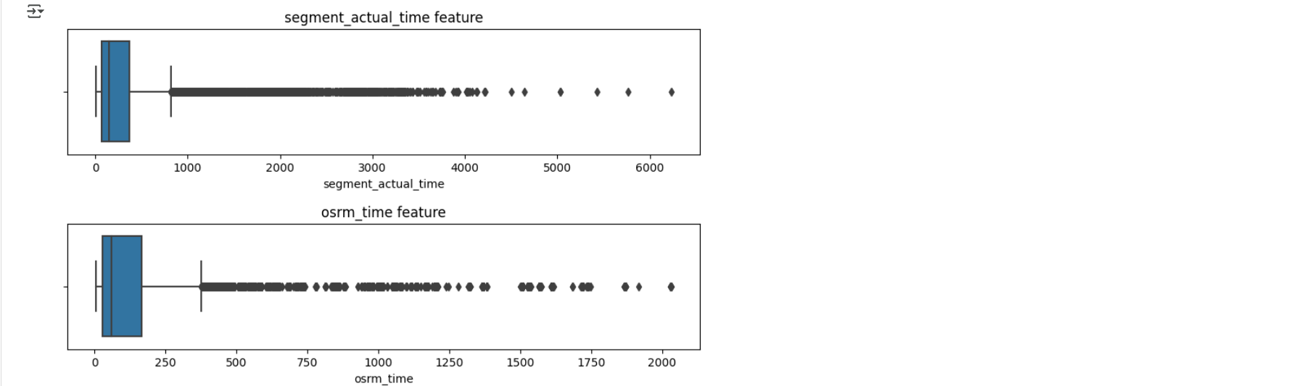

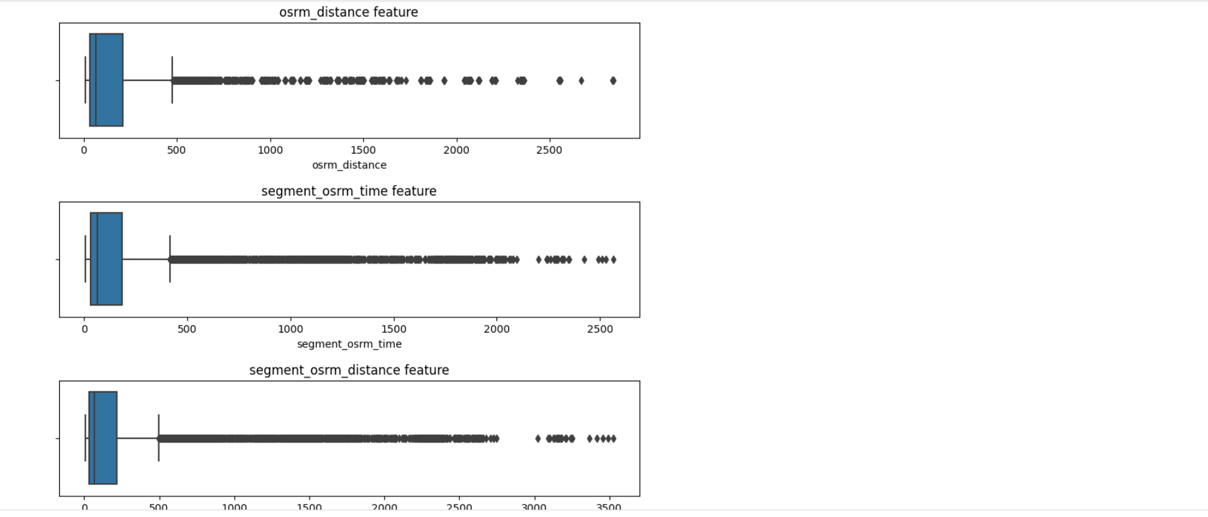

let us check if outliers are really outliers or they are occuring due to long distance/ Duration Courier

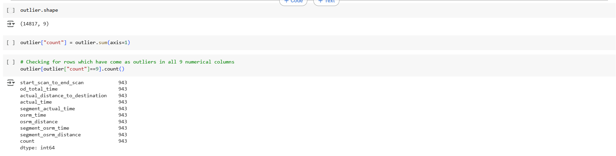

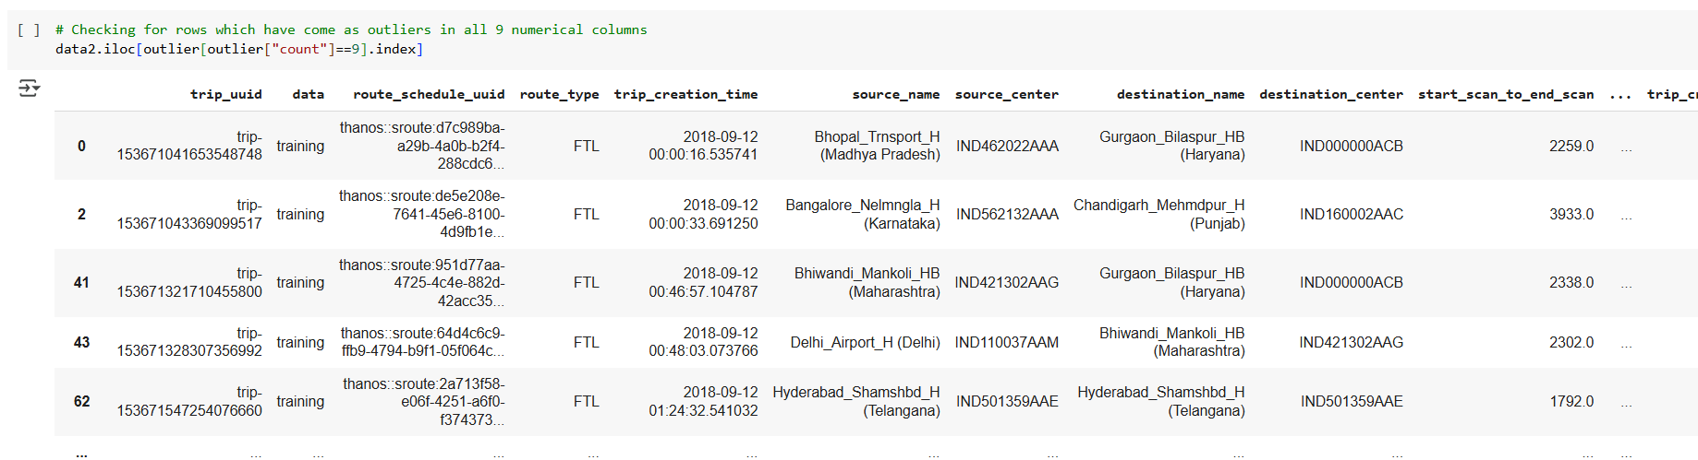

* There are total 943 Rows which have come as outlier in all 9 numerical features
* But we cannot delete the rows just because of the IQR rule, these outliers might be trips which are having very long distance & duration
* So all these outliers can be good Data points only
* so we cannot drop these outliers data point
* we will use them as OK

##### Feature Engineering 1:

Now That We Have Cleaned all the Data and Consolidate our “Trip_uuid” Data, we will extract additional Relevant features for building good ML Model

###### Features Consolidation:

In this We try to Extract Relevant Single Feature from multiple Features to reduce the Dimensionality because Dimensionality Plays important role in the performance of the Models

* "od_start_time" & "od_end_time"can be converted to single feature by calcualting time difference between both

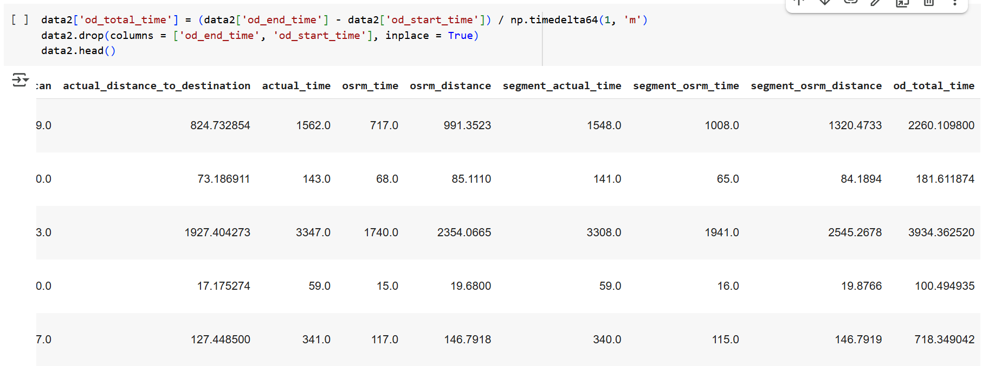

###### Feature Extraction:

Let Extract Multiple New Features from Single Feature

We can extract Day, Week, Month & Year from Trip_Creation_time to Give Grasp Seasonal Factor to our ML Model

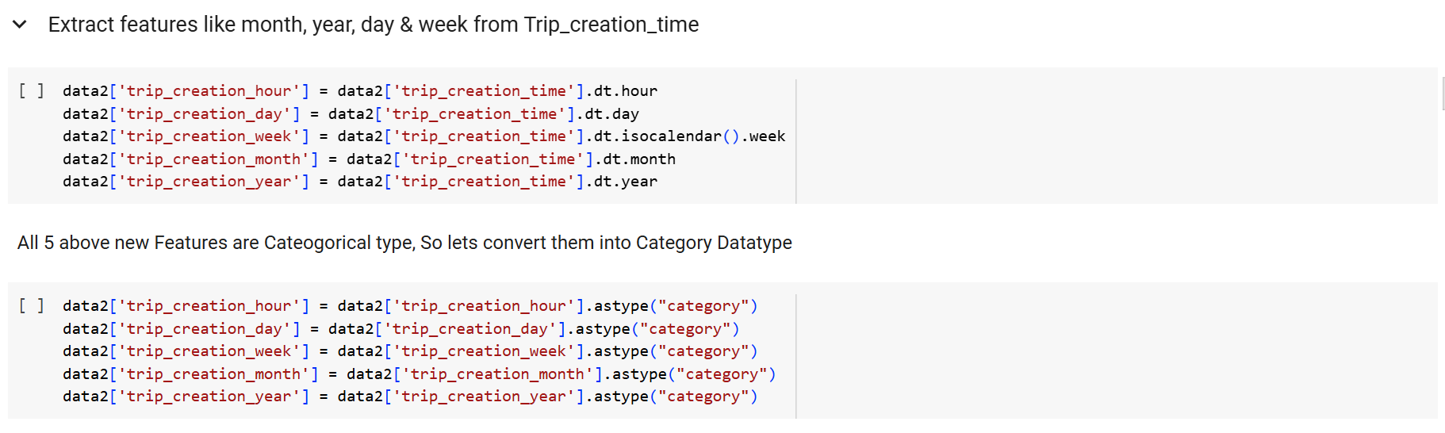

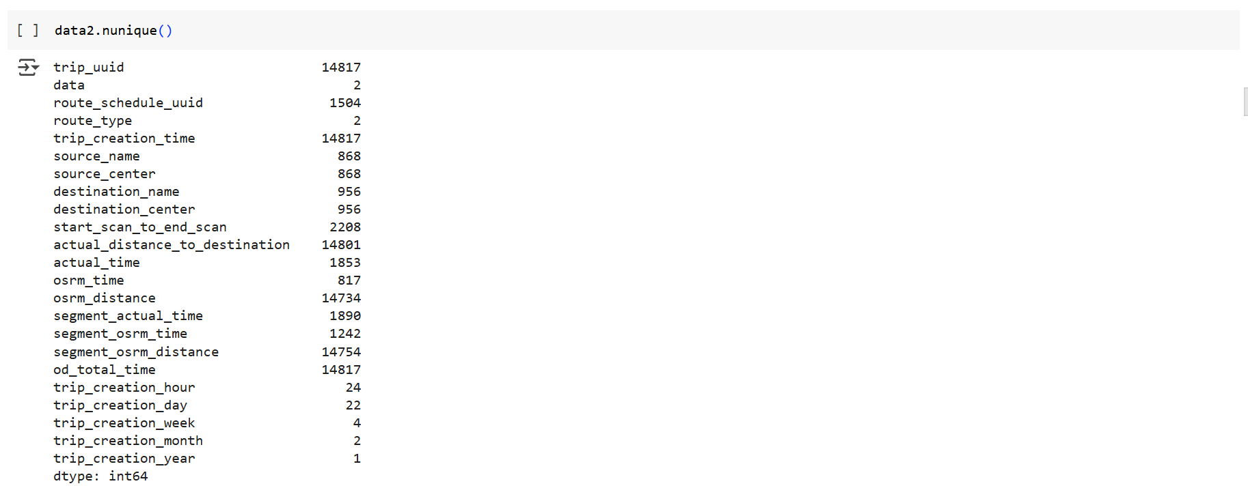

* In this Dataset "trip_creation_year" is having only 1 unique value, this feature can be dropped
* However, we will keep the feature for now [ so that this code can be generalized for any similar dataset in future]
* Now We Extract Feature like City,State from "source_name" & "destination_name"

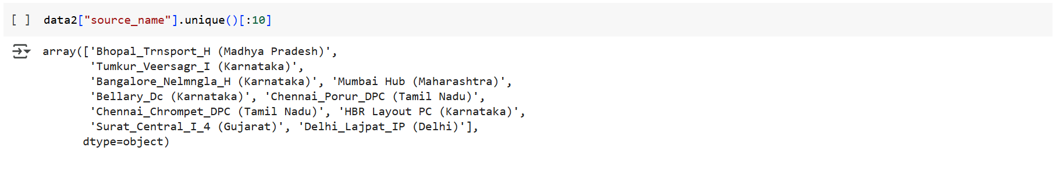

* we will have to use multiple split function to separate State, City & Place_code
* We will create functions to commonly apply for destination_name & source_name

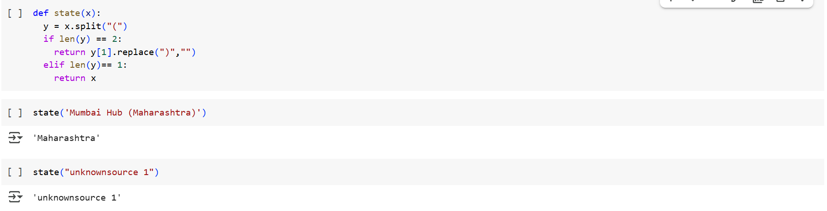

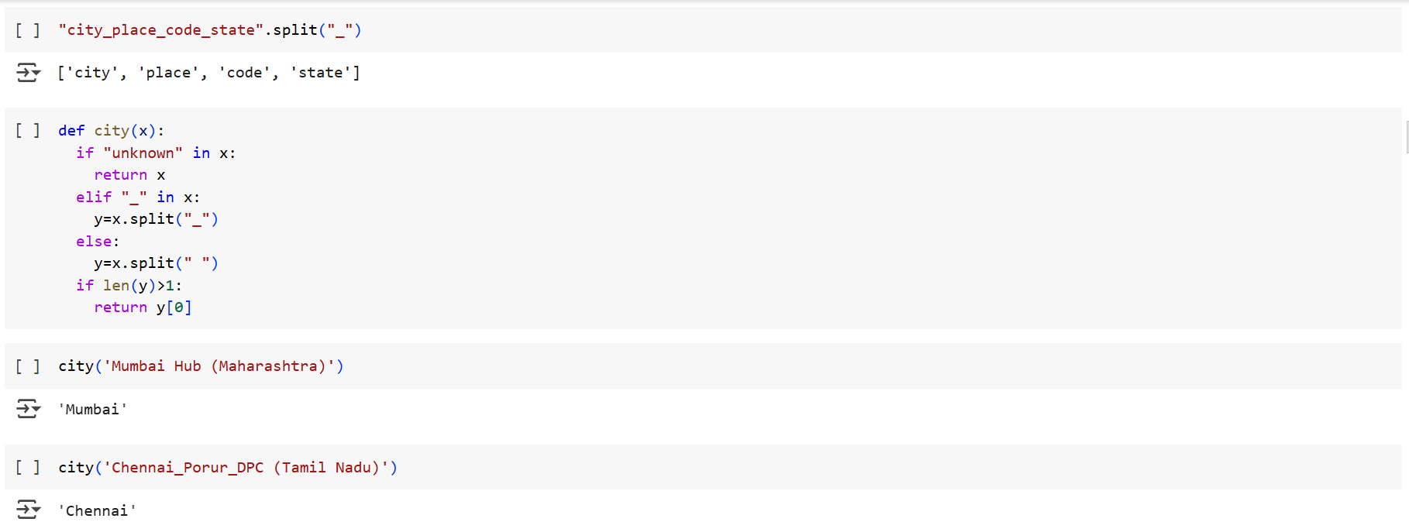

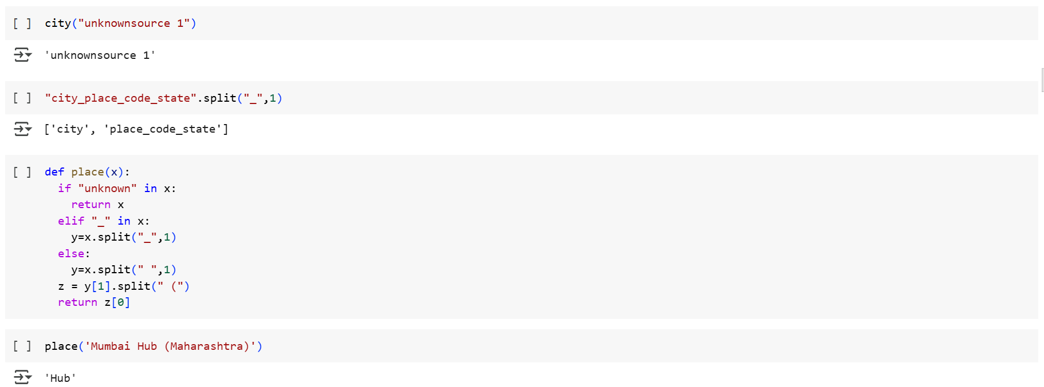

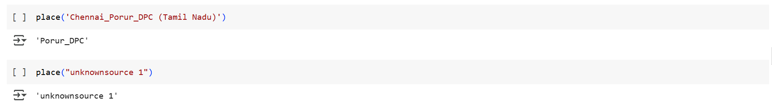

* All 3 User Functions state(),city(),place() are created and checked for proper functionality for ll types of inputs
* Now we will use these functions to create 3 new feature(State, City, Place) from sourc_name & destination_name

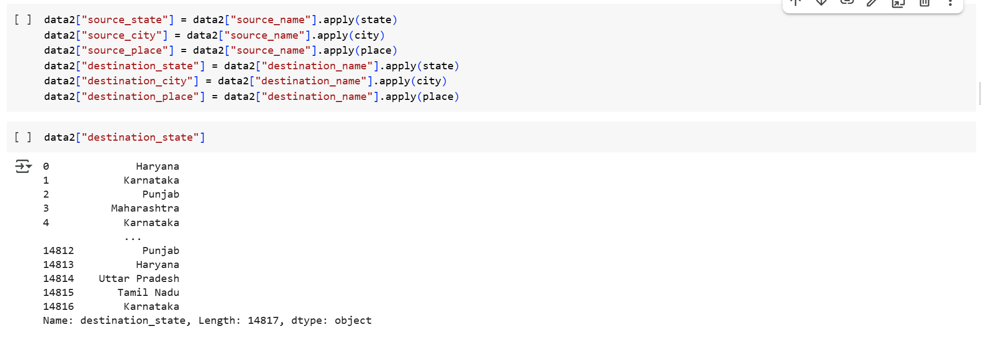

6 New Features Have been Created for Hierarchy type Inputs to ML Team, Lets Convert them to Category.

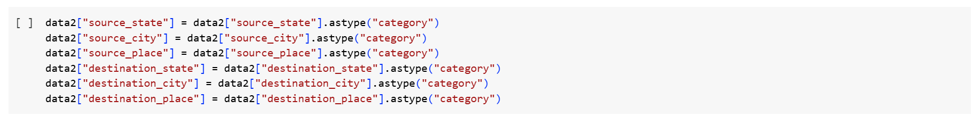

##### Statistical Analysis, Graphical Visualization & Insights

###### Unique Values in Features

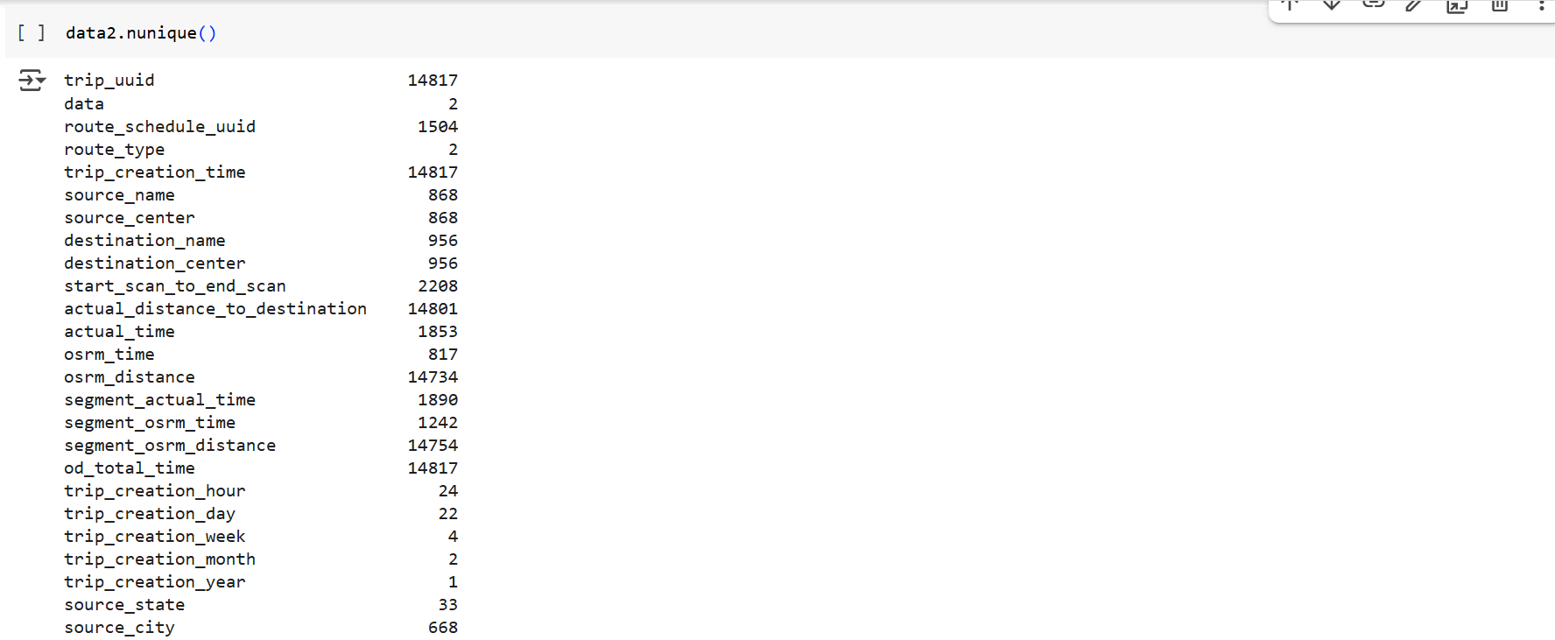

###### Data Type:

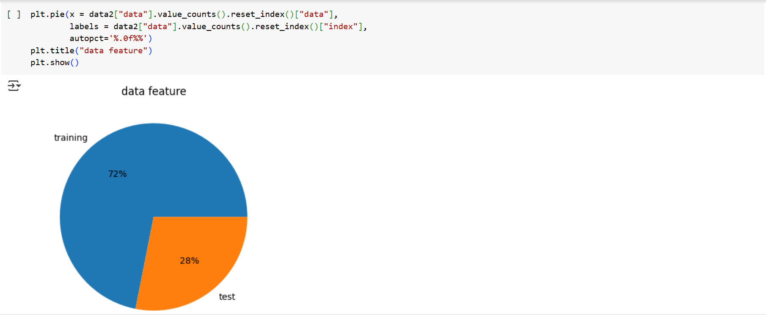

* 72% Data is used for Training
* 28% Data is used for Test

###### Route_type Features

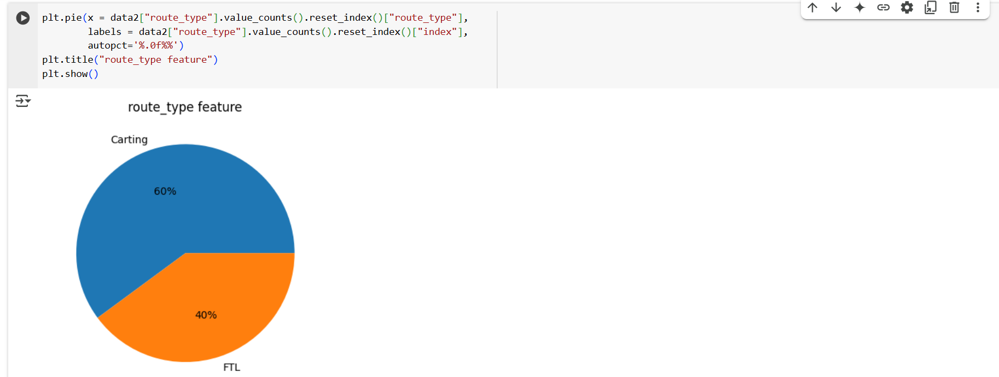

* 60% Trips are of Cart type
* 40% Trips are of FTL type

Trip_Creation_hour:

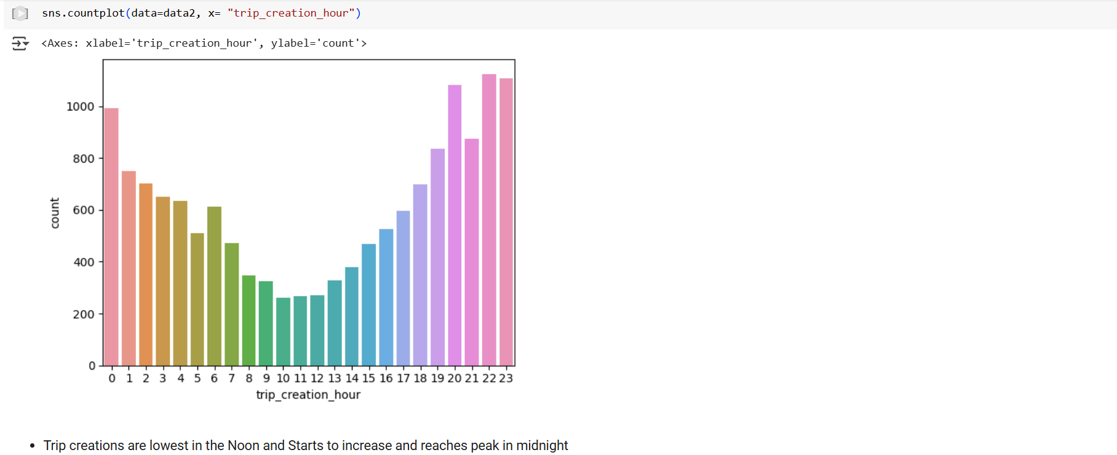

###### Trip_creation_day:

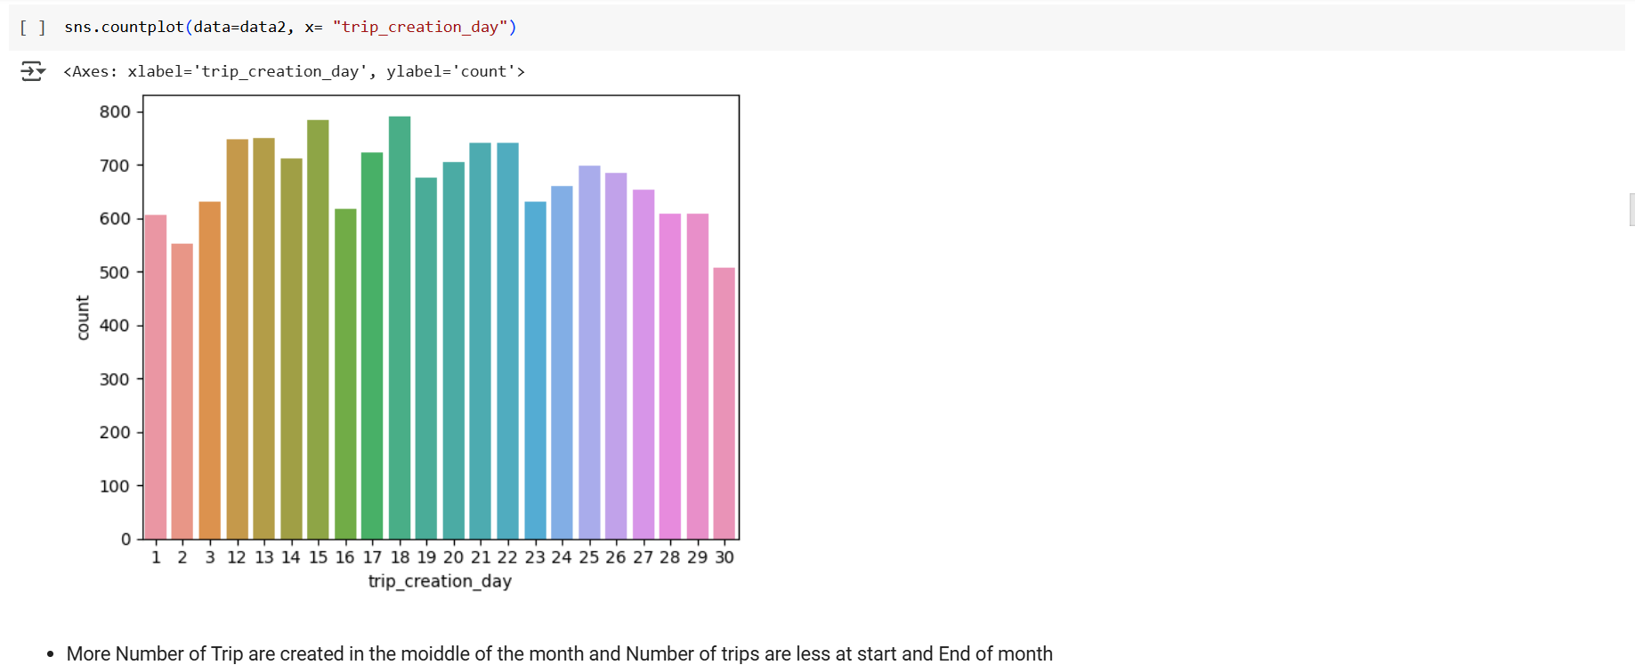

###### Source_State_Feature:

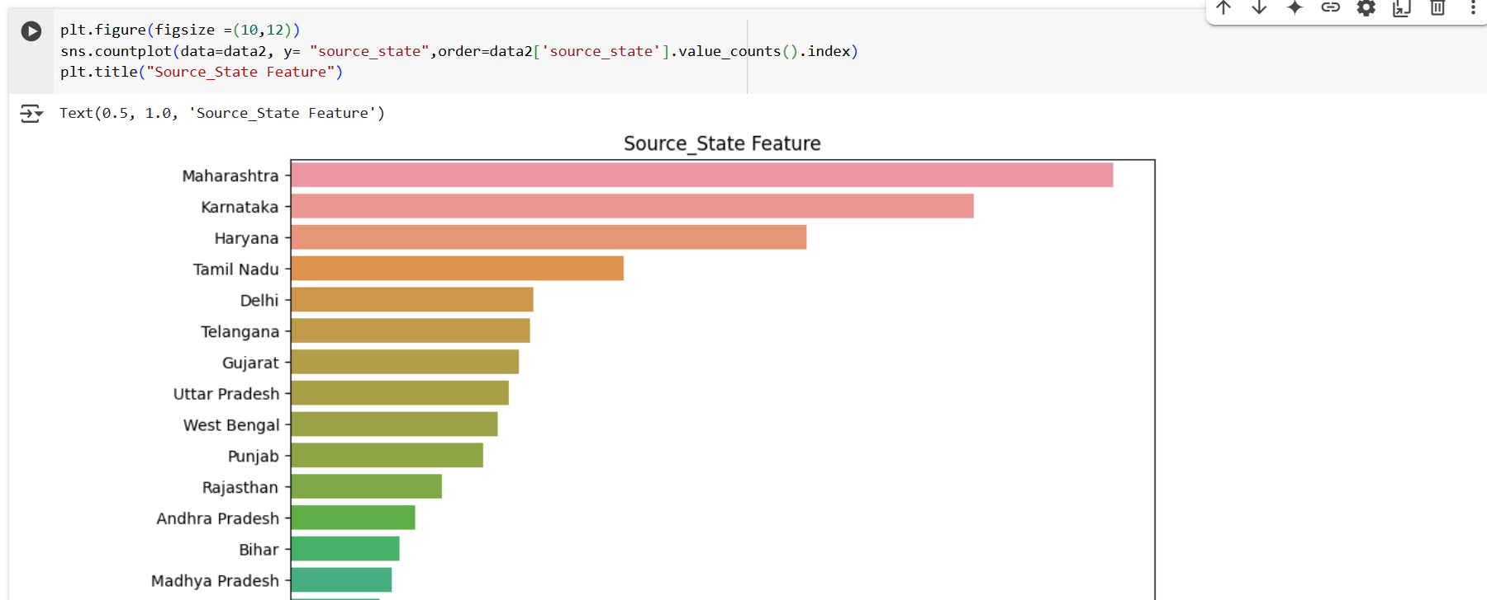

###### Destination_State_Feature:



###### Source_City_Feature:

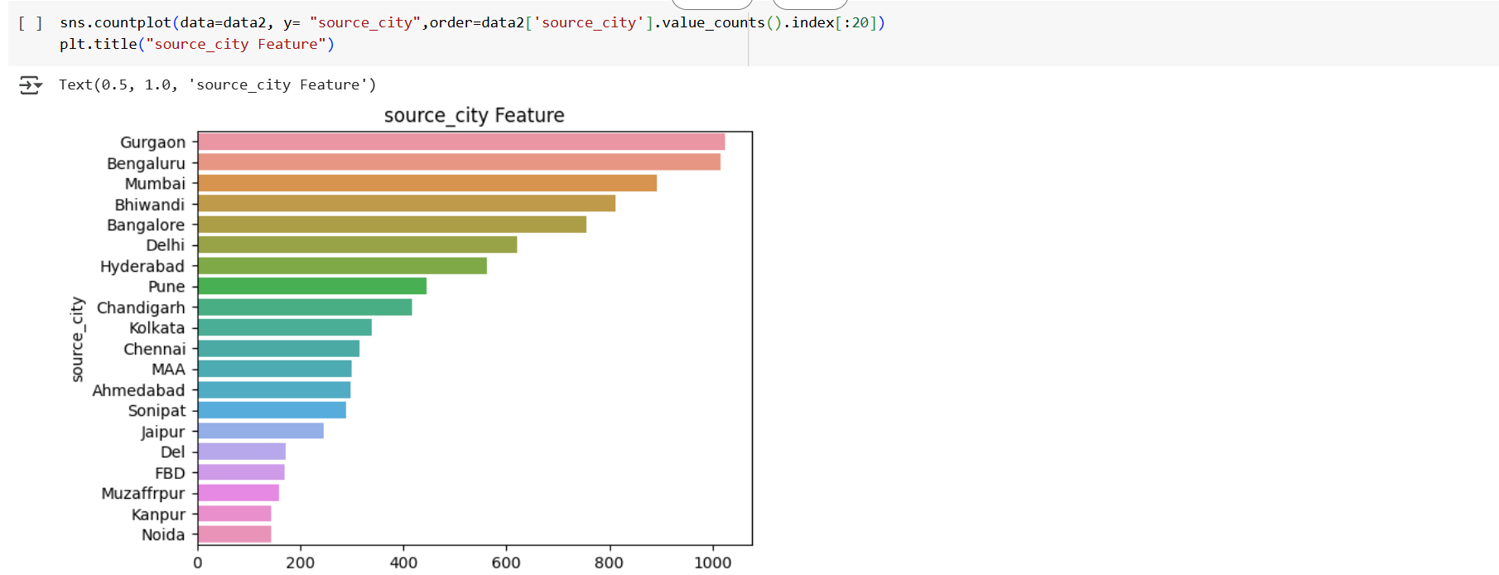

###### Destination_City_Feature:

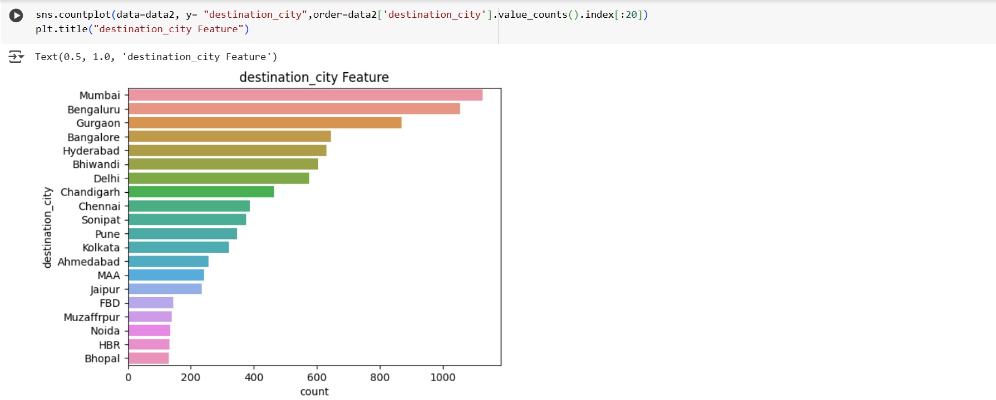

###### Start_scan_to_end_scan vs od_total_time:

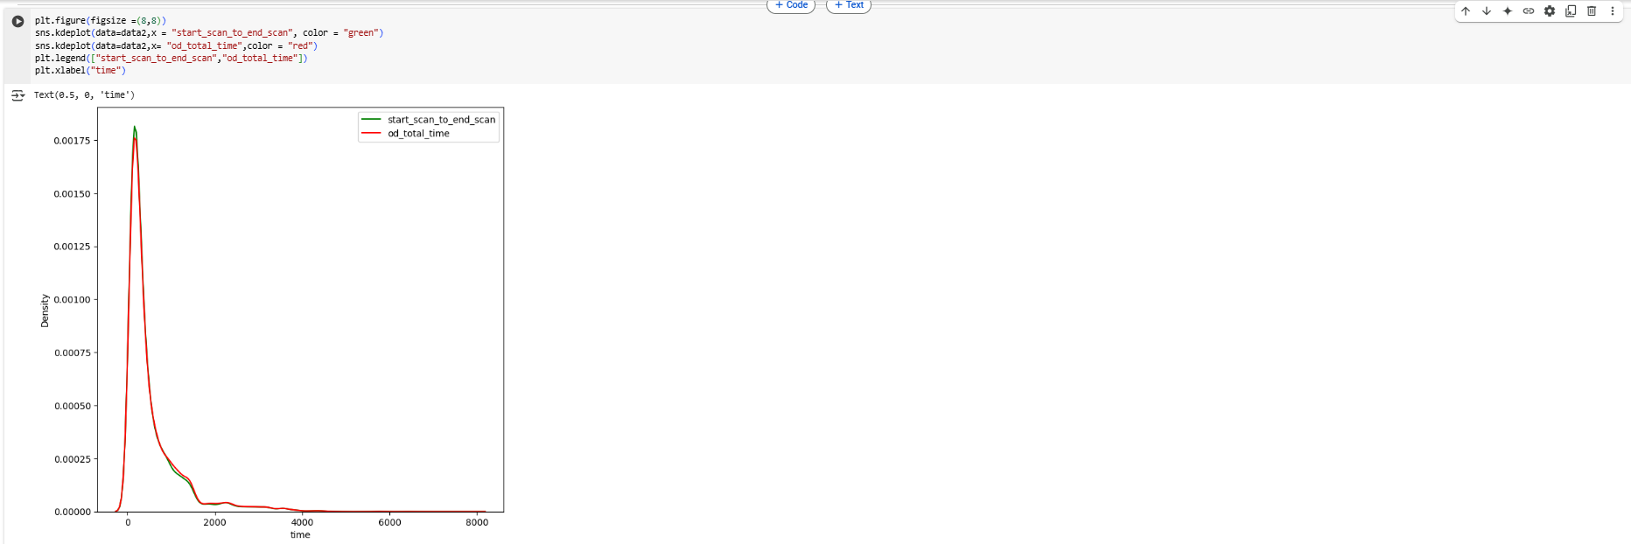

* od_total_time & start_scan_to_end_scan almost look like similar
* Further we can perform Hypothesis Testing to conclude

###### Actual_time VS OSRM_time:

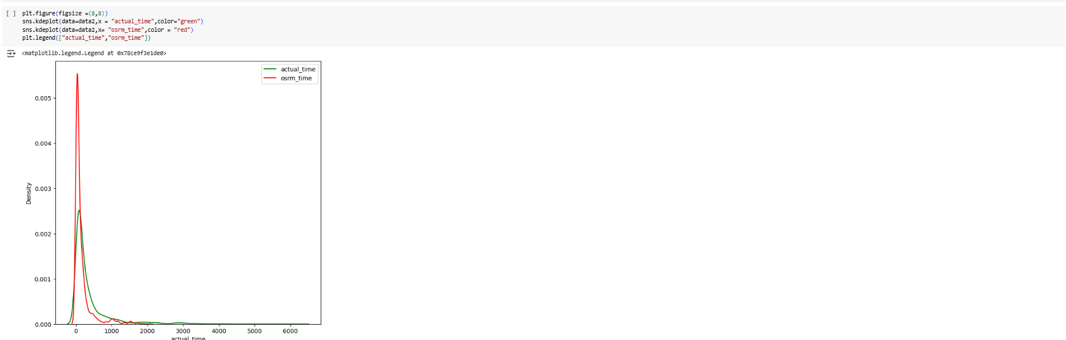

* Actual_time is seems to lower than osrm_time

###### Actual_distance_to_distance Vs osrm_distance:

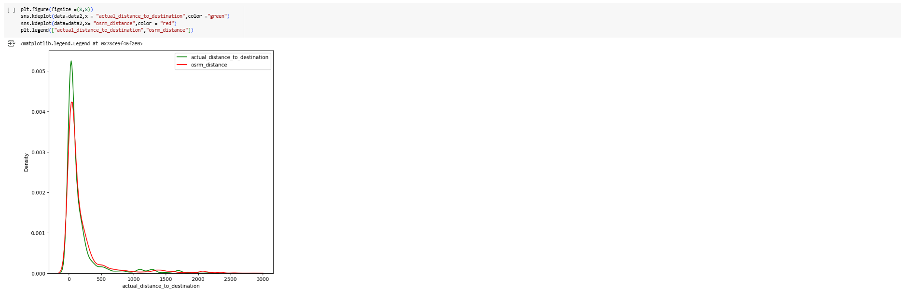

* Actual_distance_to_destination seems to be greater than osrm_distance

###### Correlation Matrix:

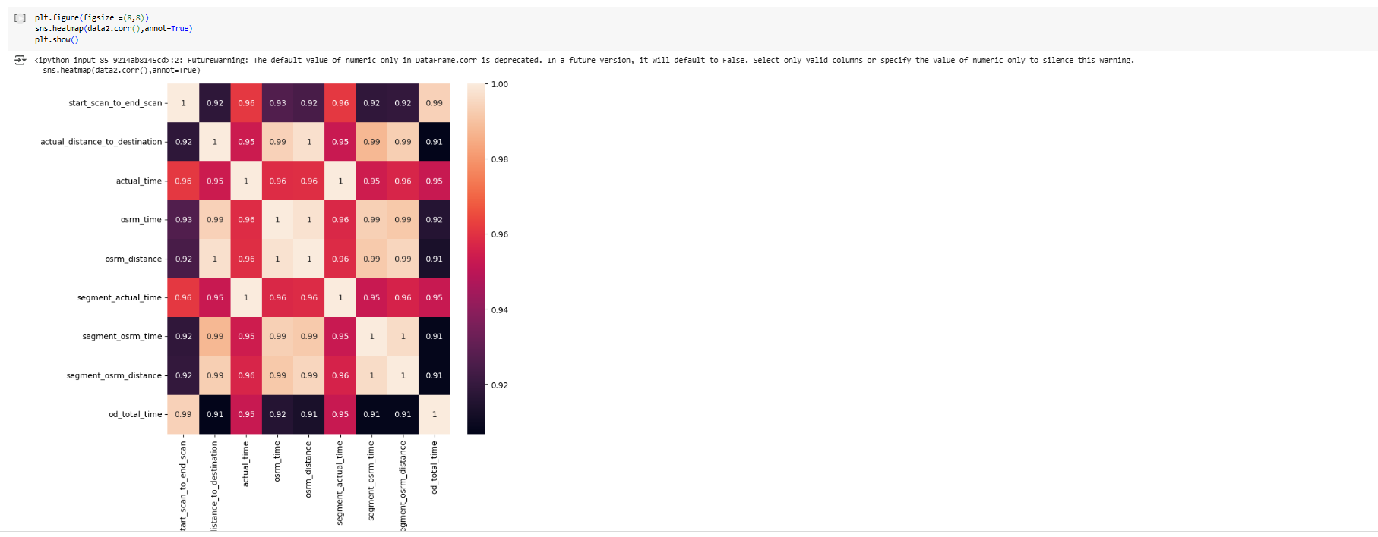

* All Time & Distance Feature are very highly correlated.

##### Feature Engineering 2:

###### Eliminate Redundant features

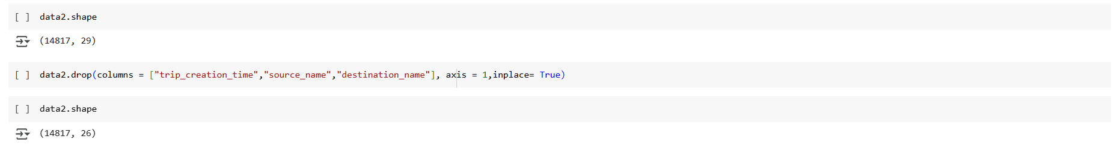

###### Encoding : Non-Numerical to Numerical

As Machine Learning Models are programs, they cannot understand Categorical Features so we have to convert them to Numerical through Encoding.

* We have to Convert all Non Numerical to Numerical Before feeding to Model
* we will use following to to convert all the Categorical data to Numerical
* "One-Hot Encoding" for Non Numerical features with 2 values [in Problem statemtent "One-Hot Encoding" explicity Requested, else we can be "label Encoder" also]
* "Target Encoder" for Non Numerical features with more than 2 values with "actual_time" as Target"

Label Encoding:

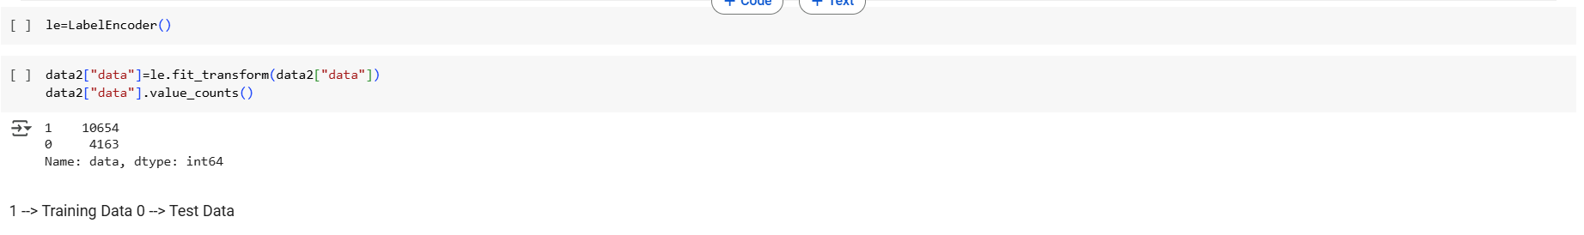

One-Hot Encoding:

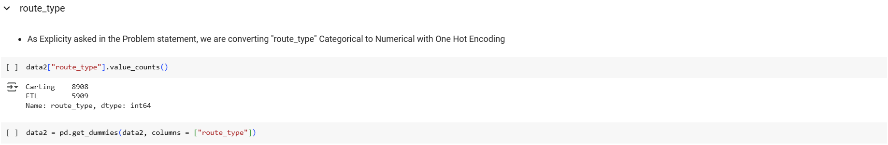

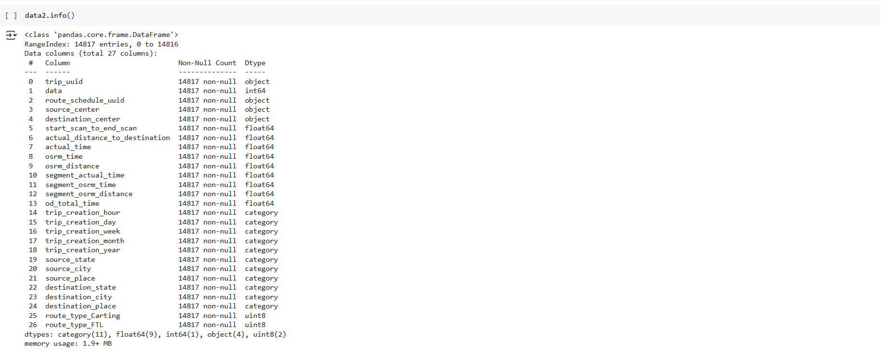

* we can see "route_type" category columns has been One Hot Encoded --> it converted into 2 Numerical columns : route_type_Carting & route_type_FTL
* Now we will converts other Non-Numrical columns with >2 group using Target Encoder

Target Encoding:

As we are working to Build Forecast Models for "Actual_time", we will use it as Target for converting Categorical to Numerical using TargetEncoder

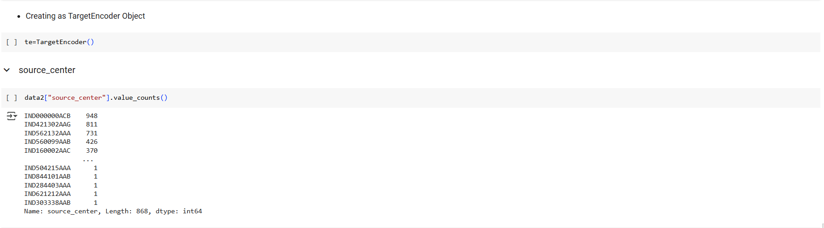

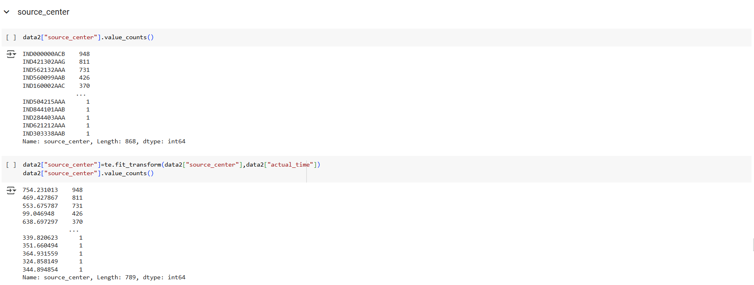

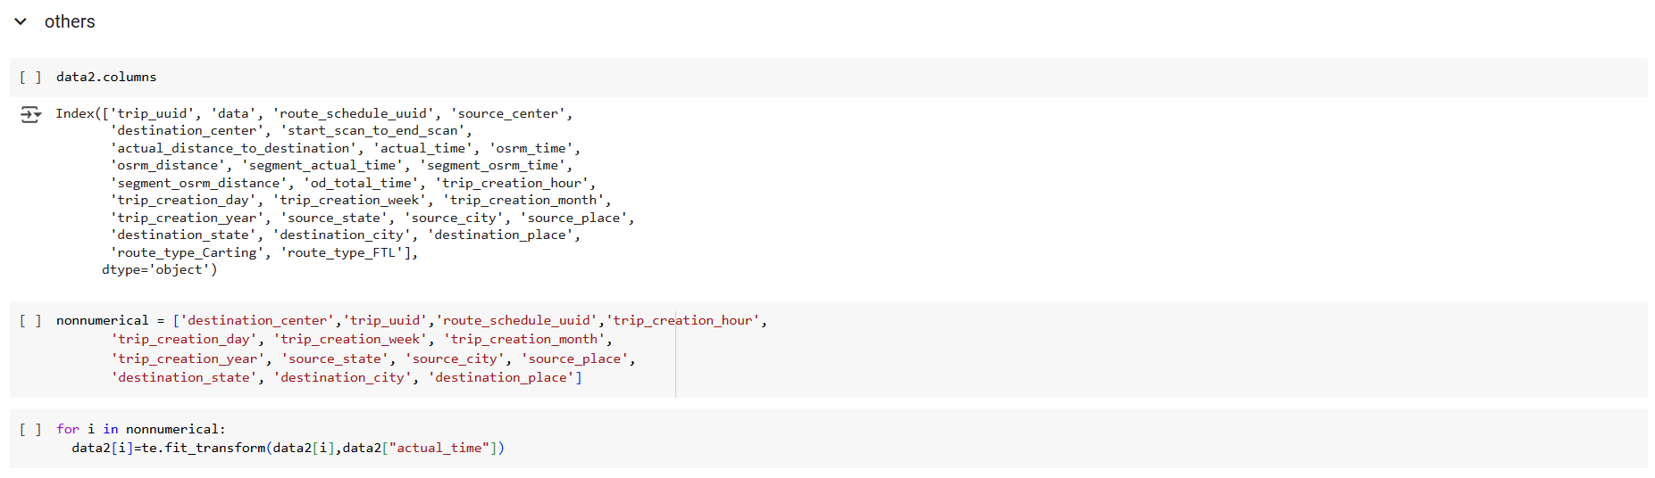

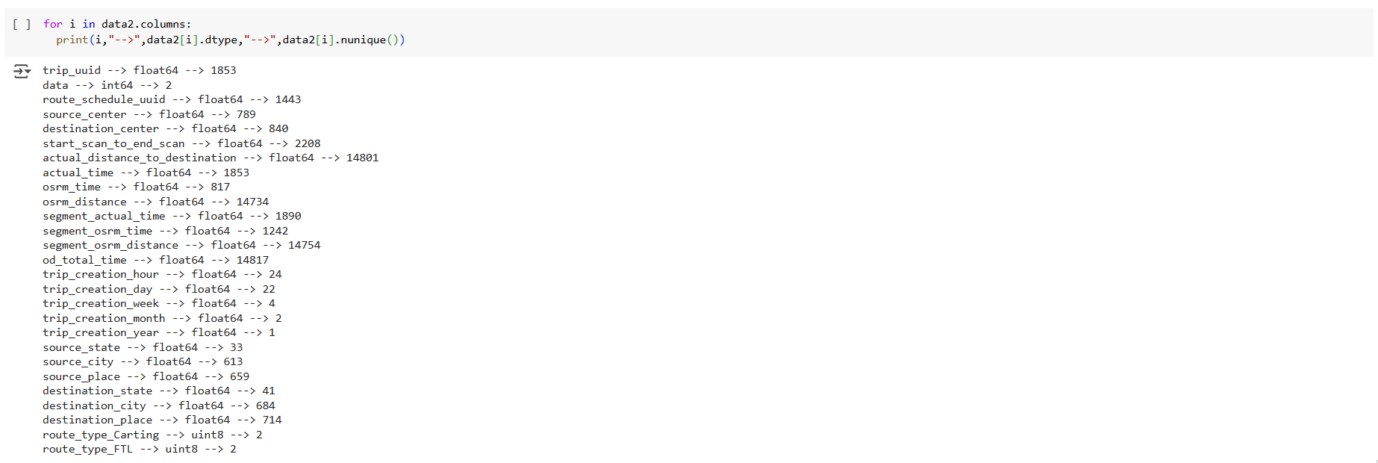

All Feature have been converted to Numerical data type

###### Scaling:

Before Scaling we will store the Row index for test and Tain data, so that we can separate data after Scaling

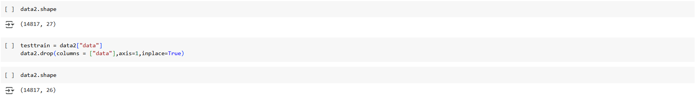

* From PCA Mathematical Derivation, we know that if Any Feature's Mean is "0", it will be easy to do Computation.
* Also, If Feature's Mean = 0, then Model Development will be good
* So, we will do Standardization instead of Normalization.

Standardization

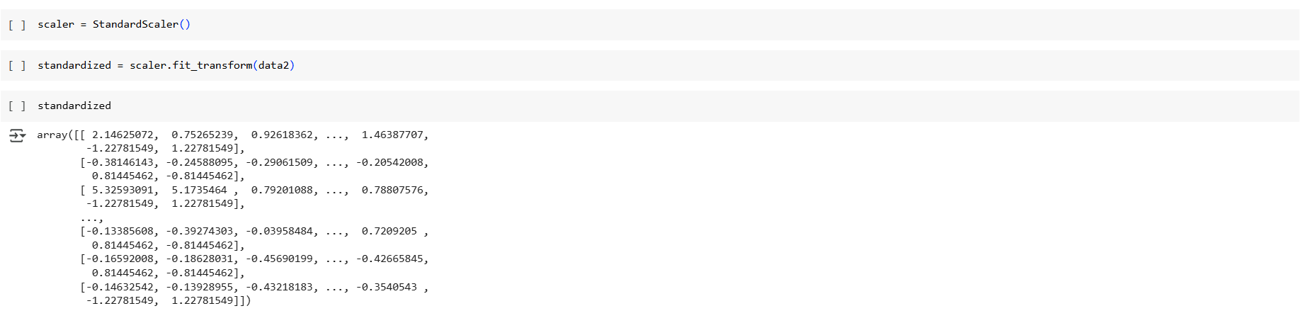

* lets convert standardized data into our initial DataFrame Format

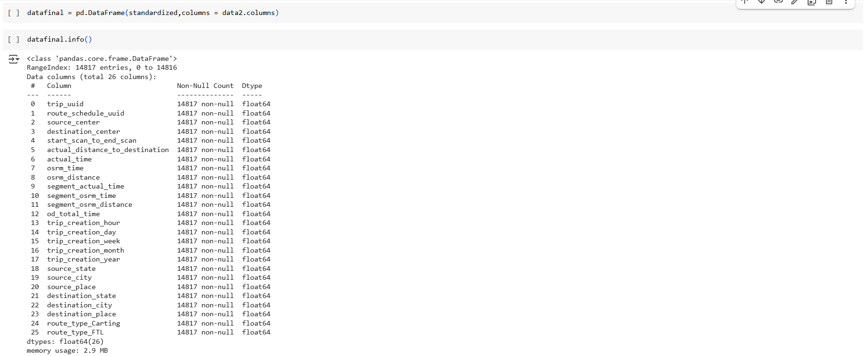

Now we see:

* Data is Cleaned for Missing Values, Outlier, Data Type
* Data has been Converted to numerical for Model Building

Now we can Separate Data for Training and Testing

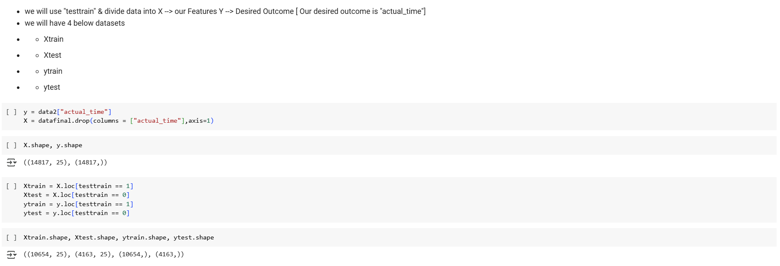

#### Business Insights

* The DataSet provided is between 2018-09-12 00:00:16.535741 & 2018-10-03 23:59:42.701692
* Training : Test Data Ratio use = 72:28
* 60% trips are of Cart Types, rest are of FTL type
* Trip creations are lowest in the Noon and Starts to increase and reaches peak in midnight
* More Number of Trip are created in the moiddle of the month and Number of trips are less at start and End of month
* There is not much effect of Week ina month for trip Creation
* Top 5 Source States:Maharastra,Karnataka,Harayana,Tamilnadu,Delhi
* Top 5 destination States: Maharastra,Karnataka,Harayana,Tamilnadu,Telangana
* Top5 Source Cities:Bengaluru,Gurgoan,Mumbai,Bhiwandi,Delhi
* Top5 Destination Cities: Bengaluru,Mumbai,Gurgoan,Hyderabad,Bhiwandi
* "od_total_time" is greater than "start_scan_to_end_scan" for a given trip_uuid
* "actual_time" is always greater than "osrm_time" for a given trip_uuid
* "actual_time" & "segment_actual_time" have approx same mean for a given trip_uuid
* "osrm_distance" is less than "segment_osrm_distance" for a given trip_uuid
* "osrm_time" is less than "segment_osrm_time" for a given trip_uuid
* "actual_distance_to_destination" is less than "osrm_distance" for a given trip_uuid

#### Recommendations:

* Major Traffic is found in Maharastra, Karnataka,Haryana --> Appropriate infrastructure & Manpower needs to be maintained to reduce logitics Delays
* Carting Type Trip from among manjor Cities (Bengaluru, Gurugaon,Mumbai,Hyderabad,Delhi,Bhiwandi) can be Converted to FTL by delhivery to further Optimize the Total trip Duration
* High Trip Creation goes on during night time, & in the middle of the month, so appropriate Resource to be maintained to reduce process bottle Necks
* Actual Trip Time is alwasy greater than Osrm predicted time, so Accordingly Buffer to be added , so that no false commitment at customer end
* Actual Distance_to_Destination is statistically lower than osrm distance, so correction might be needed for distance calculation so that price of trip can be optimised according & best value can be given to customer

### Chapter 2 : Business Case Study 2

#### Problem Description

##### About Company

A micro-mobility service provider, which offers unique vehicles for the daily commute. Starting off as a mission to eliminate traffic congestion in India, company provides the safest commute solution through a user-friendly mobile app to enable shared, solo and sustainable commuting.

Company zones are located at all the appropriate locations (including metro stations, bus stands, office spaces, residential areas, corporate offices, etc) to make those first and last miles smooth, affordable, and convenient!

##### Problem:

Company wants to Determine factors affecting the demand for these shared electric cycles.

* Which variables are significant in predicting the demand for shared electric cycles?
* How well those variables describe the electric cycle demands.

##### Dataset:

* datetime: datetime
* season: season (1: spring, 2: summer, 3: fall, 4: winter)
* holiday: whether day is a holiday or not (extracted from http://dchr.dc.gov/page/holiday-schedule)
* workingday: if day is neither weekend nor holiday is 1, otherwise is 0.
* weather:
  + 1: Clear, Few clouds, partly cloudy, partly cloudy
  + 2: Mist + Cloudy, Mist + Broken clouds, Mist + Few clouds, Mist
  + 3: Light Snow, Light Rain + Thunderstorm + Scattered clouds, Light Rain + Scattered clouds
  + 4: Heavy Rain + Ice Pallets + Thunderstorm + Mist, Snow + Fog
* temp: temperature in Celsius
* atemp: feeling temperature in Celsius
* humidity: humidity
* windspeed: wind speed
* casual: count of casual users
* registered: count of registered users
* total_count: count of total rental bikes including both casual and registered

##### Libraries Used:

import numpy as np

import pandas as pd

import matplotlib.pyplot as plt

import seaborn as sns

from scipy.stats import norm, binom, geom

from scipy.stats import ttest_1samp, ttest_ind,ttest_rel

from scipy.stats import chisquare,chi2,chi2_contingency

from scipy.stats import f_oneway,kruskal,shapiro,levene

from statsmodels.graphics.gofplots import qqplot

from scipy.stats import pearsonr,spearmanr

from scipy.stats import poisson,expon

!pip install category_encoders

from category_encoders import TargetEncoder

!pip install sklearn

from sklearn.preprocessing import LabelEncoder

##### Outcome of Analysis:

Statistically Determine the Significant Feature effecting the Demand of Shared Electric Cycle in Indian Market

Do Bivariate Analysis & Statistically conclude with Appropriate Hypothesis testing.

Hypothesis testing is important because it helps people make informed decisions based on Statistical Analysis. With Hypothesis testing we can Check Cause and Effect of Features on Outcome of ML Models and Reduce the Dimensionality of our Model

Example :

* 2- Sample T-Test to check if Working Day influences the number of electric cycles rented
* ANNOVA to check if No. of cycles rented is similar or different in different 1. weather 2. season
* Chi-square test to check if Weather is dependent on the season.

#### Analysis:

As we have seen Data Cleaning in Depth in Business Case 1, we will Do Univariate & Bivariate Analysis on Cleaned Data and Then Do Hypothesis testing to determine the Significant features effecting the demand of Shared cycle.

Here we will follow a Systematic Approach to Conclude w.r.t each Feature

1. Univariate Analysis
2. Bivariate Analysis
3. Hypothesis Testing

##### Univariate, Bivariate Analysis Set up

Lets define all the User defined functions for doing Bivariate analysis in this section

We will create user defined function to get Bivariate plots : "bivariateplot(info,cat,num)"

* info --> Dataframe
* cat --> any category column header
* num --> any numerical column header

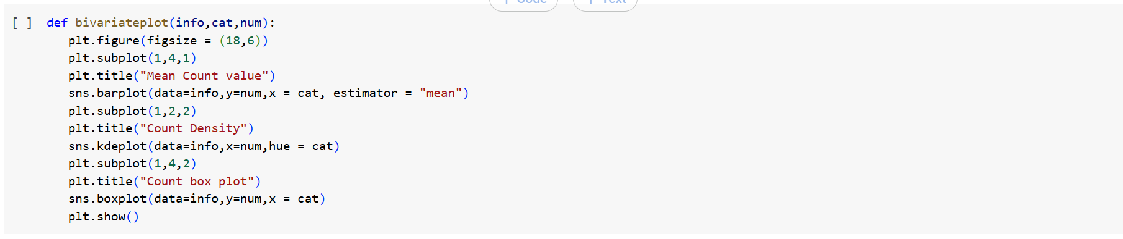

we will create another user defined function to get all statistical parameters of bivariate Boxplot

* cat --> any category column
* num --> any numerical column



##### Hypothesis Testing setup:

In this section let us fix the Confidence level & Level of Signification for all our Hypothesis testing

As this is with respect to predicting demand Situation

* let us Assume we want 95% Confidence to reject Null Hypothesis
* so for every Hypothesis testing, Level of Significane will be "0.05 "

##### Impact of Datetime on User Count

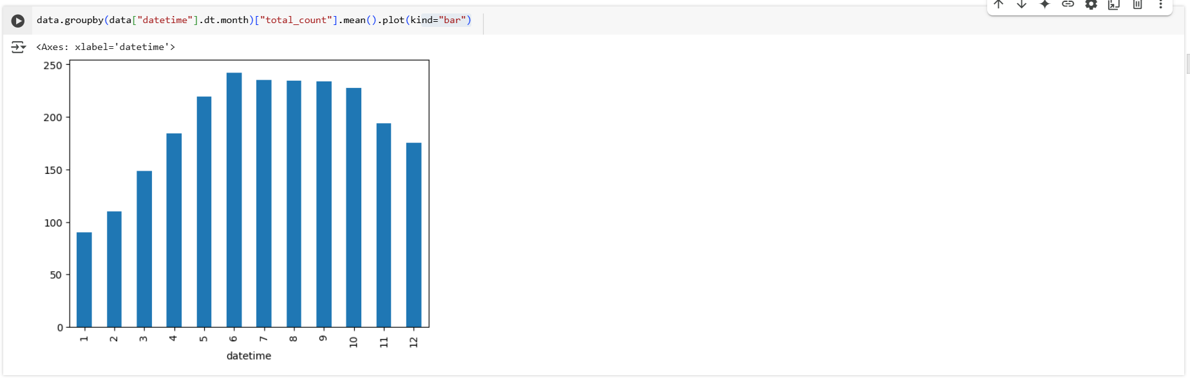

* User Count is highly active in the month from 5 ~ 10
* Lets us check if Datetime has any correlation with season

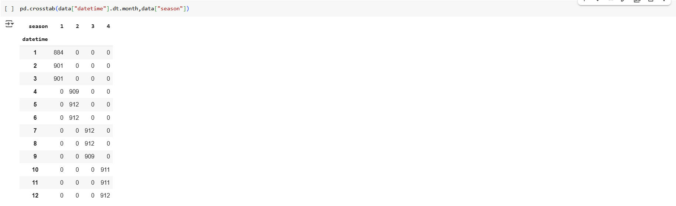

* It seems there is relation between Datetime Month & Season
* Lets conclude our inference with Hypothesis Testing

Lets do Hypothesis testing to check dependence of Seasons on datetime

###### Hypothesis testing:

As Datetime & Season are both Categorical Data, we will do Chi2_Contigency test to test their Dependence

Null Hypothesis can be set as below

* Ho: Datetime & Season are independent
* Ha: Datetime & Seasons are not Independent

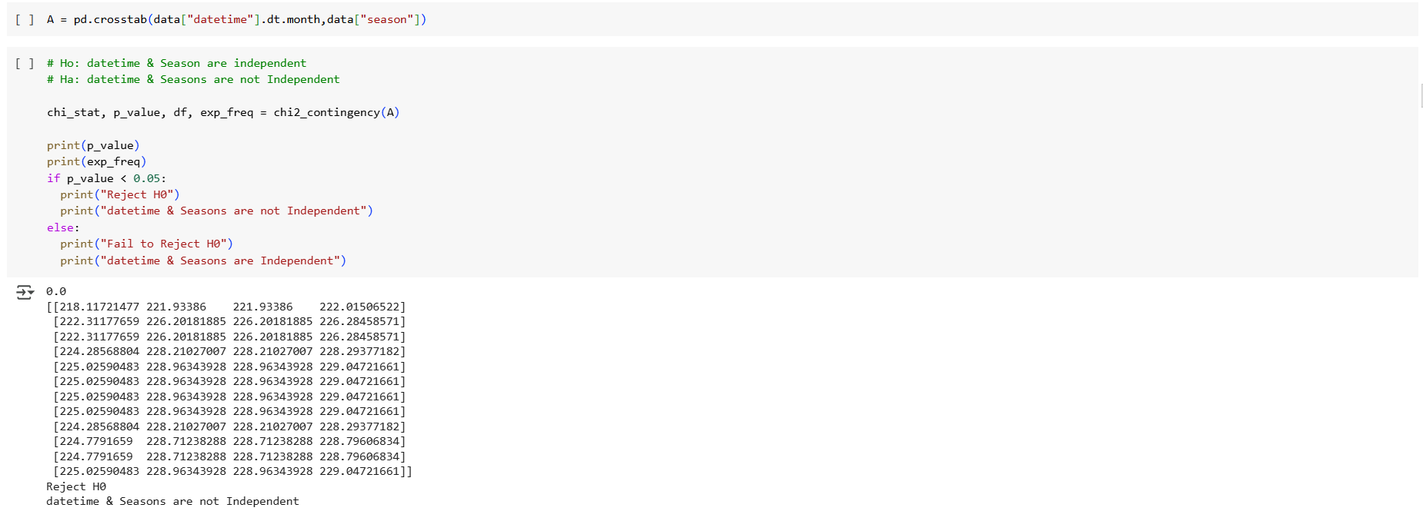

* with >95% , we can conclude that Datetime & Season are very much dependent on each other,So further we will continue our analysis only on Seasons

##### Impact of Season on User Count

###### Season:

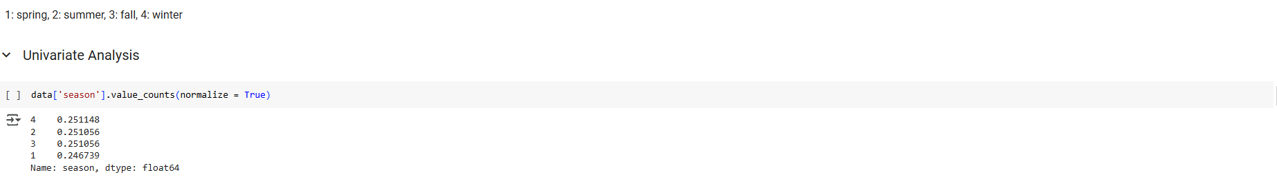

###### Season & total_count:

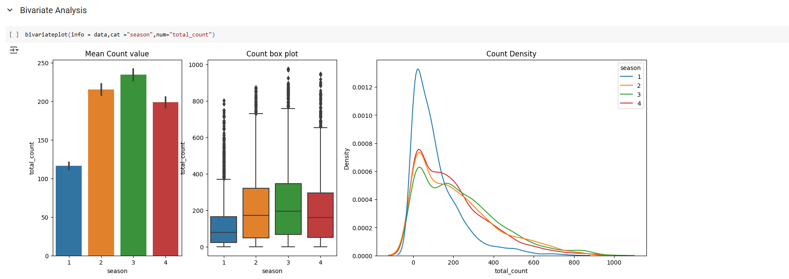

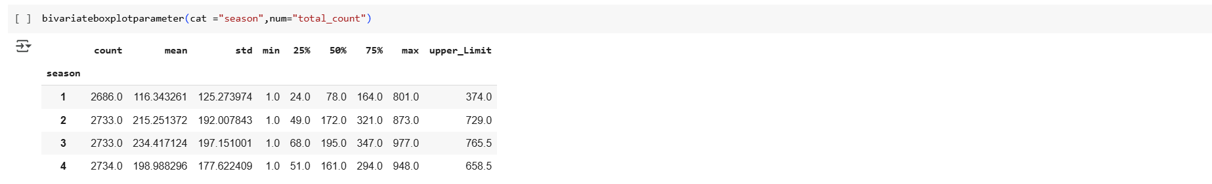

* No of user total_count in "1:Spring" season are very low with upper limit of 374
* whereas user total_count is highest in "3:fall" are high with upper limit count as 765

Let us do Hypothesis testing to check if Season has effect on Total_Count

###### Hypothesis testing:

As we have 4 groups in seasons Category --> we will use **ANNOVA** & check how does seasons effect on user count

* Ho --> All seasons have same user count mean
* Ha --> Some seasons user count Mean are different

Before using ANNOVA, we will check if all 4 season category data is following Normal Distribution & does they have equal variance

For Normal Distribution, we will use **Shapiro test** with below Hypothesis Condition

* H0 : Data is Gaussian
* Ha : Data is not Gaussian

For Equal Variances Check, we will use **Levene Test** with below Hypothesis condition

* H0: Variances are equal
* Ha: Variances are not equal

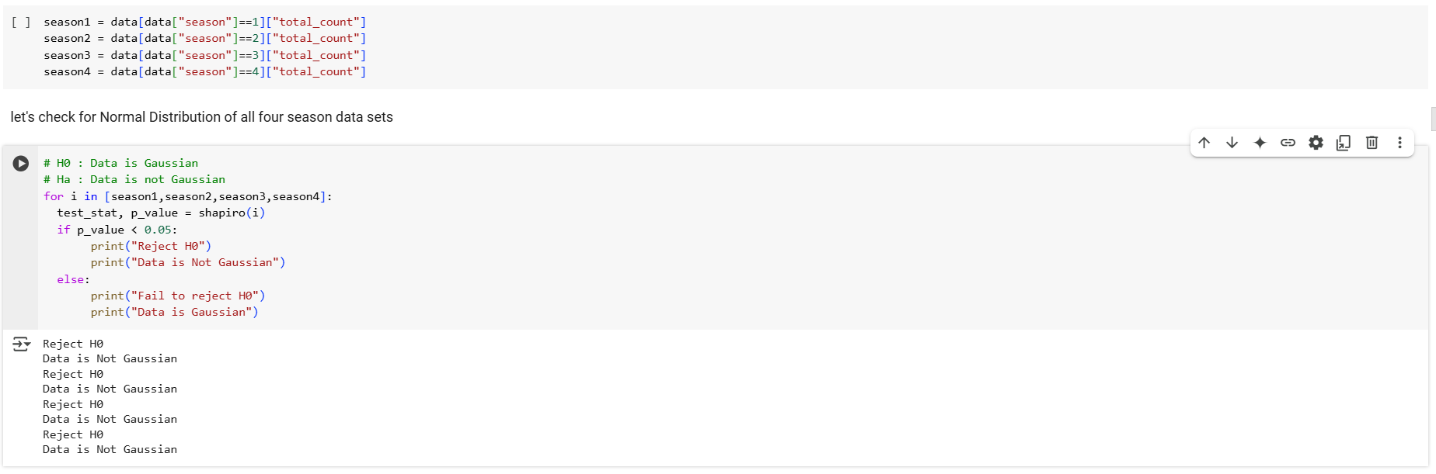

* All 4 Season Data sets are not following Normal Distribution
* Once will check Histogram plot.
* Now we will do Levene test to check for equal Variances.

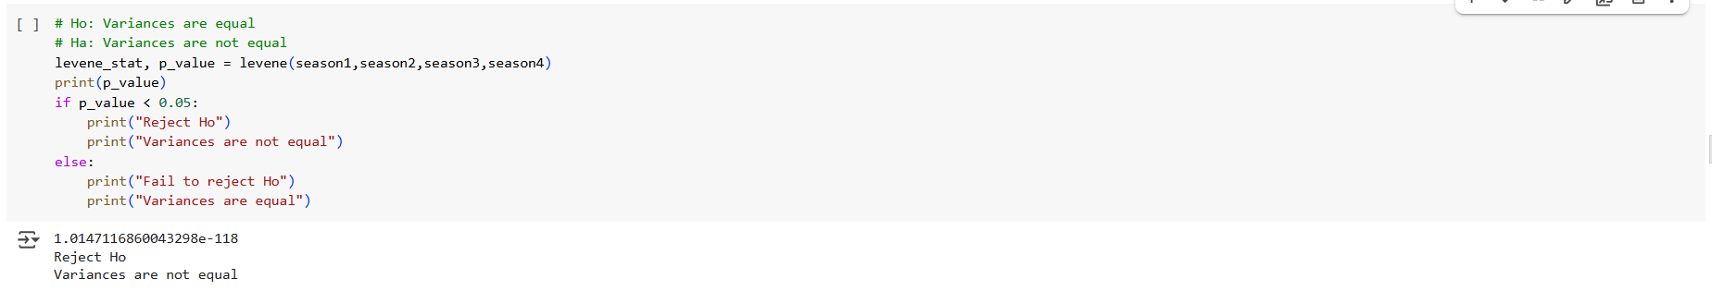

* All four Seaons Datasets do not have equal Variance
* So 2 of ANNOVA assumption fails, we will do **kruskal Wallis** test

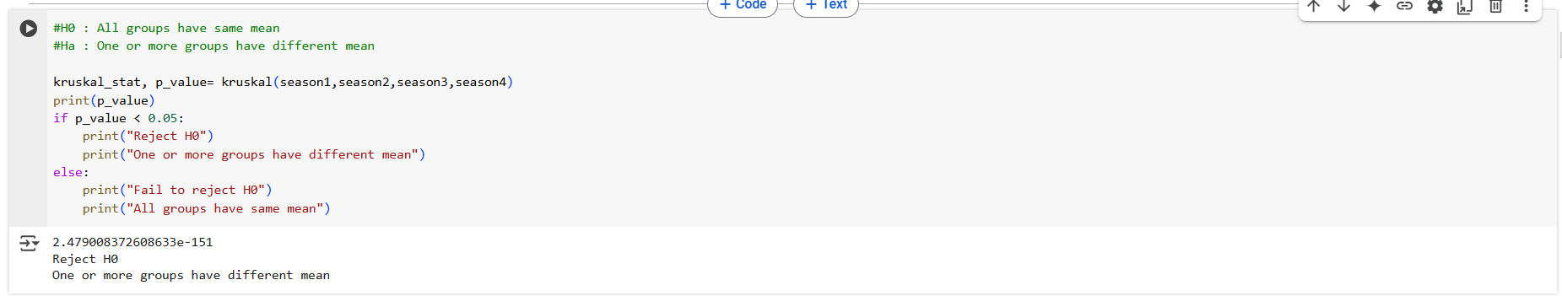

From Kruskal Walli Test, With >95% confidence we can say that **Season has impact on total_user Count**

##### **Impact of Weather on User Count**

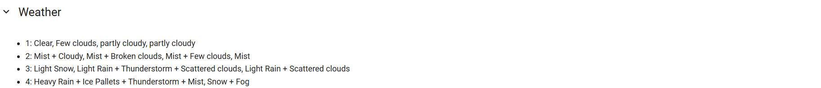

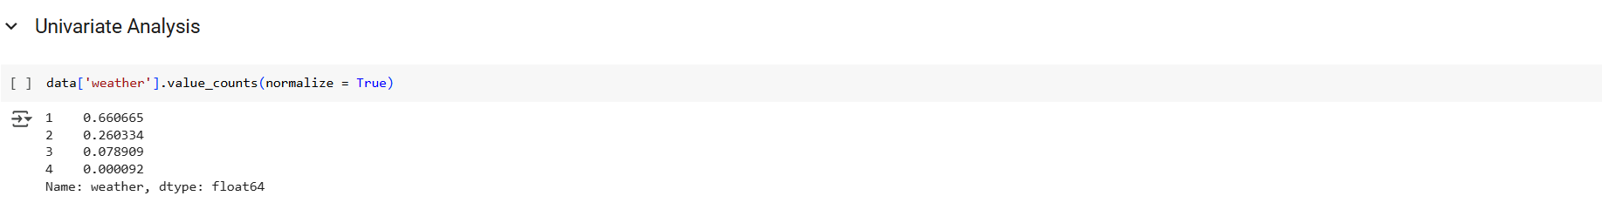

###### Weather & total_count:

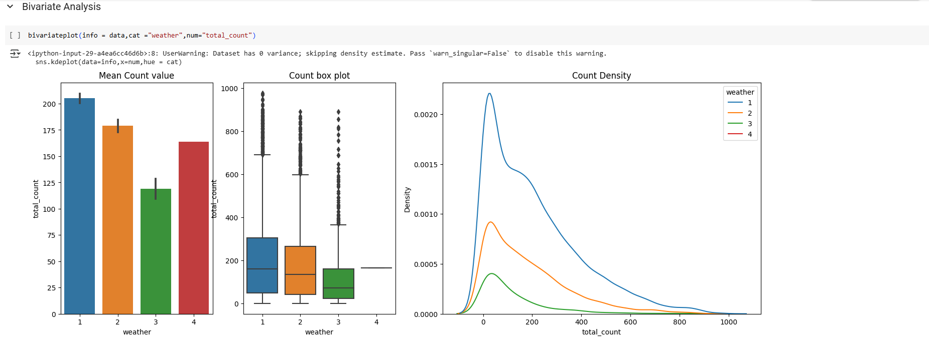

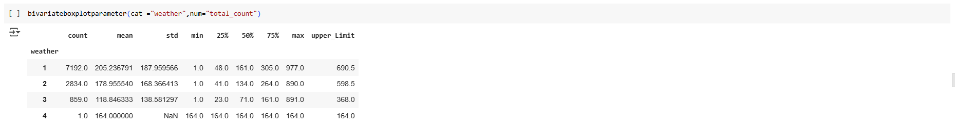

* No of user total_count reduced as the weather became severe
* Weather:1 has total_count upper limit as 690
* weather:3 has total_count upper limit as 368
* There was only one booking for weather:4 with 164 users[registered : 158 & casual:6

Now let us do Hypothesis Testing to check if Weather has impact on total_Count

###### Hypothesis Testing:

As we have 4 groups in weather Category --> we will use **ANNOVA** & check how does weather effect on user count

* Ho --> All weather's have same user count mean
* Ha --> Some weather's user count Mean are different

Before using ANNOVA, we will check if all 4 weather category data is following Normal Distribution & does they have equal variance

For Normal Distribution, we will use **Shapiro test** with below Hypothesis Condition

* H0 : Data is Gaussian
* Ha : Data is not Gaussian

For Equal Variances Check, we will use **Levene Test** with below Hypothesis condition

* H0: Variances are equal
* Ha: Variances are not equal



let's check for Normal Distribution of all four weather data sets, But weather4 has only 1 reading, so we cannot do Shapiro test

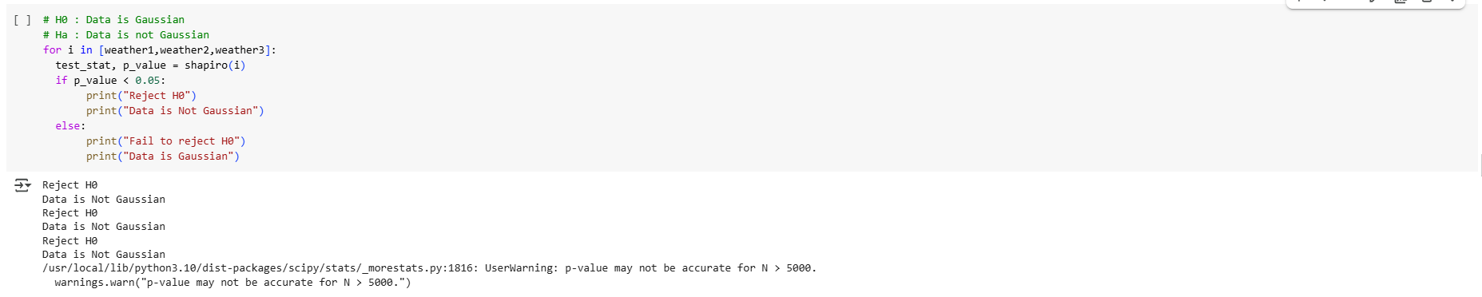

* From Shapiro --> we can conclude that 4 weather data sets are not following Normal Distribution
* Now we will do Levene test to check for equal Variances.

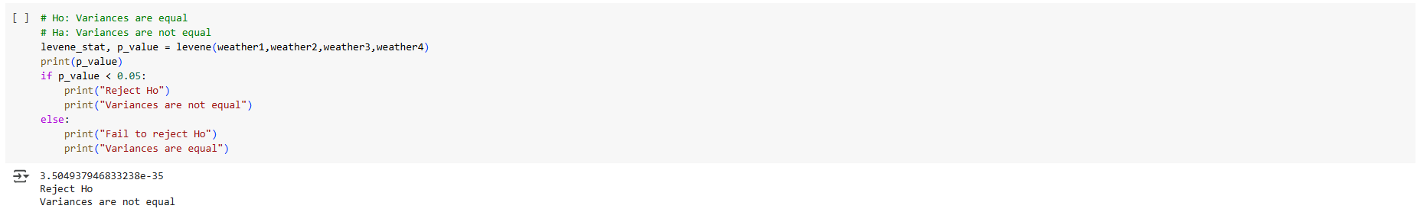

* All four weather Datasets do not have equal Variance
* So 2 of ANNOVA assumption fails, we will do **kruskal Wallis** test

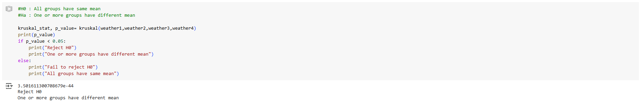

From Kruskal Walli Test, With >95% confidence we can say that **weather has impact on total_user Count**

##### Dependency of Weather and Season

As Weather & Season are both Categorical Data, we will do **Chi- Squared Test** with below Hypothesis Condition

* Ho: Weather & Season are independent
* Ha: Weather & Seasons are not Independent

###### Bivariate Analysis:

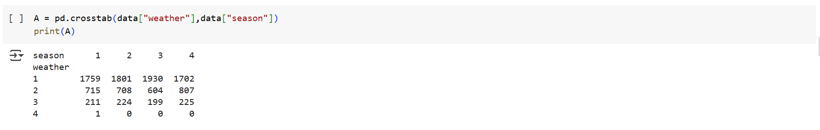

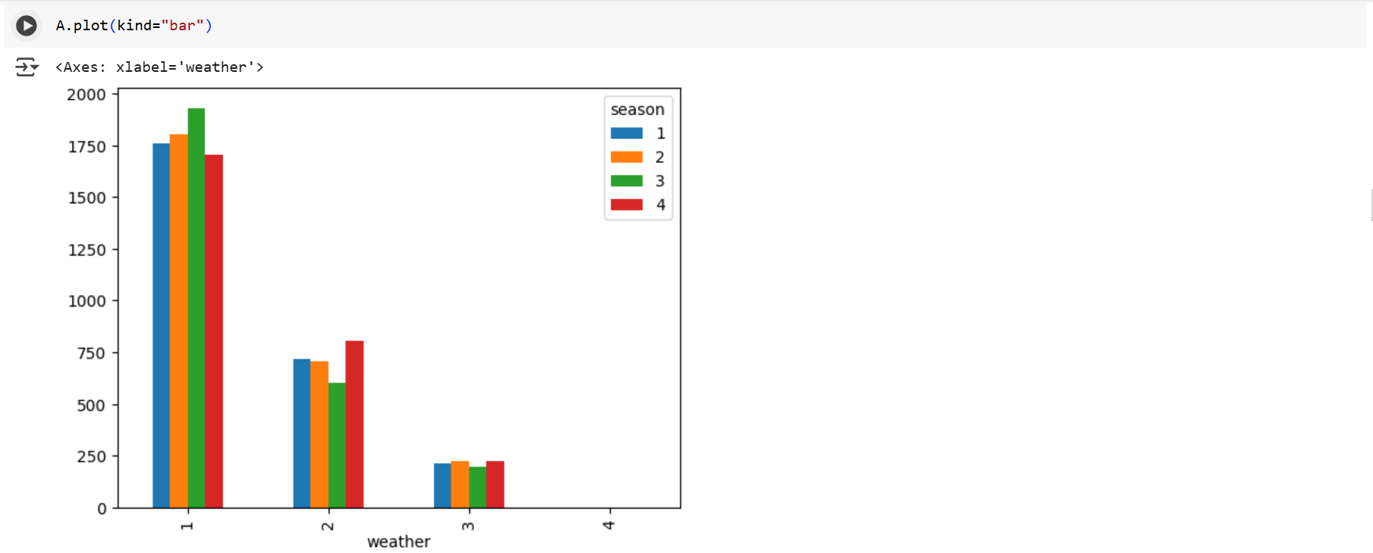

Now let us check , how Mean of total_count varies in combination of Season & weather

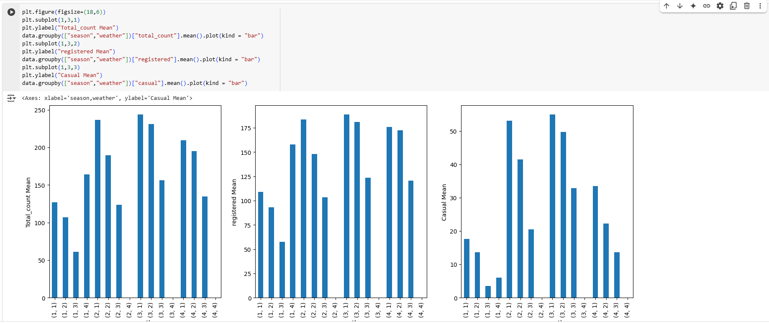

From Bar plot we can see User Count Highly active in Weather1[Clear, Few clouds] & Season3[Fall]

Now Let us Check Dependency of Weather and Season with Hypothesis Testing

As Weather & Season are both Categorical Data, we will do Chi2_Contigency test to test their Dependence.

Null Hypothesis can be set as below.

* Ho: Weather & Season are independent
* Ha: Weather & Seasons are not Independent

But for Chi Sqaured test, Expected values in each cell has to be > 5,So we remove Weather4 data and do Chi2_Contingency test again

A[:3] will remove 4rth row from table

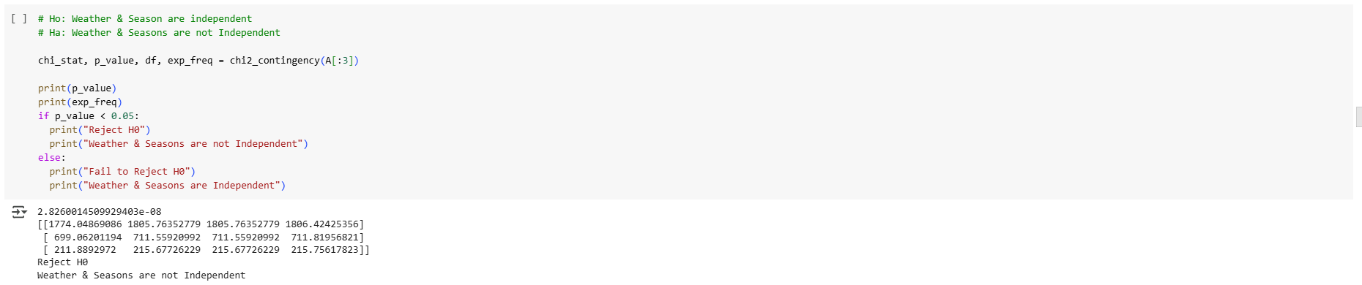

However, result is same with >95% Confidence we can conclude that **Weather & Seasons are Dependent**

##### Impact of Holiday on User Count:

###### Univariate Analysis:

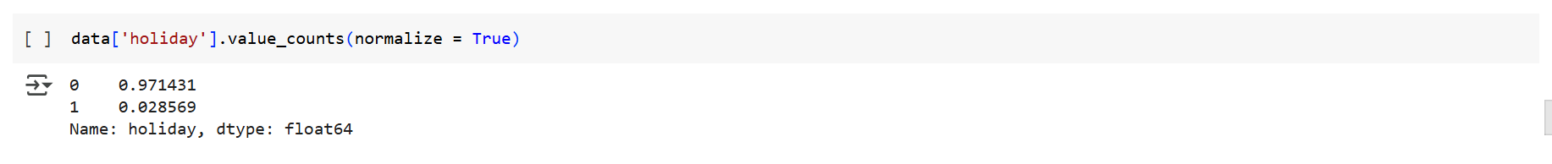

###### Bivariate Analysis:

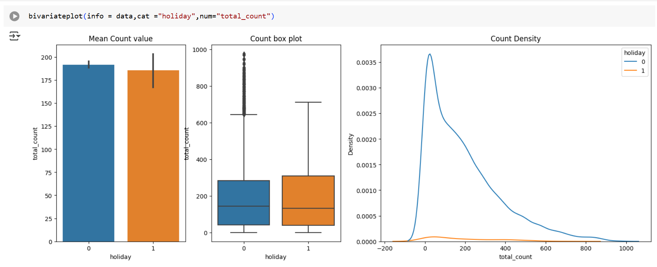

* No of user total_count reduced on a holiday compared to Non-Holiday
* Now lets do Hypothesis Testing to check if Holiday has impact on User Count

###### Hypothesis Testing:

As we have only 2 groups in Holiday day Category --> we will use **2 Sample/Independent T-test** & check how does Holiday day effect on user count, **First We will do two tailed test** & **later on if we reject Ho in two tailed test then we will do single tailed test**

* Ho --> User Count Mean is same on Holiday & Non Holiday
* Ha --> User Count Mean is not same on Holiday & Non Holiday



Before using 2 Sample/Independent T test, we will check if 2 Samples have equal variance

For Equal Variances Check, we will use Levene Test with below Hypothesis condition

* H0: Variances are equal
* Ha: Variances are not equal

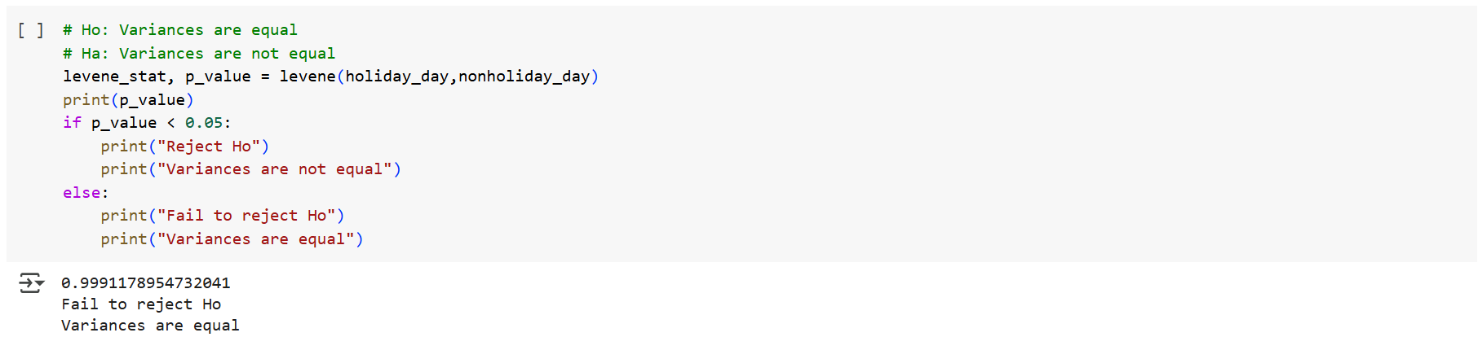

* Levene hypothesis test proved that both samples have same Variance.
* So we can proceed with 2 Sample/Independent T-Test

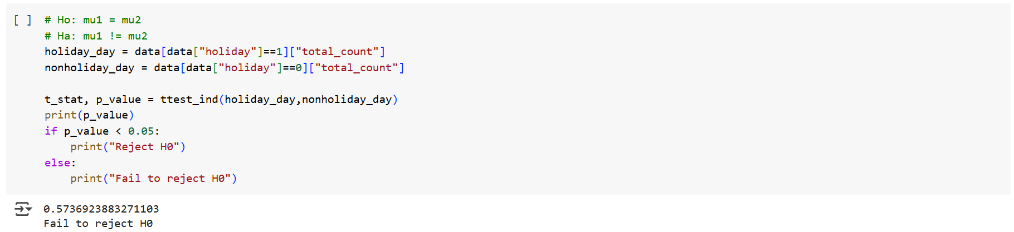

with 95% confidence we can that **Holiday day/Non Holiday day has no impact on Total_user count mean**

##### Impact of Workingday on User Count:

###### Univariate Analysis:

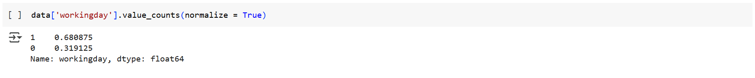

###### Bivariate Analysis:

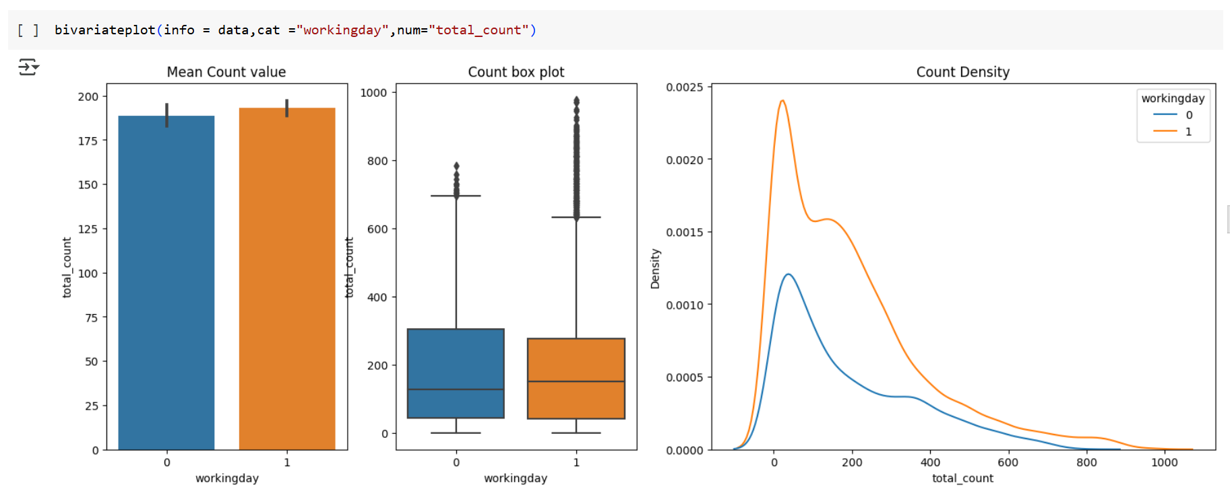

* Working day/Non working day Total_count Mean has very less difference
* Now lets do Hypothesis Testing to check if Workingday has impact on User Count

###### Hypothesis Testing:

As we have only 2 groups in Working day Category --> we will use 2 Sample/Independent T-test & check how does working day effect on user count, First We will do two tailed test & later on if we reject Ho in two tailed test then we will do single tailed test

* Ho --> User Count Mean is same on workinday & Non workinday
* Ha --> User Count Mean is not same on workinday & Non workinday



Before using 2 Sample/Independent T test, we will check if 2 Samples have equal variance

For Equal Variances Check, we will use Levene Test with below Hypothesis condition

* H0: Variances are equal
* Ha: Variances are not equal

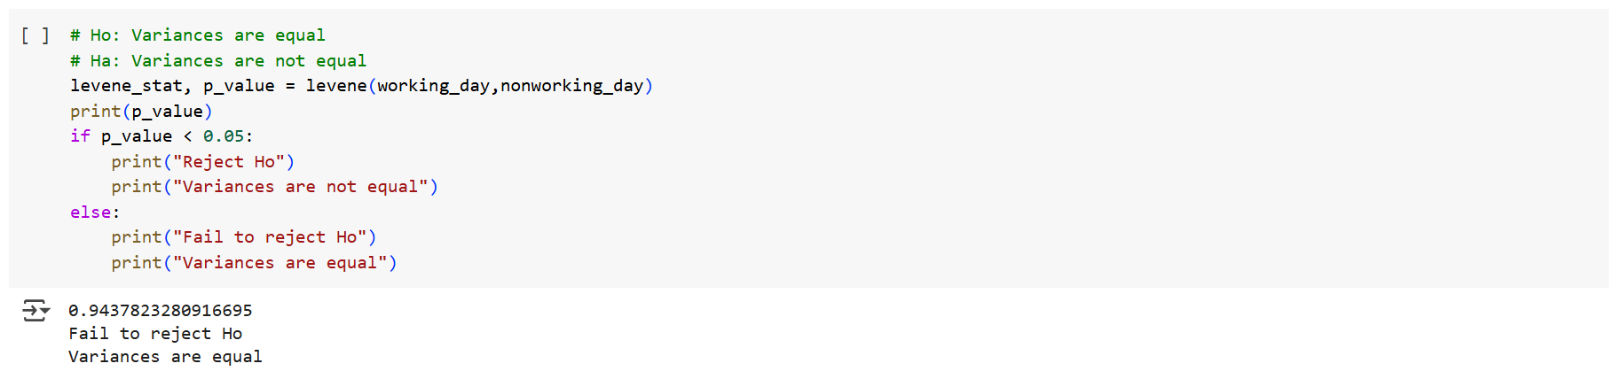

* Levene hypothesis test proved that both samples have same Variance
* So we can proceed with 2 Sample/Independent T-Test

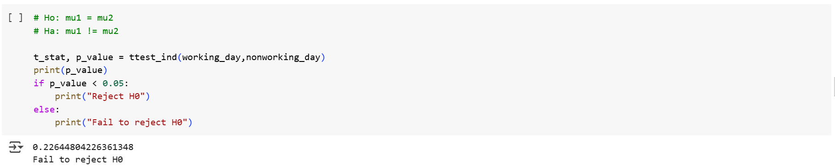

* with 95% confidence we can that **working day/Non Working day has no impact on Total_user count mean**

##### Impact of Temp on User Count:

###### Univariate Analysis:

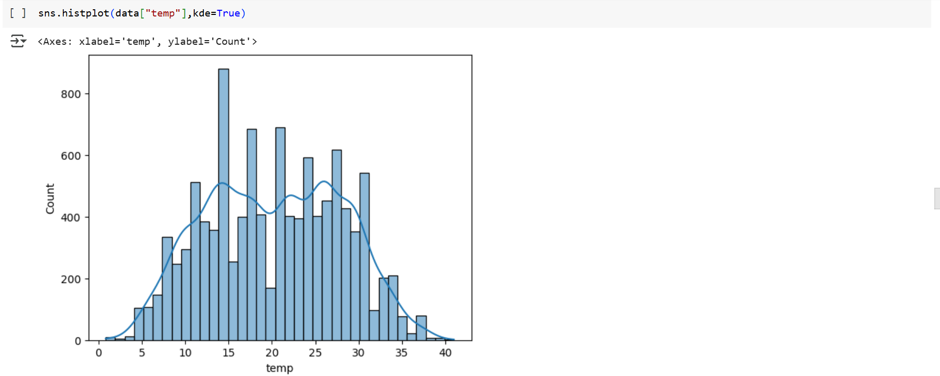

###### Bivariate Analysis:

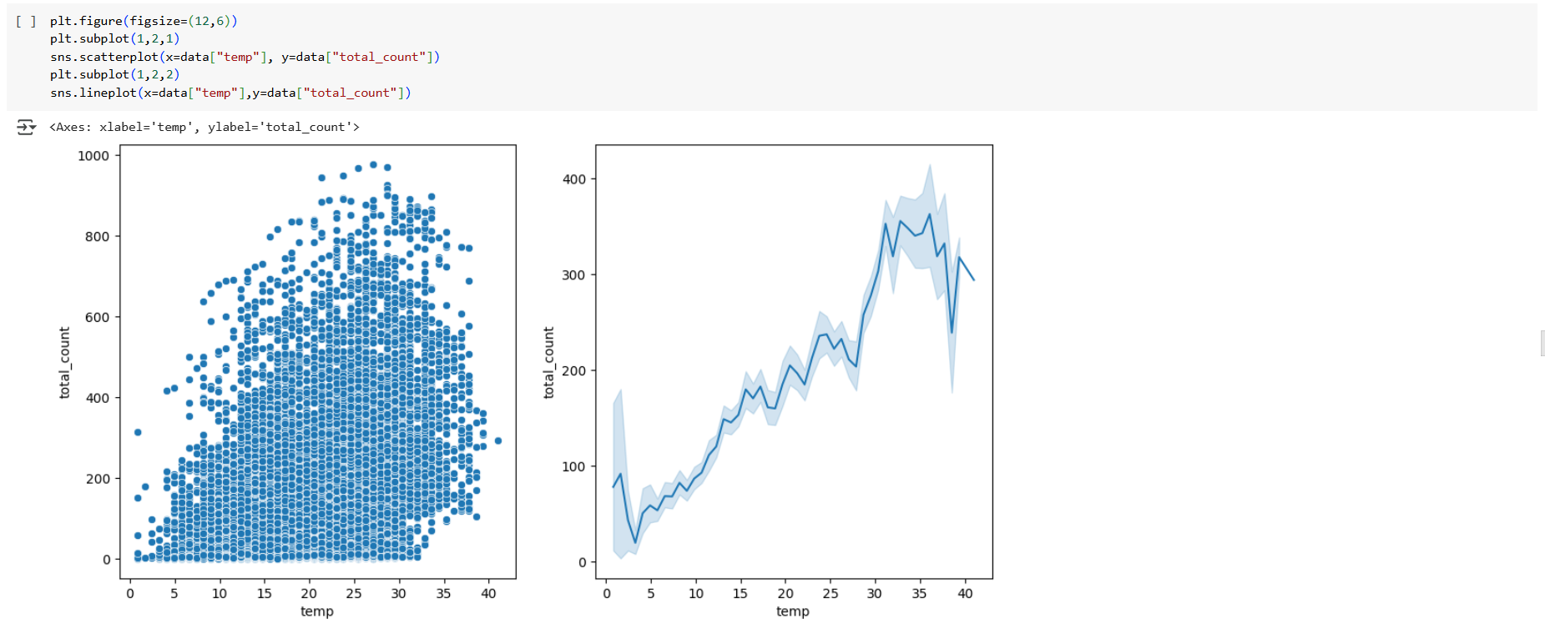

* from lineplot, users Avg count increased as the temperature increased till 36 deg Celsius & then count dropped
* from scatter plot We can see there is no linear relationship between temperature and Total_count, so we will do spearman Correlation test

###### Hypothesis Testing:

As Temp and Users Count are both numerical, we will do Spearman Test as relation is somewhat nonlinear as seen in scatterplot

* Ho: No correlation between Temp & Total_count
* Ha: There is correlation between Temp & Total_count

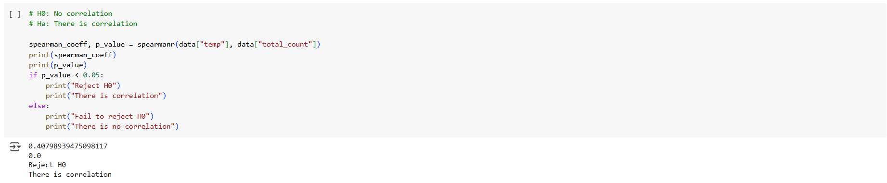

with >95% Confidence we can that **Temp has good positve correlation with Total_users count**

##### **Impact of Humidity on User Count:**

###### Univariate Analysis:

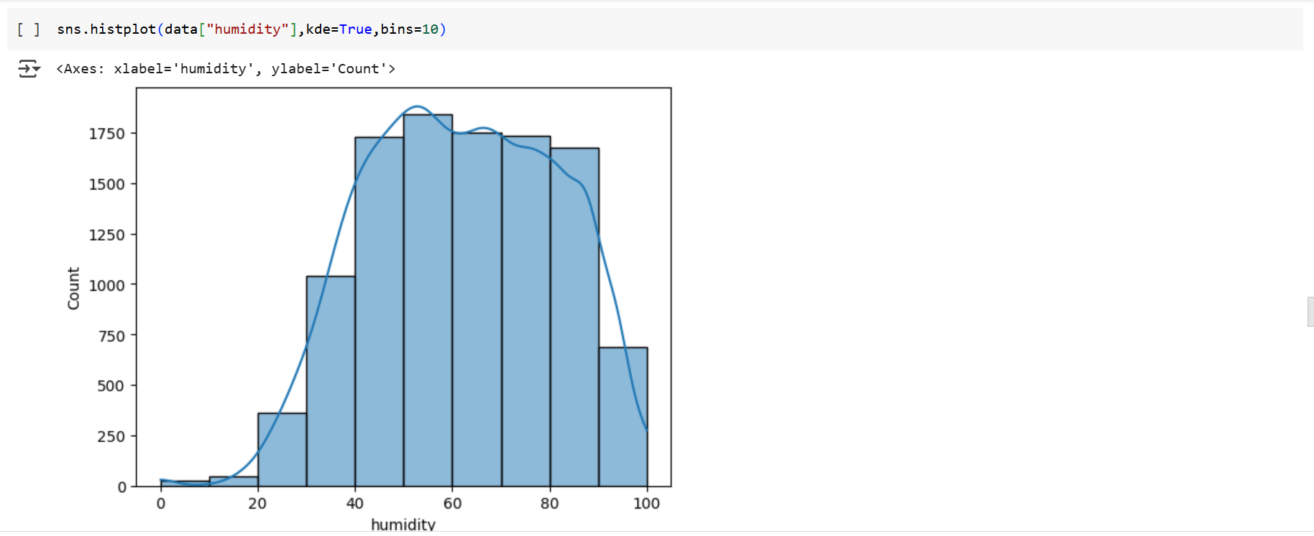

* humidity covers vast range from 0 to 100
* we can see distribution is left skewed, Humidity was mostly found in the range 40 ~ 100

###### Bivariate Analysis:

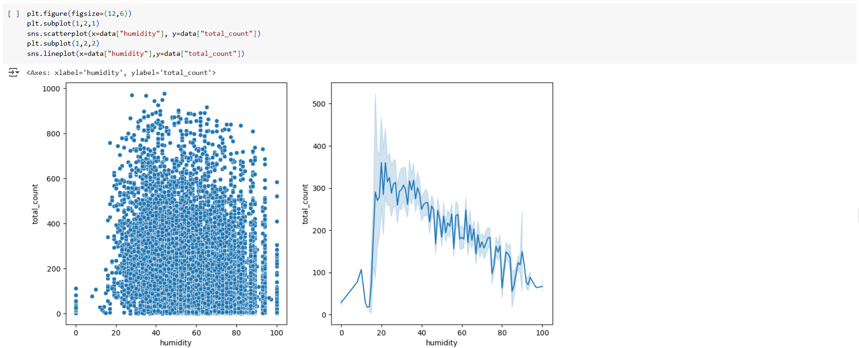

* from lineplot,Avg Users count reduced with increase in humididty
* Avg Users count peaked in the humidity range of 20-22 & then grdually dropped
* from scatter plot We can see there is no linear relationship between humidity and Total_count, but somewhat nonlinear relationship exists from humidity 20 to 100 -->Humidity increase, avg count decreases, so we will do spearman Correlation test

###### Hypothesis Testing:

As humidity and Users Count are both numerical, we will do Spearman Test as relation is somewhat nonlinear as seen in scatterplot

* Ho: No correlation between humidity & Total_count
* Ha: There is correlation between humidity & Total_count

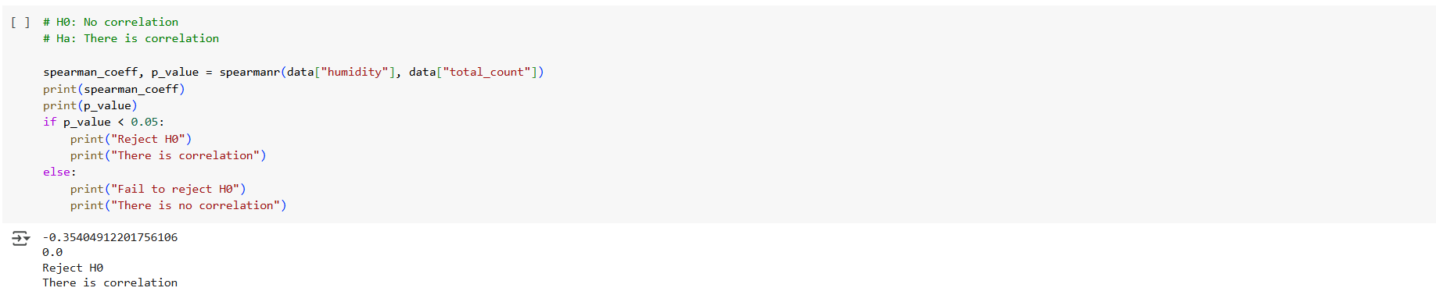

with >95% Confidence we can that **Humidity has good negative correlation with Total_users count**

##### Impact of Windspeed on User Count

###### Univariate Analysis:

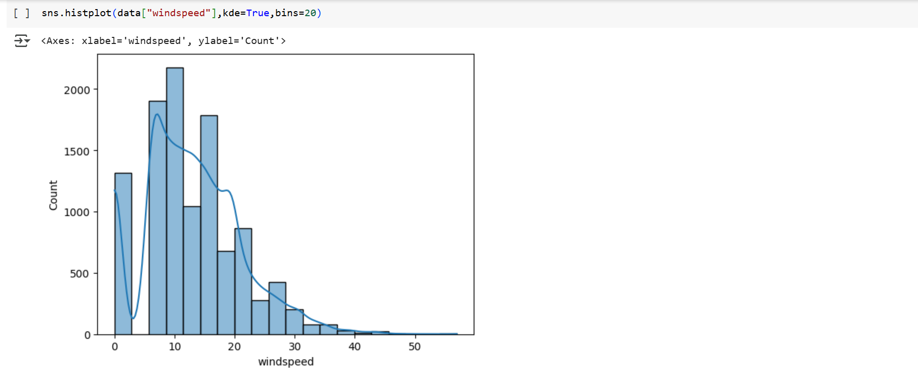

* windspeed covers vast range from 0 to 56
* Mostly wind are in the range 8 ~ 24

###### Bivariate Analysis:

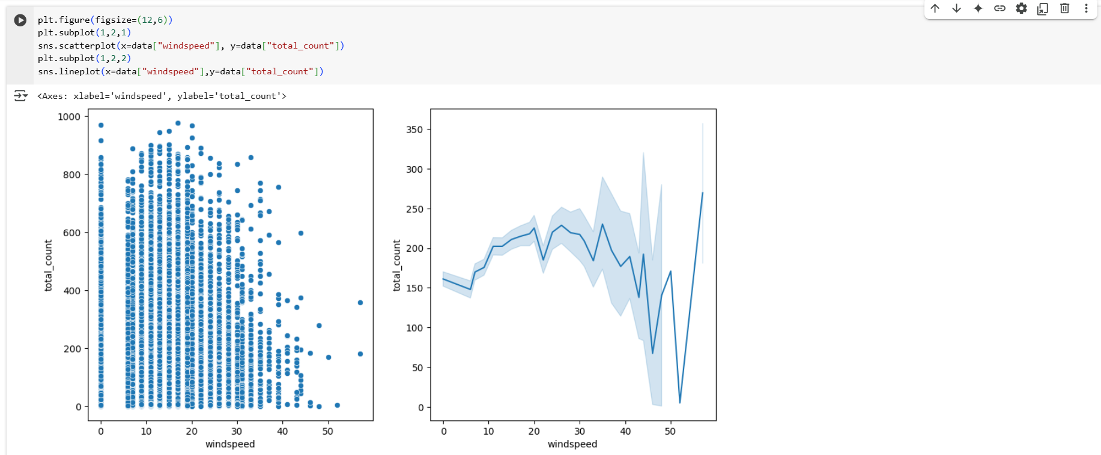

* from lineplot,Avg Users count reduced with increase in humididty
* Avg Users count peaked in the Windspeed range of 20-35
* from scatter plot We can see there is no linear relationship between windspeed and Total_count, but somewhat nonlinear relationship exists --> windspeed increase, avg count increases &decreases, so we will do spearman Correlation test

###### Hypothesis Testing:

As windspeed and Users Count are both numerical, we will do Spearman Test as relation is somewhat nonlinear as seen in scatterplot

* Ho: No correlation between windspeed & Total_count
* Ha: There is correlation between windspeed & Total_count

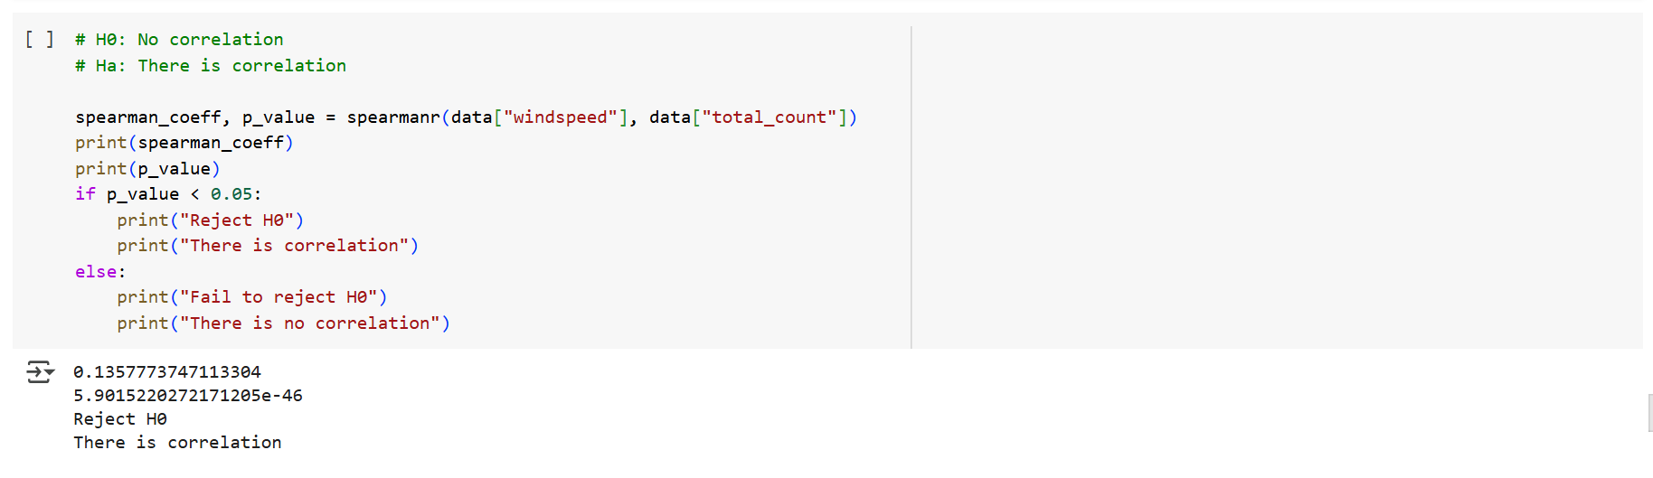

with >95% Confidence we can that **Windspeed has very less positive correlation with Total_users count**

##### Correlation matrix:

* In this Section we will try solution through different approach i.e., feature Engineering.
* I will use "Label Encoder" & "Target encoder with Total_count as Target" to convert all the Categorical data to Numerical.
* Then i will use Correlation values to find the most Signification Feature to predict User_count on a given day.

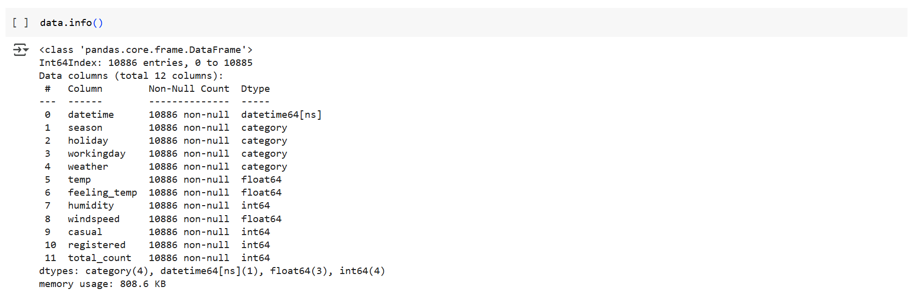

Lets Create Target Encoder and Label Encoder to Convert Categorical to Numerical



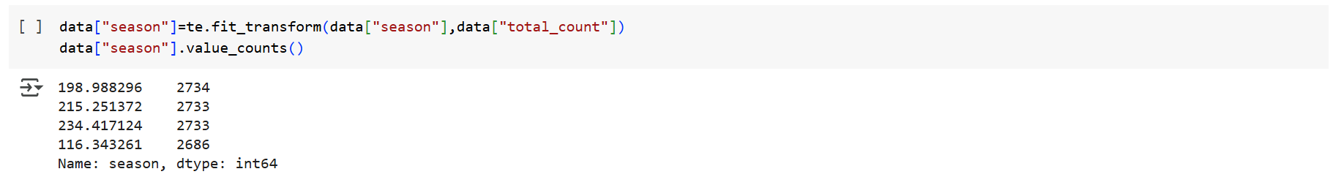

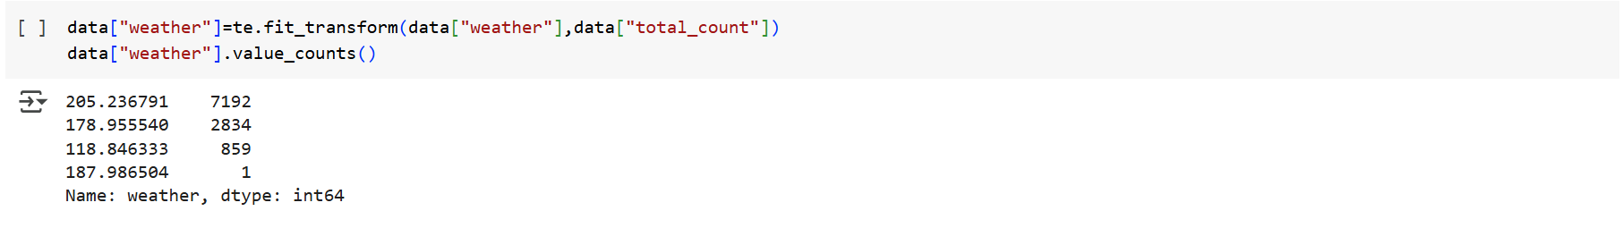



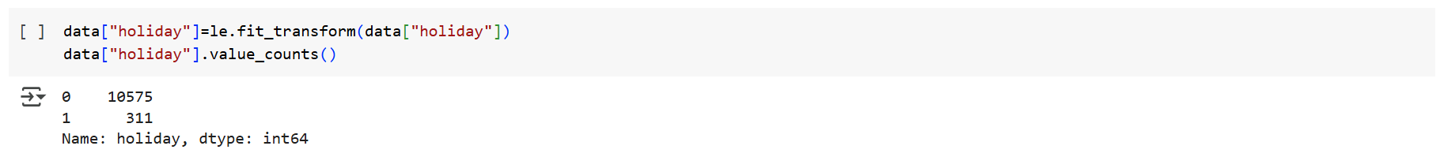

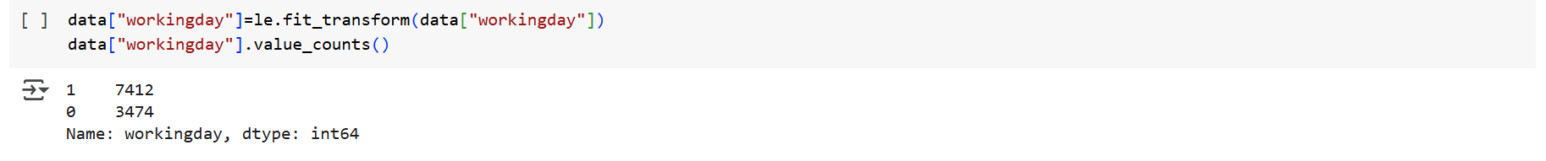

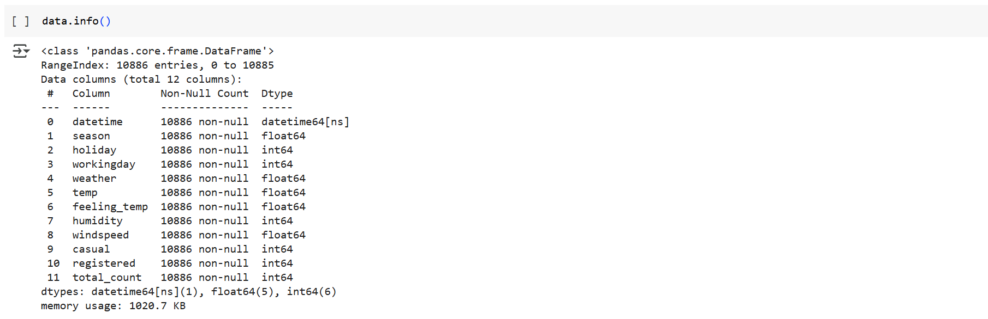

* All features have been converted to Numerical except for datetime.
* let’s drop that datetime feature.



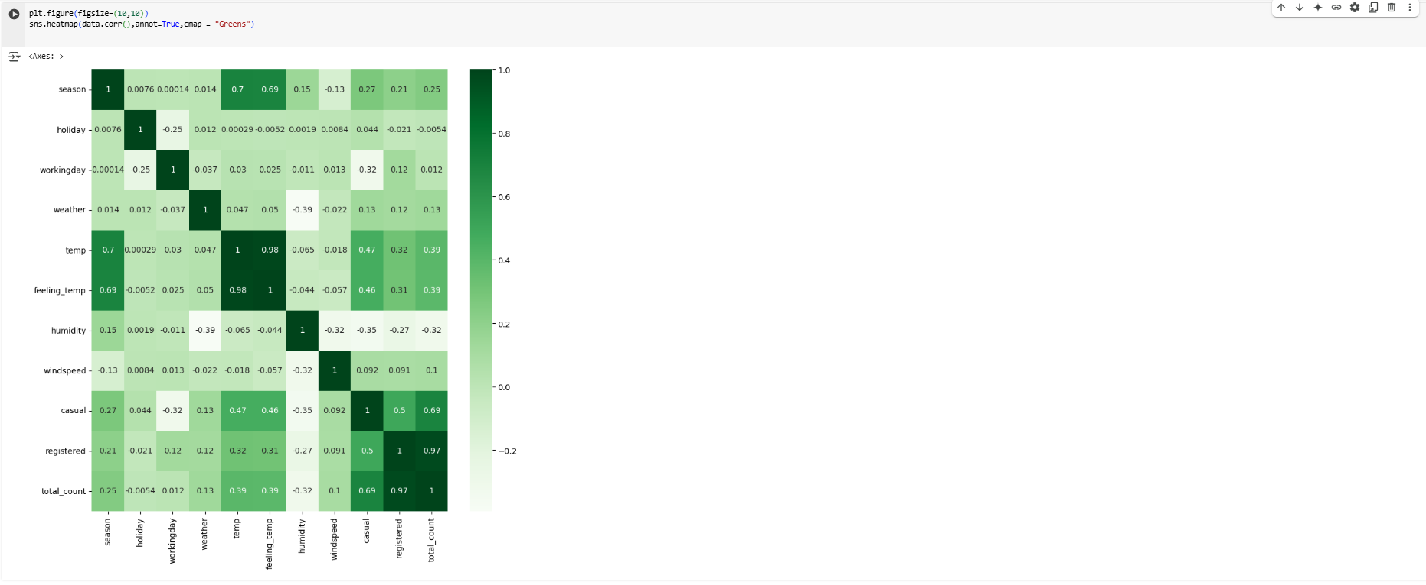

Simialr to what we have conclude in Hypothesis Testing for Total_count, Correlation matrix values are also Giving same output

* Holiday & working daya has no impact on Total_count
* Season & Weather have impact on Total_count
* temp & feeling_temp are positively correlated on Total_count
* Humidity is negatively correlated on Total_count
* Windspeed has very less Positive Correlation on Total_count

As we Target encoded feature w.r.t Total_count, the above correlation matrix is giving correct correlation values for total_count only

#### Business Insights

##### Overall Summary:

* total_count of user per day range between 0 to 647, however there are some unsual booking some days ranging from 648 to 977 per day
* registered user per day range between 0 to 501, however there are some unsual booking some days ranging from 502 to 886 per day
* casual user per day range between 0 to 116, however there are some unsual booking some days ranging from 117 to 367 per day

##### Seasons:

* No of user total_count in "1:Spring" season are very low with upper limit of 374 & Average Total_count of 116
* whereas user total_count is highest in "3:fall" are high with upper limit count as 765 & Average Total_count of 234
* With >95% Confidence we can say that Total_count, Registered & Casual User count are impacted by Seasons

##### Weather:

* No of user total_count reduced as the weather became severe
* No of user total_count in Weather:1 is high with upper limit of 690 & Average of 205
* No of user total_count in Weather:3 is low with upper limit of 368 & Average of 118
* There was only one booking for weather:4 with 164 users[registered : 158 & casual:6]
* With >95% Confidence we can say that Total_count, Registered & Casual User count are impacted by Weather

##### Holiday:

* Mean of Total_Count reduced on a holiday compared to Non-Holiday, However in Contradiction Hypothesis testing proved with 95% confidence that Holiday day/Non Holiday day has no impact on Total_user count mean
* Mean of Registered user reduced on a holiday compared to Non-Holiday & to Affirm Hypothesis testing proved with 95% confidence that Holiday day/Non Holiday day has impact on Registered count
* No of user Casual increase on a holiday compared to Non-Holiday & to affirm Hypothesis testing proved with 95% confidence that Casual user count is higher on Holiday compared to Non Holiday

##### Workingday:

* Total_count Mean of Working day & Non Workingday has not much diffeence and to affirm that Hypothesis testing proved with 95% confidence that Workingday/Non Workingday has no impact on Total_user count mean
* Registered user counts is higher on a working day compared to Non working day and to affirm Hypothesis testing proved with >95% confidence that registered user count is higher on Working day compared to Nonworking day
* Casual user count is higher on a non working day compared to working day and to affirm Hypothesis testing proved with >95% confidence that Casual user count is higher on Nonworking day compared to Working day

##### Humidity:

* Avg Users count peaked in the humidity range of 20-22 & then grdually dropped
* To affirm Hypothesis testing proved with >95% Confidence that Humidity has good negative correlation with Total_users, Registered & Casual User Count

##### Windspeed:

* Mostly wind are in the range 8 ~ 24 & Avg Users count peaked in the Windspeed range of 20-35
* To affirm Hypothesis testing proved with >95% Confidence that Windspeed has very less positive correlation with Total_users, Registered & Casual User Count

#### Recommendations

* Maximum usage is found in the Fall Season, its Better to avoid Possible Maintenance activity during that season & Keep More Electric bikes ready to use
* Similarly as Usage is less in Spring season, All Possible Maintenance to be done in fall season
* In weather3,4, user count is very less due to harsh weather conditions, Company can modify the design to instantly install sepal shield(motorcycle shield that protects riders from harsh weather conditions) to make it viable to use in harsh weather conditions also, so its can retain customer base even in harsh weather conditions
* Casual User increase on Holiday & Non working day, Company can better prepare its logistics to cater those unplanned Casual users & convert them to regular customers with some additional feel good service
* Temperature play quite some role for user to use, when temperature is in the range 0 ~ 20, Company can provide additional comfort mechanism[low cost handle heaters] to increase user count

### Chapter 3 : Business Case Study 3

#### Problem Description:

##### About Company

A leading Indian education institute specializing in test preparation for study abroad exams like GMAT, GRE, SAT, TOEFL, and IELTS, providing comprehensive classroom training and admission counseling to help students enter top universities worldwide, it is known for its thorough research and focus on filling the information gap regarding education abroad, with multiple centers across India and Nepal.

##### Problem:

Company recently launched a feature where students/learners can come to their website and check their probability of getting into the IVY league college. This feature estimates the chances of graduate admission from an Indian perspective.

* They want to understand what factors are important in graduate admissions and how these factors are interrelated among themselves.
* It will also help predict one's chances of admission given the rest of the variables.

##### Dataset:

* Serial No. (Unique row ID)
* GRE Scores (out of 340)
* TOEFL Scores (out of 120)
* University Rating (out of 5)
* Statement of Purpose and Letter of Recommendation Strength (out of 5)
* Undergraduate GPA (out of 10)
* Research Experience (either 0 or 1)
* Chance of Admit (ranging from 0 to 1) 🡪 **Output of Regression**

##### Libraries Used:

import numpy as np

import pandas as pd

import matplotlib.pyplot as plt

import seaborn as sns

from scipy.stats import mannwhitneyu

from scipy.stats import kruskal

from scipy.stats import spearmanr

import statsmodels.api as sm

from sklearn.preprocessing import MinMaxScaler,StandardScaler

from sklearn.model_selection import train_test_split

from statsmodels.stats.outliers_influence import variance_inflation_factor

from sklearn.linear_model import LinearRegression,Lasso,Ridge

from sklearn.preprocessing import PolynomialFeatures

from scipy import stats

from scipy.stats import  kstest

from scipy.stats import shapiro,levene

from statsmodels.graphics.gofplots import qqplot

##### Outcome of Analysis:

* Use Non-graphical and graphical analysis for getting inferences about variables.
* Check correlation among independent variables and how they interact with each other.
* Use Linear Regression from (Statsmodel library) and explain the results.
* Test the assumptions of linear regression:
* Multicollinearity check by VIF score
* Mean of residuals
* Linearity of variables (no pattern in residual plot)
* Test for Homoscedasticity
* Normality of residuals
* Do model evaluation- MAE, RMSE, R2 score, Adjusted R2.
* Try out different Linear Regression like Lasso, Ridge & Polynomial Features
* Provide actionable Insights & Recommendations

#### Analysis:

As we have seen Data Cleaning & Hypothesis Testing in Depth in previous Business Cases, we will Do Univariate & Bivariate Analysis on Cleaned Data and Then Do Linear Regression Modelling

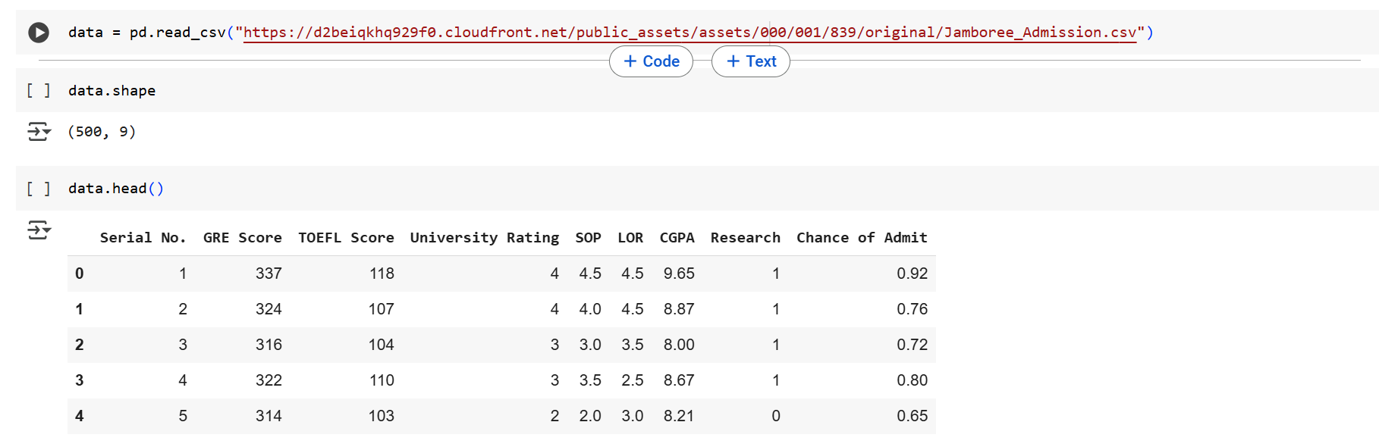

##### Statistical Analysis, Graphical Visualization:

Checking the Unique Values for each Variable

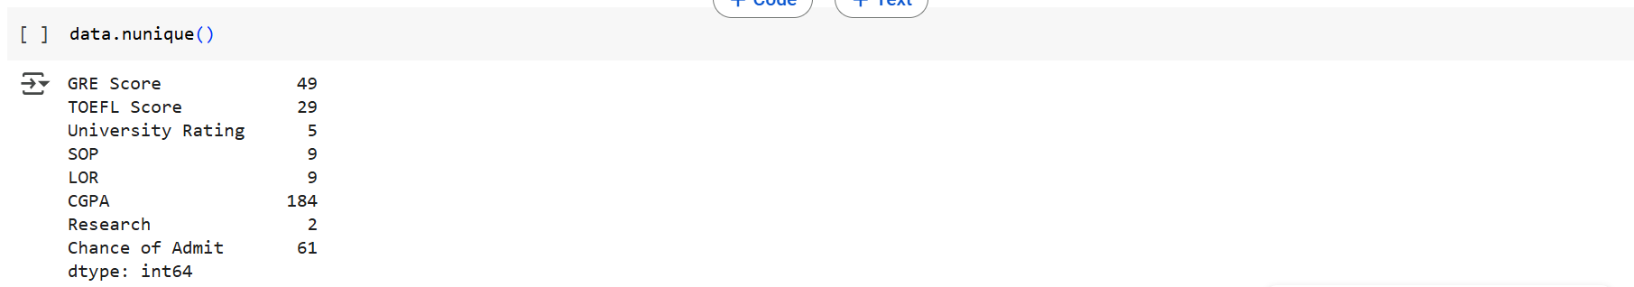

Statistical Analysis:

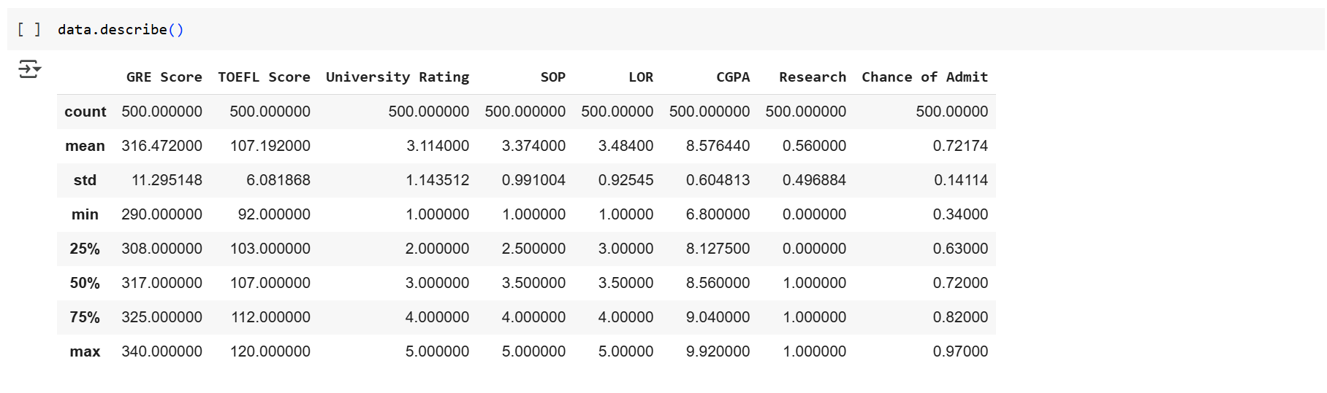

###### Research:

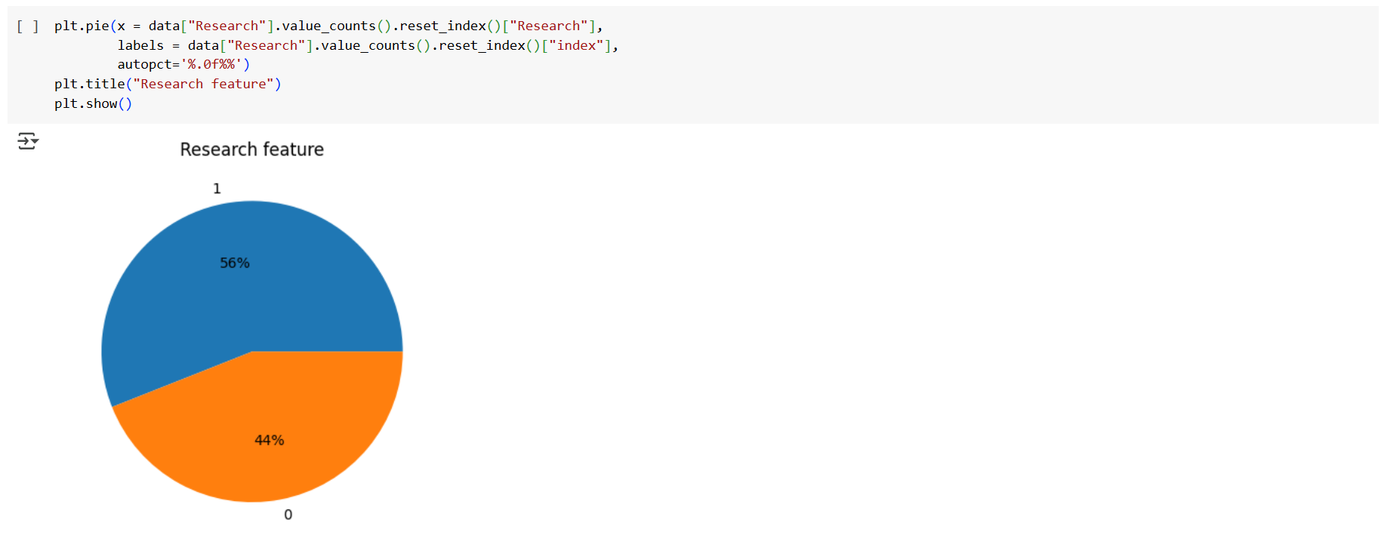

* 56% Students have Research Experience
* 44% Students do have Research Experience
* Let us Check what effect does Research have on “Chance of Admit”

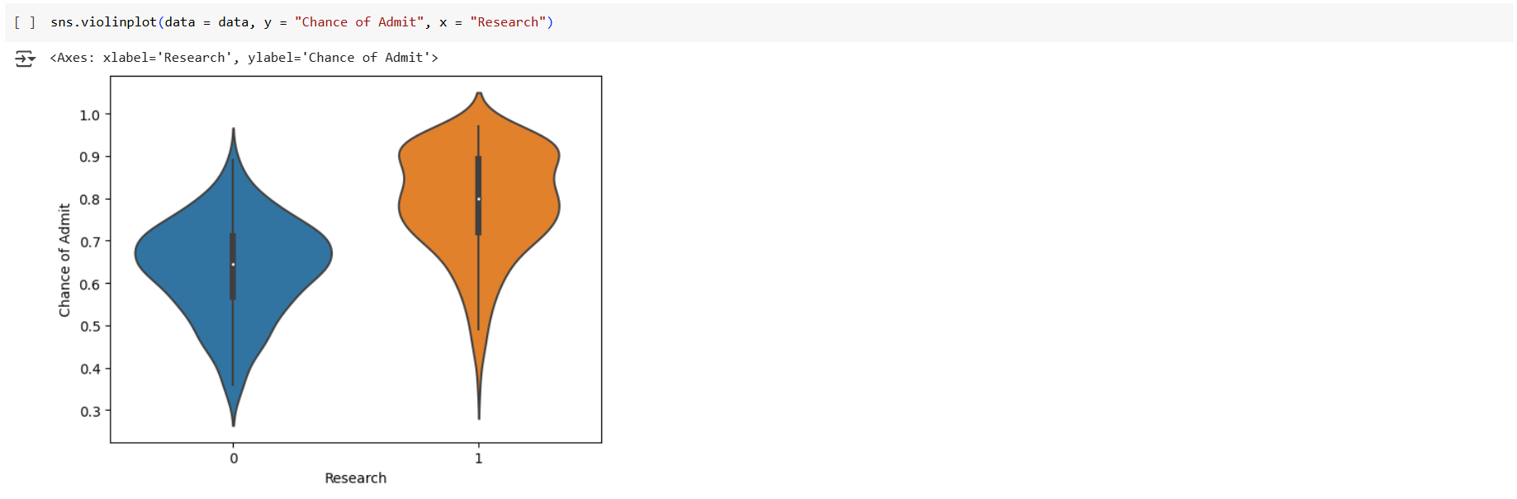

* Chance of Admit is higher for student who has Research Experience

###### GRE Score

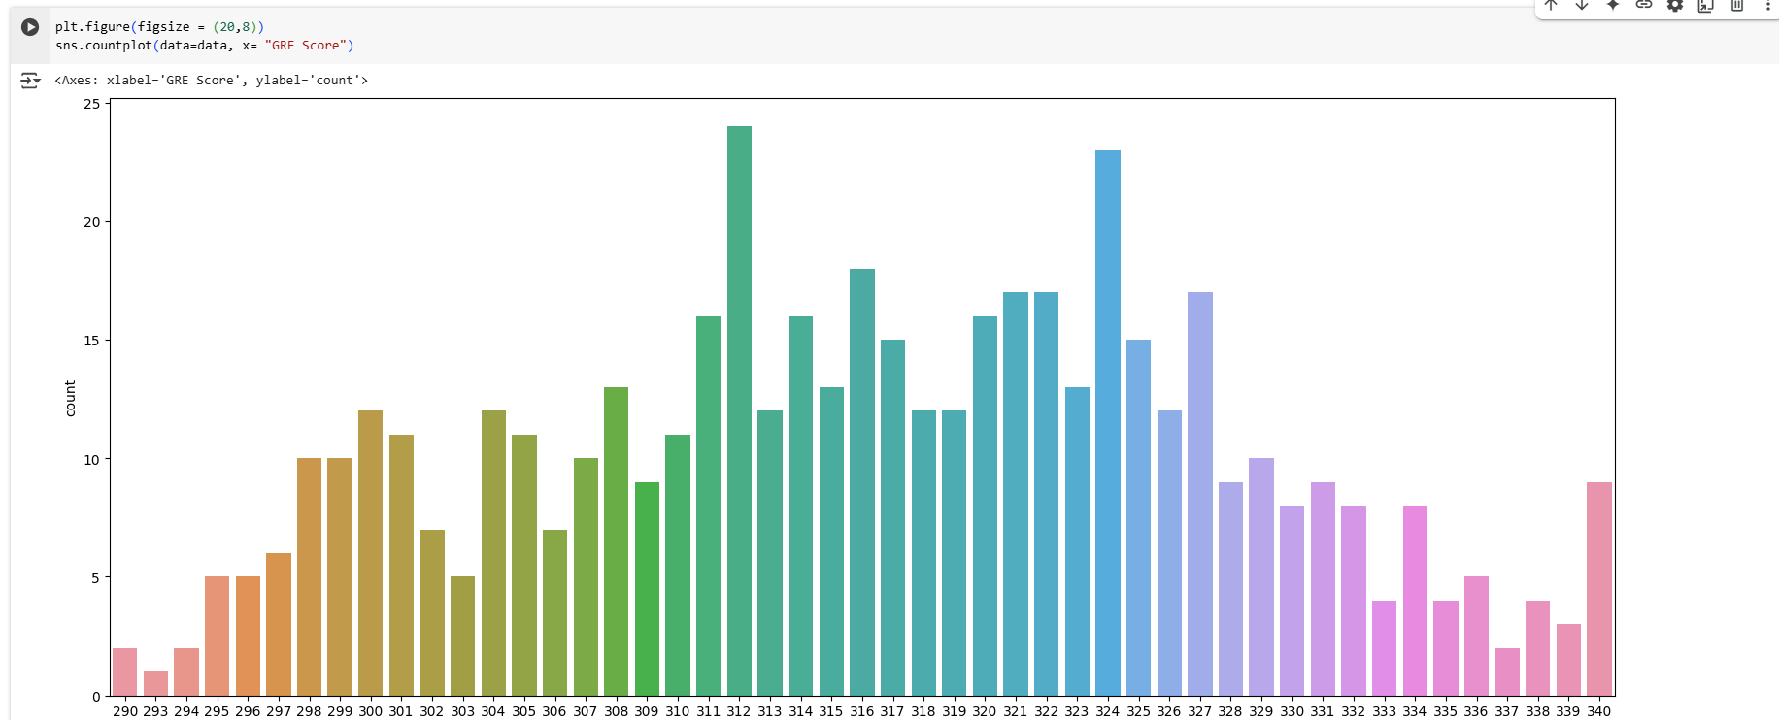

* GRE Scores are greater than 290, More No of Data points are in that range 310 ~ 327
* Let us Check what effect does GRE Score have on “Chance of Admit”

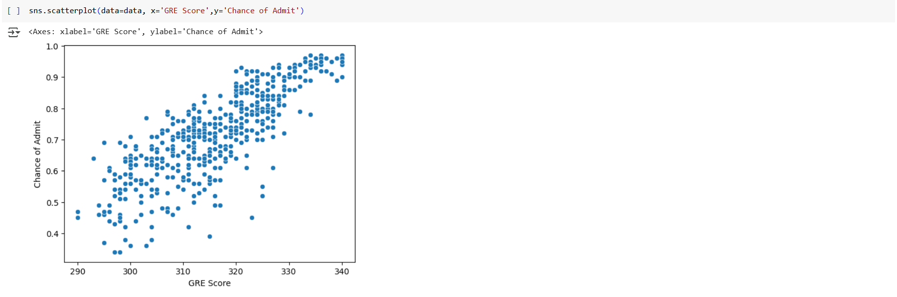

* Chance of Admit increased with increase in GRE Score

###### TOEFL Score

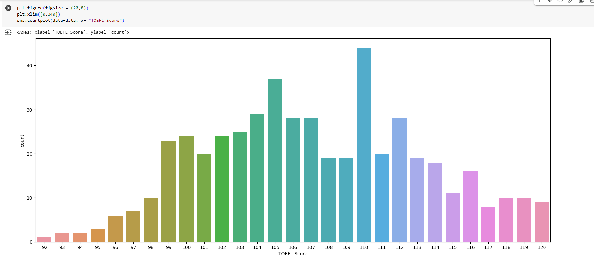

* TOEFL Scores are greater than 91, More No of Data points are in that range 99~112
* Let us Check what effect does TOEFL have on “Chance of Admit”

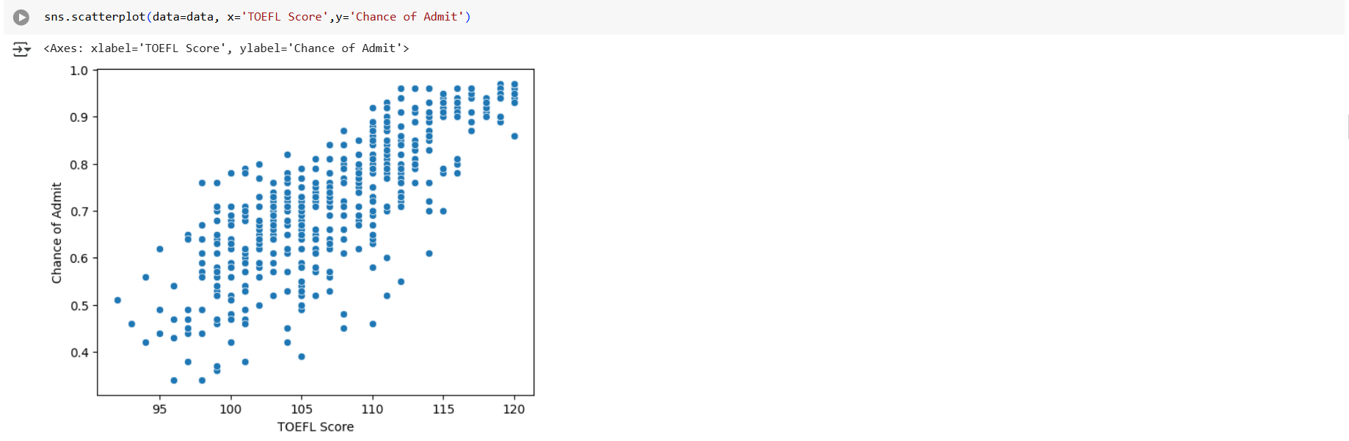

* Chance of Admit increased with increase in TOEFL Score

###### University Rating:

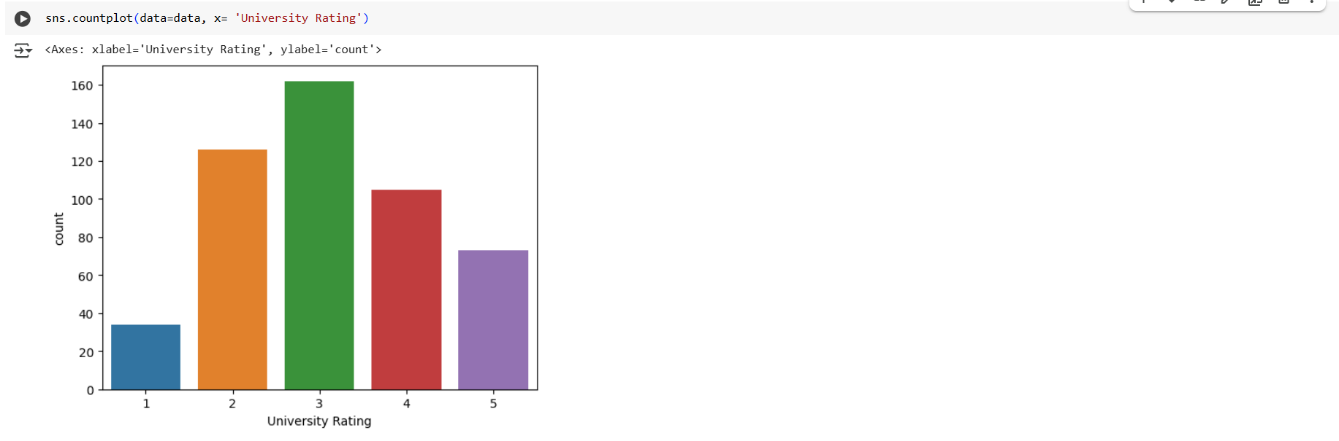

* More no of Student applied for University Ranking = 3
* Let us Check what effect does University ranking have on “Chance of Admit”

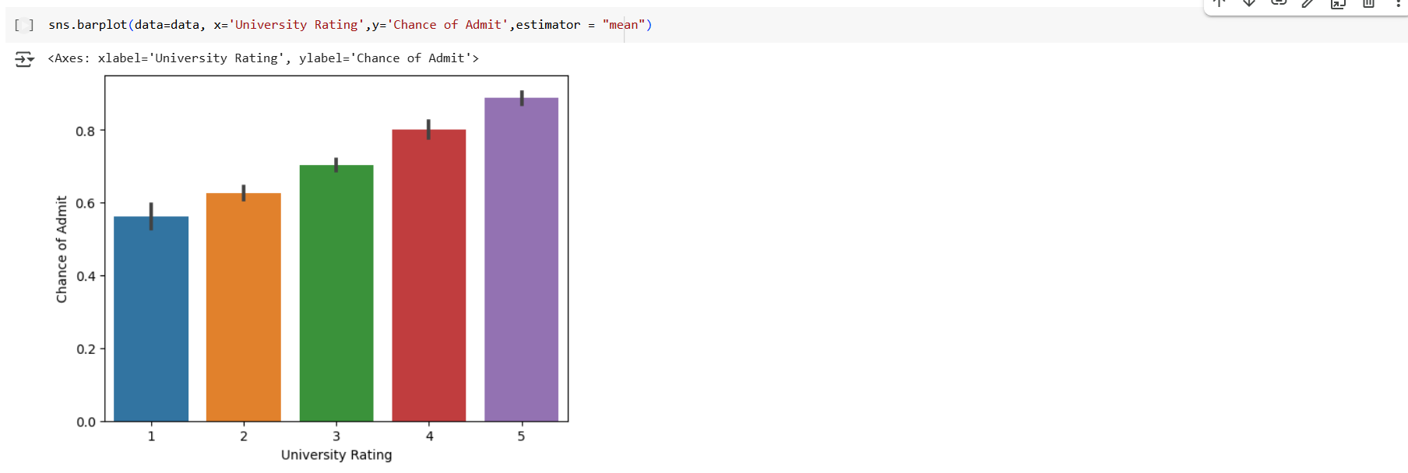

* Chance of Admit on an average increased with increase in University Rating

###### LOR

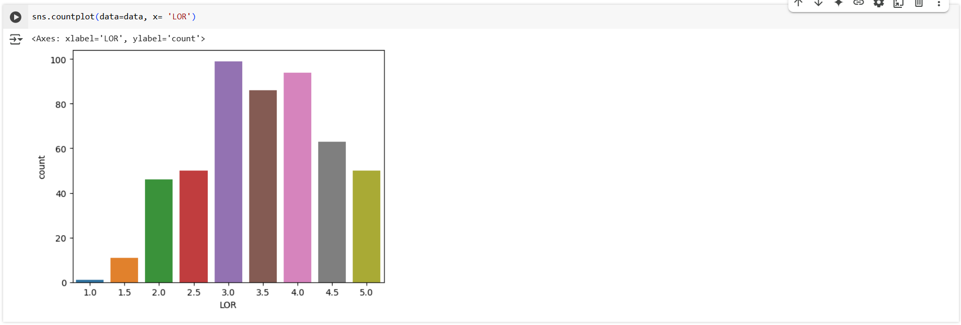

* LOR ranged from 1 ~ 5
* Maximum rating lies between 3 ~ 4.5
* Let us Check what effect does LOR have on “Chance of Admit”

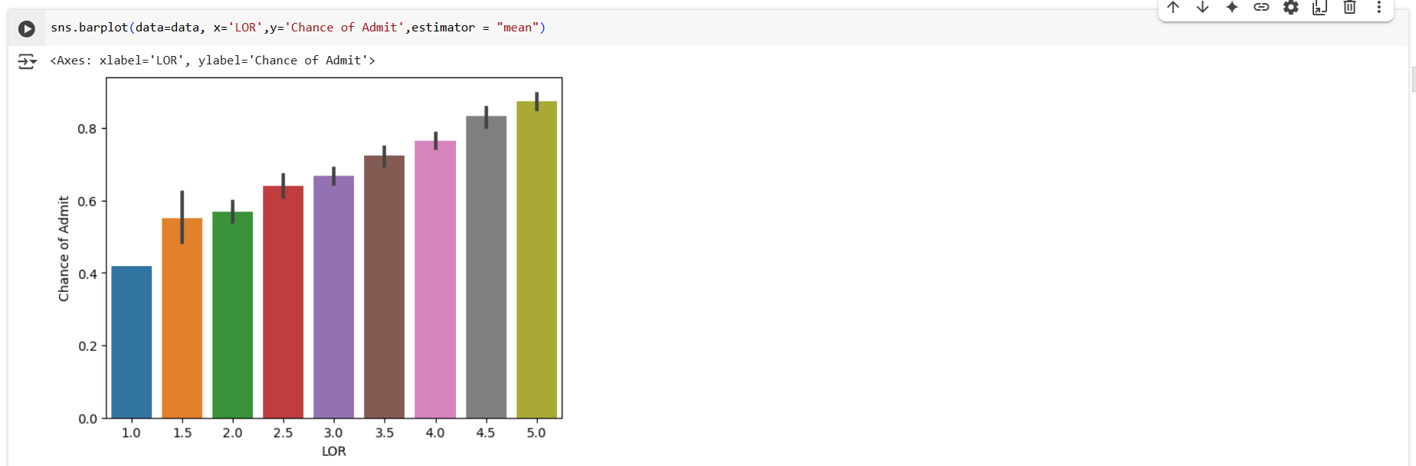

* Chance of Admit on an average increased with increase in LOR Rating

###### SOP

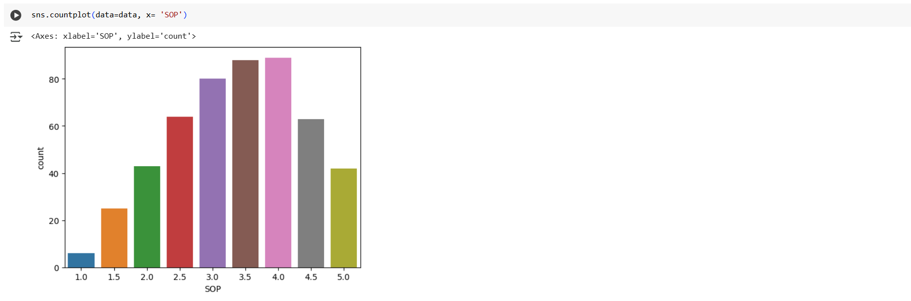

* SOP ranged from 1 ~ 5
* Maximum rating lies between 2.5 ~ 4.5
* Let us Check what effect does SOP have on “Chance of Admit”

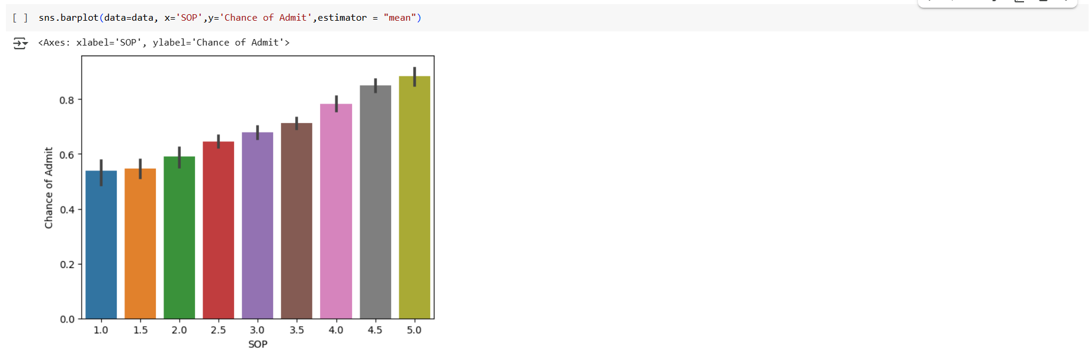

* Chance of Admit on an average increased with increase in SOP Rating

###### CGPA

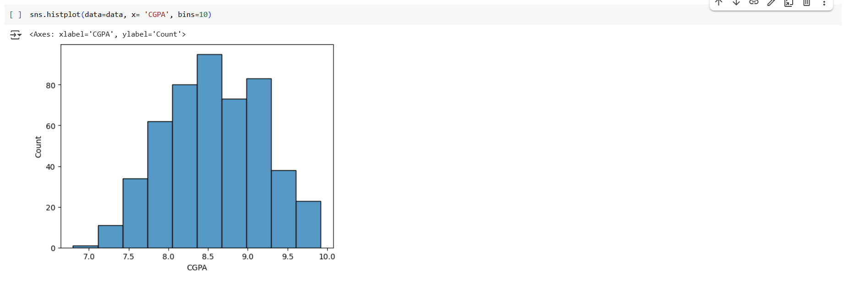

* CGPA of the Student are >= 7.0
* Maximum range lies between 7.5 ~ 9.5
* most of the Student applied are meritorious
* Let us Check what effect does CGPA have on “Chance of Admit”

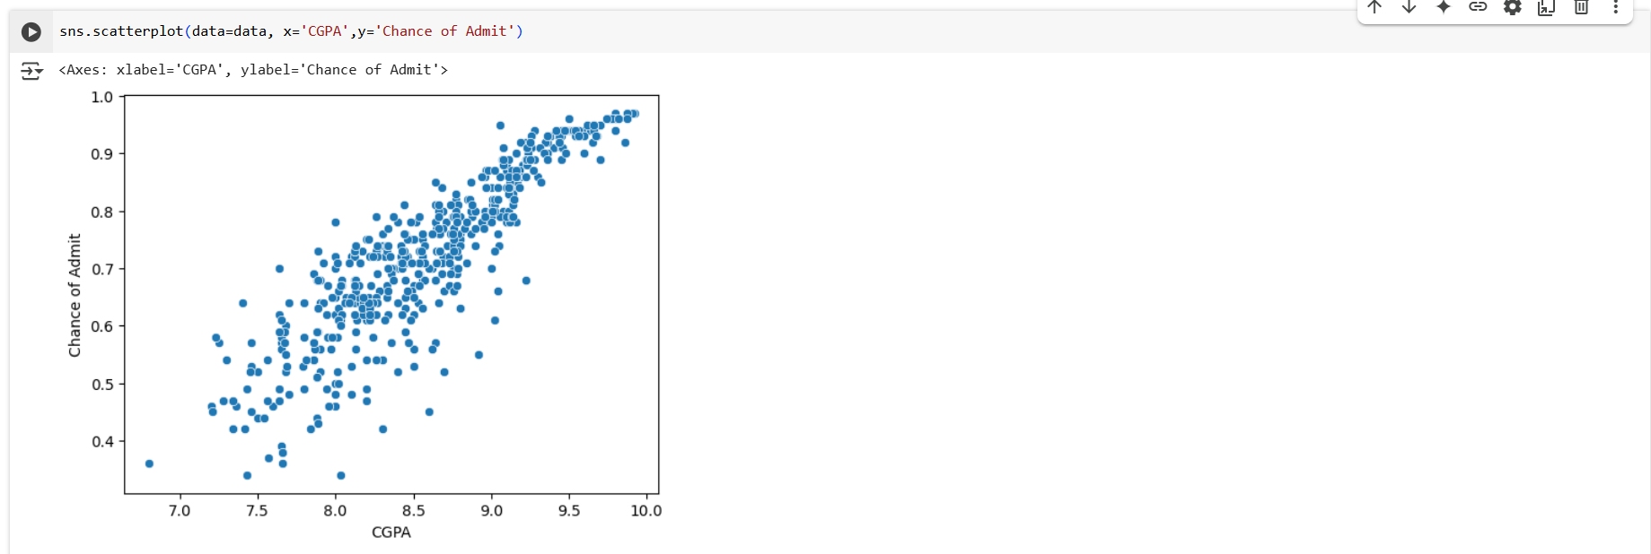

* Chance of Admit increased with increase in CGPA

###### Overall Correlation:

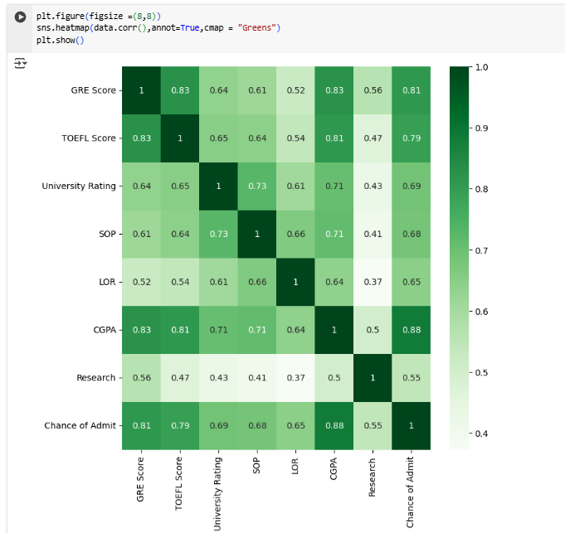

* All features have Positive correlation with "Chance of Admit."
* CGPA[0.88],GRE Score[0.81],TOEFL Score[0.79] has very high correlation with "Chance of Admit"
* Further SOP[0.68], LOR[0.65] has almost same Correlation with ""Chance of Admit"
* Comparatively Low Correlation is found w.r.t Research & "Chance of Admit"[0.55], However is positively impactful.

##### Hypothesis Testing:

In this Data Different test [Num-Num,Cat-Num] can be done

But our objective to correctly predict "Chance of Admit", so we will do Hypothesis testing for below combinations for check if infact feature has effect on "Chance of Admit"

* GRE Score and Chance of Admit
* TOEFL Score and Change of Admit
* CGPA & Chance of Admit
* LOP & Chance of Admit
* SOP & Chance of Admit
* University Rating & Chance of Admit
* Research & Chance of Admit

###### Test Setup:

In this section let us fix the Confidence level & Level of Signification for our Hypothesis testing.

As this is with respect to predicting Chance_of_Admit

* let us Assume we want 95% Confidence to reject Null Hypothesis, so for every Hypothesis testing, Level of Significance will be "0.05 "
* As our purpose of Hypothesis testing to just verify the relation of Feature not to give final judgement...We will use Non Parametric test to avoid assumptions checking
* However final judgment of impact of each feature will be given after training Linear Regression model
* for Num-Num, we will use “**spearmanr test”**
  + Ha: There is correlation
  + H0: No correlation

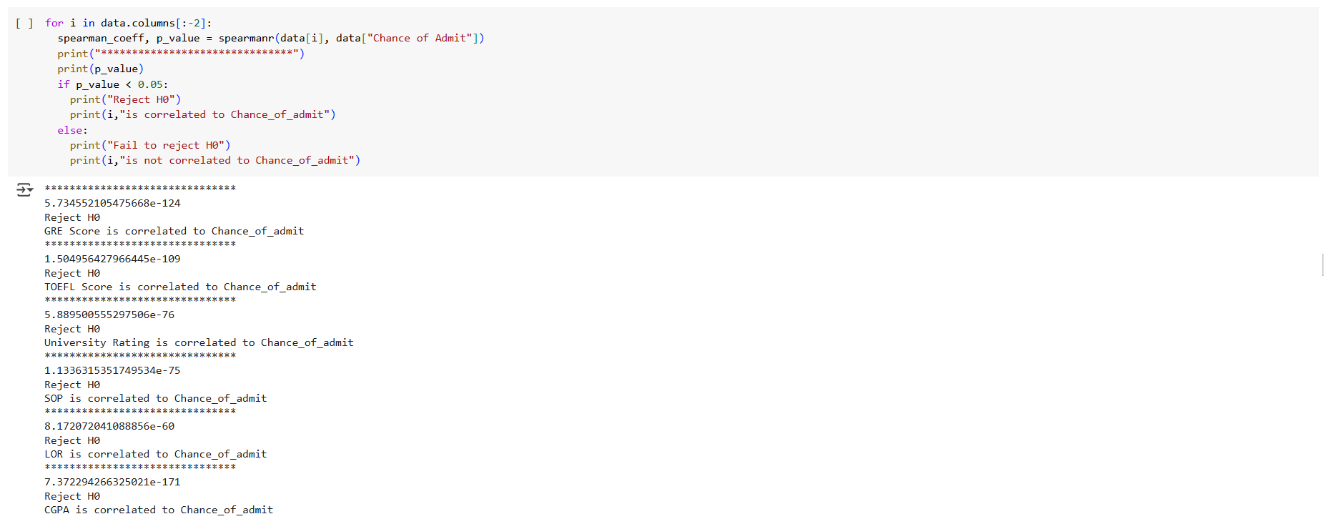

From Hypothesis testing, we can say all feature are correlated to "Chance of Admit", we will proceed for data preparation for Model Building

##### Data Preparation for Modelling:

###### Scaling:

As we have seen Earlier, each of our features are in different scales we will have to **scale them** to

1. Improve Model Performance
2. Faster Convergence
3. Reduced Sensitivity
4. Enhanced Interpretability
5. Consistence Across Model

However Scaling can be done in 2 ways : Standardization and Normalization

But Standardization can be done only if Data is in Normal Distribution

So to check Normal Distribution we will do **KS Test**

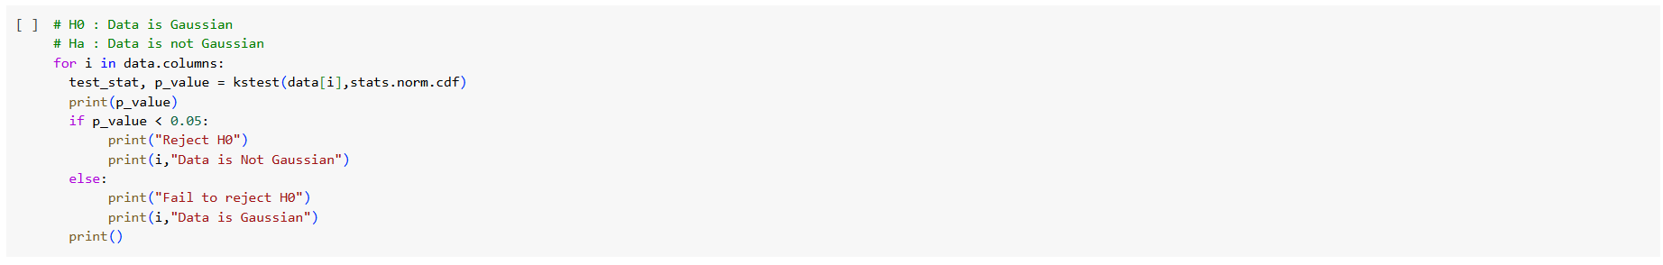

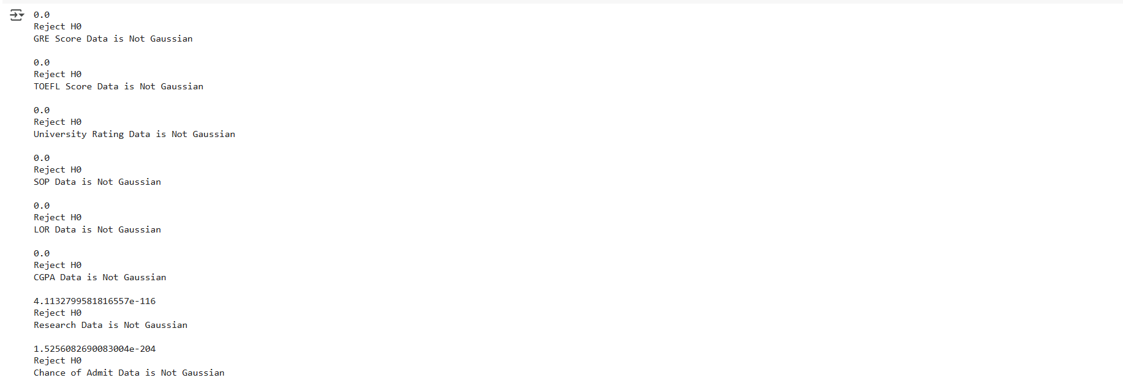

* we have observed that All the Numericals are not following Normal Distribution, so we cannot do Standardization
* Now we will do Normalization using Minmax Scaler

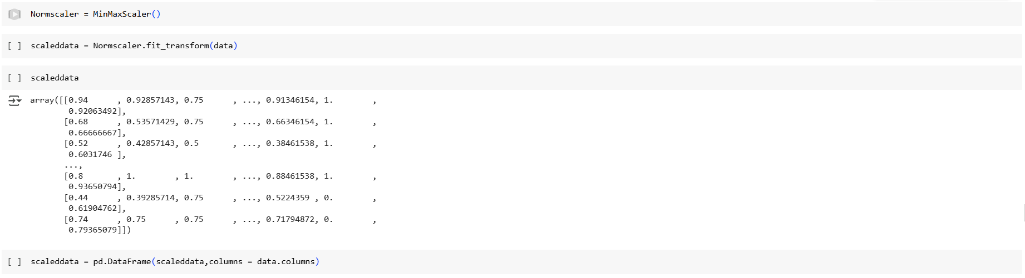

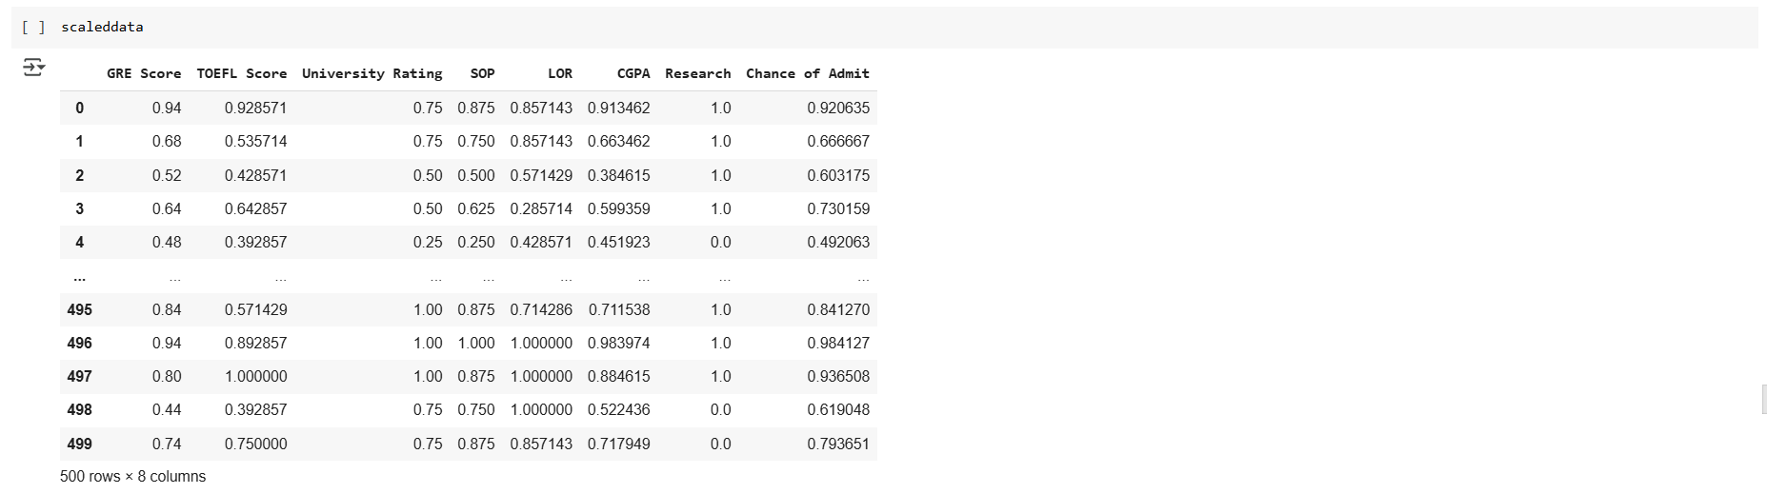

###### Test & Training Splitting

Splitting data into training and test sets is crucial to evaluate model performance on unseen data, prevent overfitting, and ensure the model generalizes well to new data. This helps in building robust and reliable machine learning models.

* Our desired Outcome is "Chance of Admit", So we will divide our scaleddata into X,y
* We will use 80:20 ratio for train & test. Further we will Divide X & y as below data sets
* Xtrain
* Xtest
* ytrain
* ytest



##### Model Building - Linear Regression[OLS]



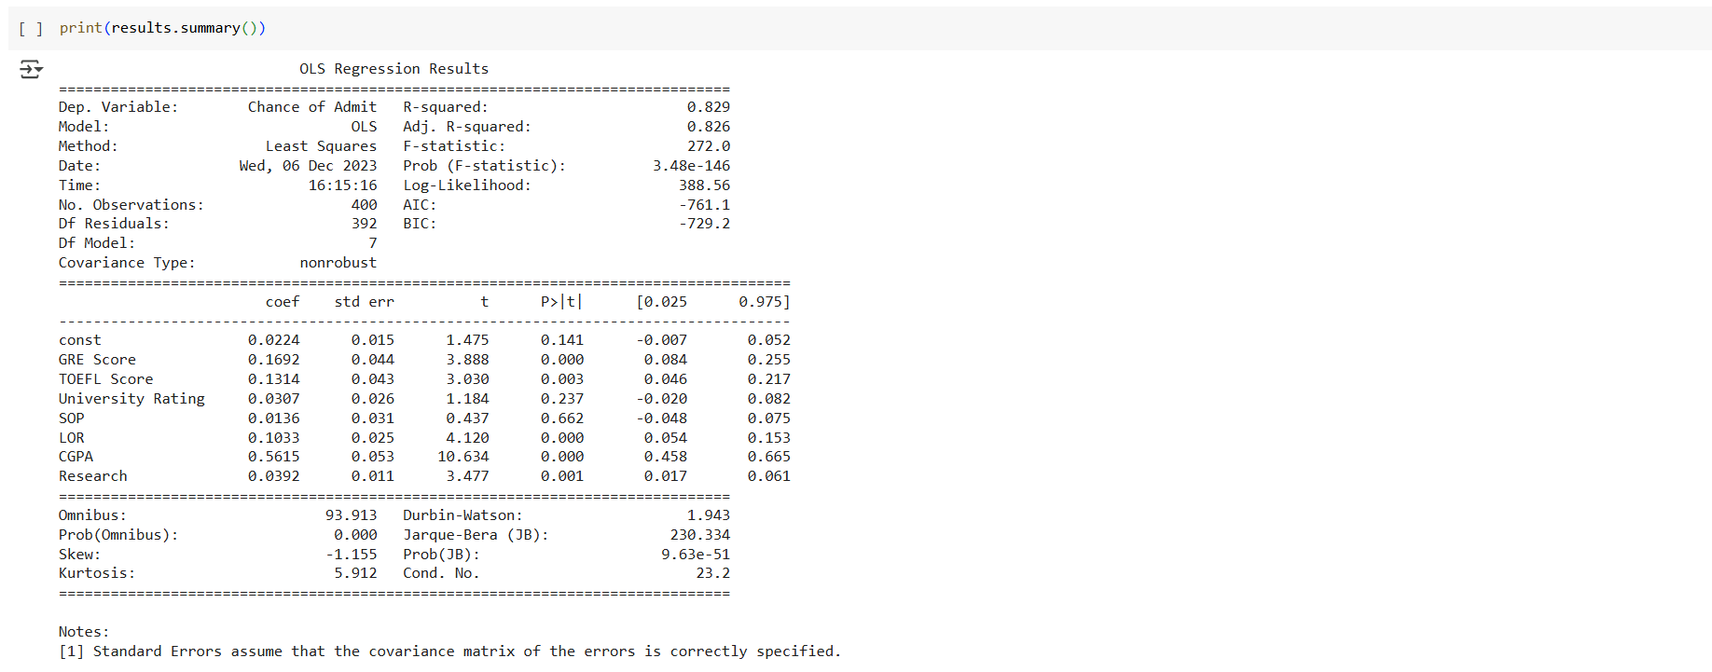

* From Summary R- Squared is 0.829 and R-Squared Adj is 0.826, from whcih we can say all the features in the model are relevant
* Prob (F-statistic):3.48e-146 --> is very low, which mean we can reject our null hypothesis [H0: Weights of all features are equal to Zero ; Ha: Weight of Some features are not equal to zero]
* from P>|t| of feature Weights , we can confidently say Weights of CGPA,GRE Score, TOEFL Score, LOR, Research are correct & significant to our model as their P>|t| is very low
* However weight of University Rating and SOP are not so significant to our model as their P>|t| is very high

Lets Calculate Predicted Y values for Test and Train Data

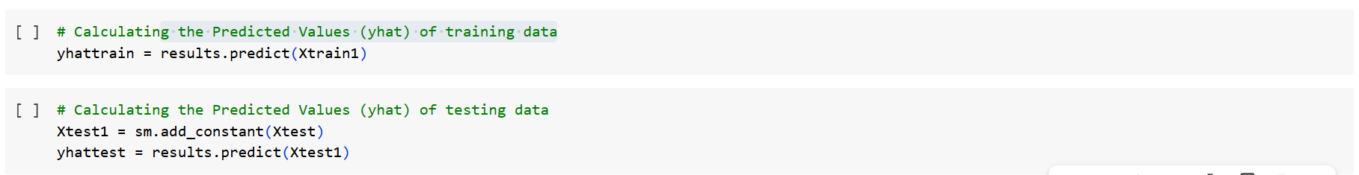

Let Calculate the Coefficients of Each Feature:

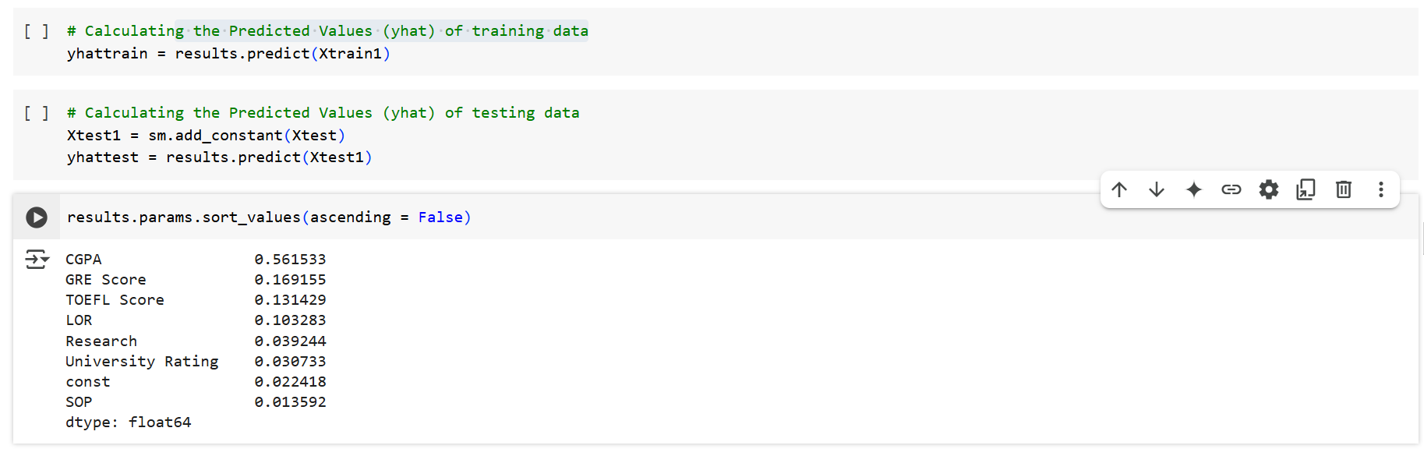

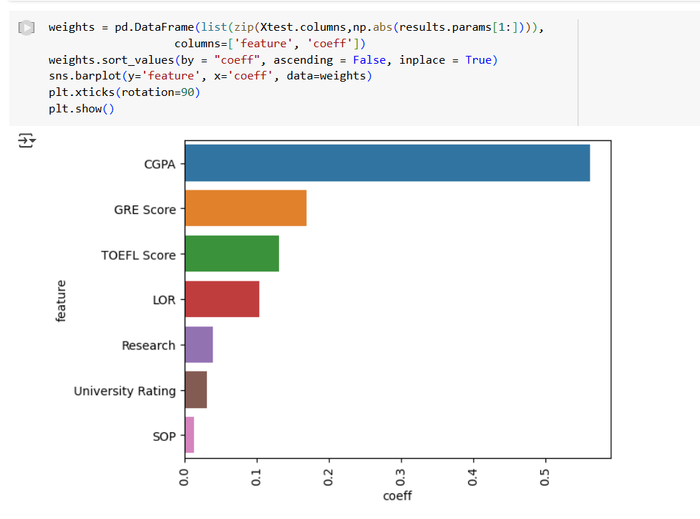

* CGPA is the most important Feature for predicting "Chance of Admit"
* Next comes GRE Score, TOEFL Score, LOR
* Research, University Rating & SOP has least effect for Predicting "Chance of Admit"

Let us Plot Y & Yhat to See how good Model is Predicting:

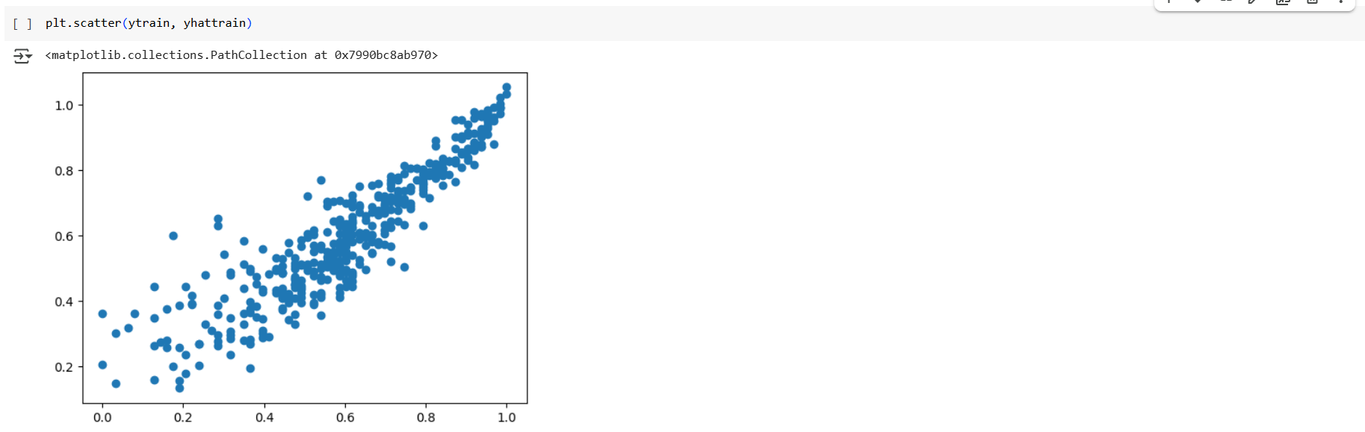

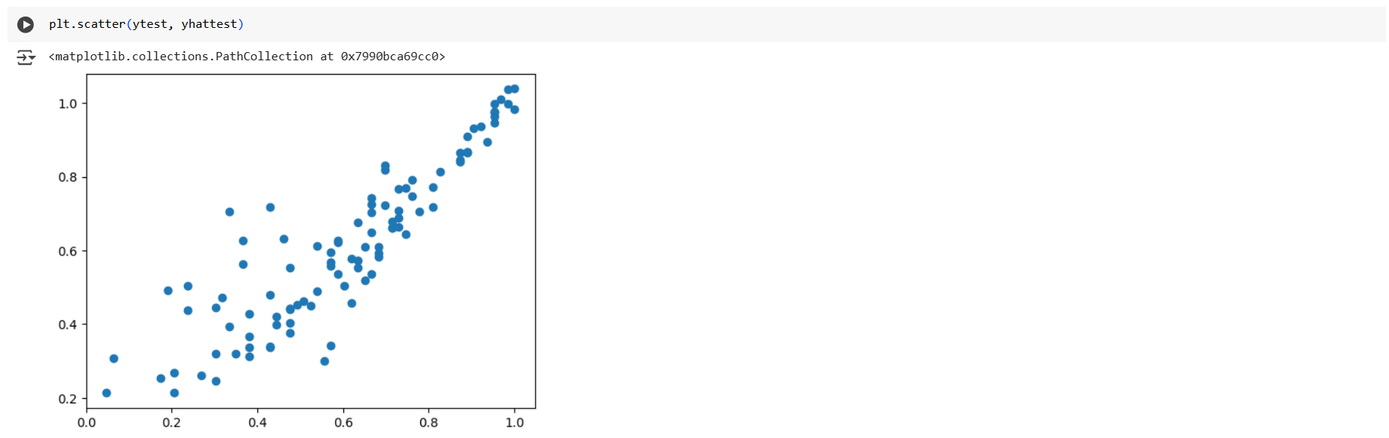

* from Yhat and yactual plot we can say , model is predicting good
* Now lets check R-square of Testing & Training data

###### R-Square

R-squared, also known as the coefficient of determination, is important because it measures the proportion of the variance in the dependent variable that is predictable from the independent variables. This helps in assessing the goodness of fit of a regression model and understanding how well the model explains the variability of the outcome

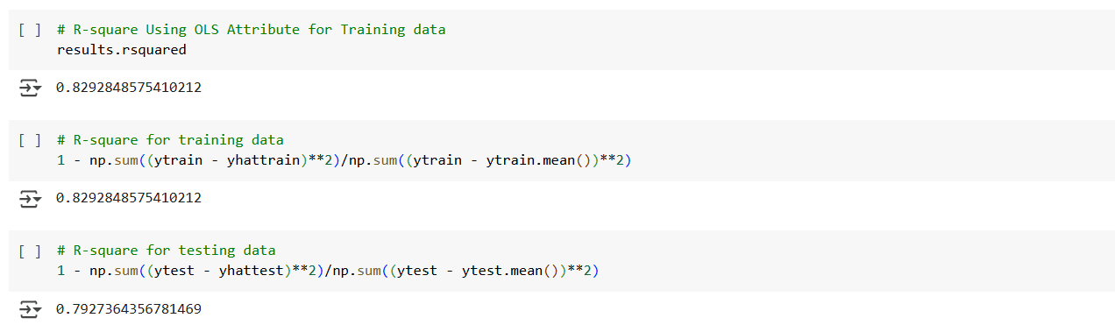

* From R-square Values of Test & Train Data, we can say model is neither Overfit nor Underfit
* It is appropriately Fit

###### R-Square adjusted

Adjusted R-squared is important because it accounts for the number of predictors in a model, providing a more accurate measure of model fit by penalizing the inclusion of irrelevant variables. This helps in selecting models that truly improve predictive power without overfitting.

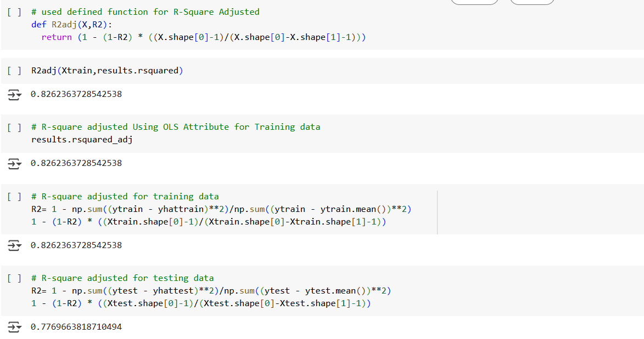

* From Comparison of R-Square and R-Square Adjusted, we see difference b/w R-Square & R-Square adj for Training [0.829 - 0.826 = 0.003] , for testing [ 0.792 - 0.776 = 0.016] is very small
* So we can conclude there are no irrelevant features inline with our earlier Hypothesis Testing

###### Mean Absolute Error

Mean Absolute Error (MAE) is a metric used to measure the average magnitude of errors in a set of predictions, without considering their direction. It is calculated as the average of the absolute differences between predicted and actual values, providing a straightforward measure of prediction accuracy. Lower MAE values indicate better model performance

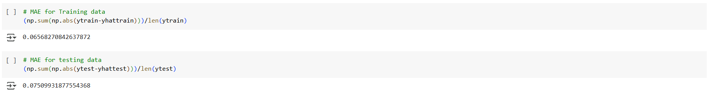

* Both Test & Train data MAE Values are very low meaning our model is performing good

###### Root Mean Square Error

Root Mean Square Error (RMSE) is a metric used to measure the average magnitude of errors in a set of predictions. It is calculated as the square root of the average of the squared differences between predicted and actual values. RMSE gives higher weight to larger errors, making it useful for identifying models with significant prediction errors. Lower RMSE values indicate better model performance

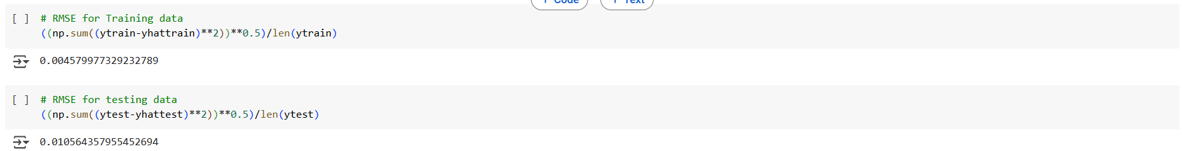

Both Test & Train data RMSE Values are very low meaning our model is performing good

##### Linear Regression Assumptions

###### VIF

Variance Inflation Factor (VIF) is a measure used in linear regression to detect multicollinearity among predictor variables. High VIF values indicate that a predictor variable is highly correlated with other predictors, which can inflate the variance of the coefficient estimates and make the model unstable. Generally, a VIF value above 5 suggests significant multicollinearity that may need to be addressed.

Below is Iterative code for removing High VIF features by maintaining threshold for VIF<=5 [iterates code till none of features VIF >5

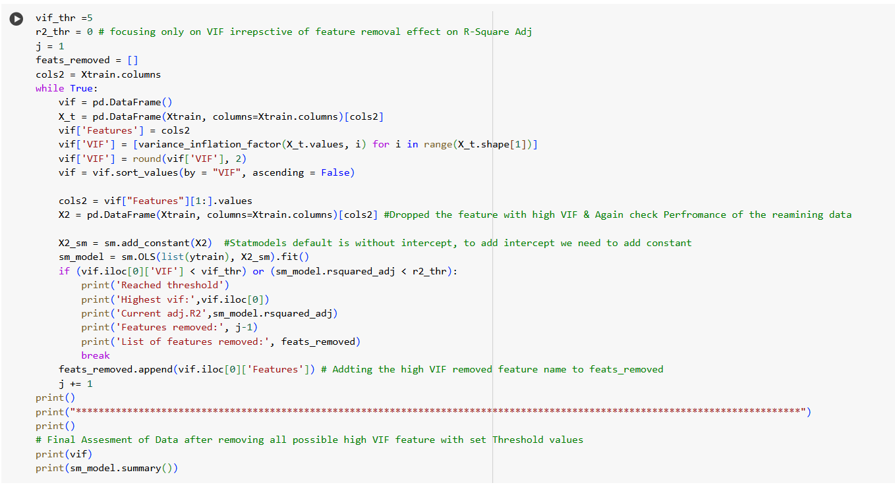

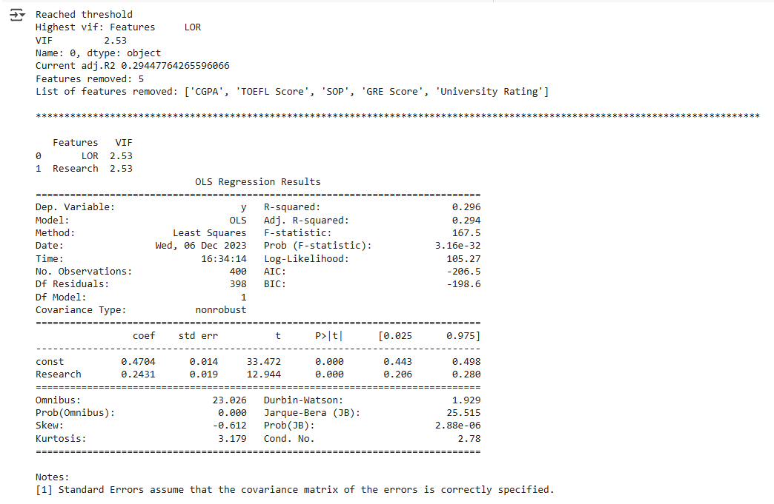

* By focusing only on VIF Score < 5 --> five Feaures ['CGPA', 'TOEFL Score', 'SOP', 'GRE Score', 'University Rating'] have been Removed
* As a results Rsqure_adj of the model came down to 0.294 --> Not a good Model for Prediction
* Now we will focus both on VIF & R-Square Adj
* Below is Iterative code for auto removing High VIF features by maintaing threshold for **VIF<=5 & Rsquare_adj >=0.8**

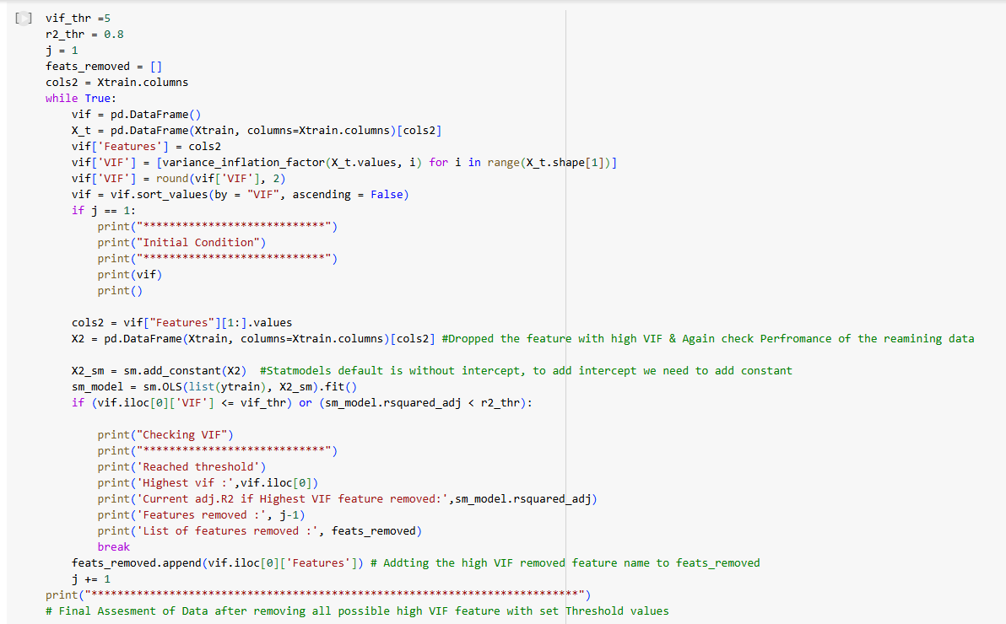

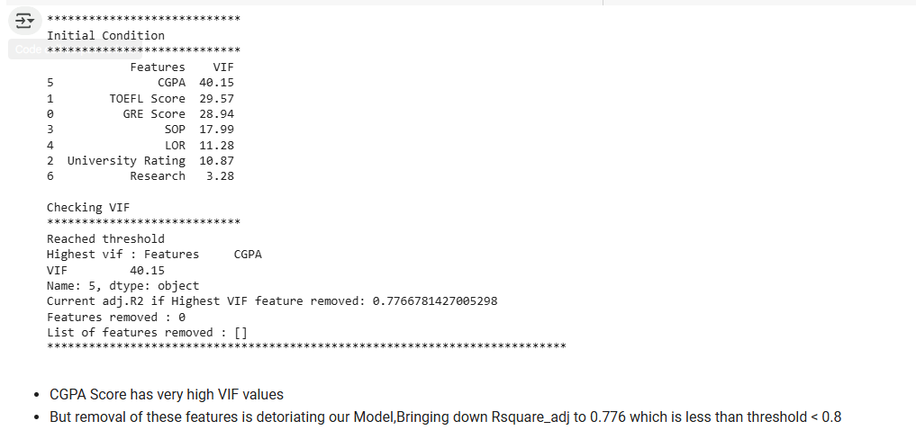

###### Mean of Residuals

The mean of residuals assumption in linear regression states that the average of the residuals (errors) should be zero. This ensures that the model's predictions are unbiased, meaning the predicted values are, on average, equal to the actual values. If this assumption holds, it indicates that the model is correctly specified

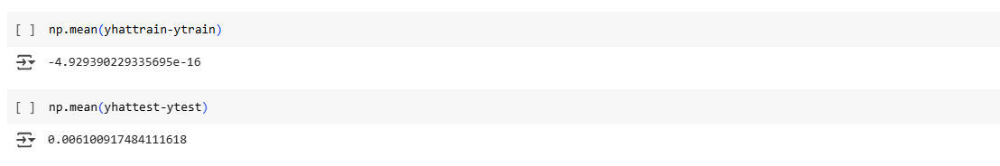

* Mean of Residuals are almost equivalent to Zero

###### Linearity of Variables

The linearity of variables assumption in linear regression states that there should be a linear relationship between the independent variables and the dependent variable. This means that changes in the predictor variables should result in proportional changes in the response variable. Ensuring this assumption holds helps in accurately modeling the relationship and making reliable predictions.

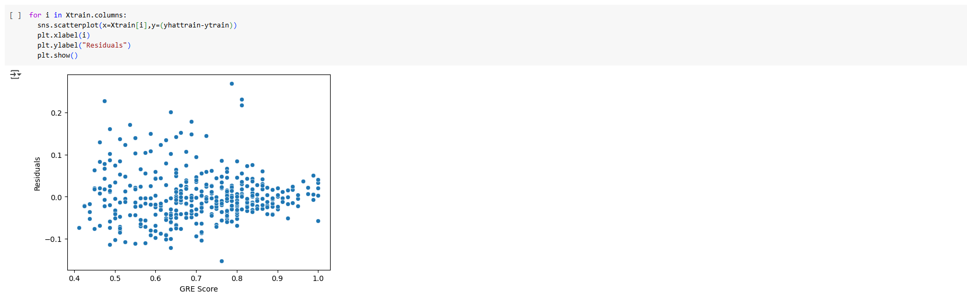

* We can say No Rigid pattern observed for Residual w.r.t Features.

###### No Heteroskedasticity

Heteroskedasticity in regression analysis refers to the condition where the variance of the residuals (errors) is not constant across all levels of the independent variables. This violates one of the key assumptions of ordinary least squares (OLS) regression, which assumes homoscedasticity (constant variance). When heteroskedasticity is present, it can lead to inefficient estimates and unreliable hypothesis tests.

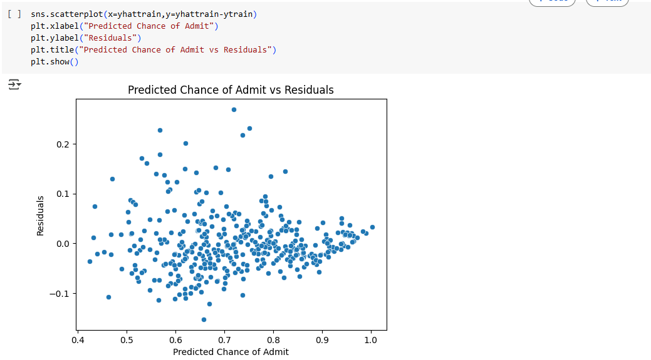

* Very Slight Heteroskedasticity is Present
* However we can say variance is almost same for all data point

###### Normality of Residuals

The normality of residuals assumption in linear regression states that the residuals (errors) should be normally distributed. This is important for valid hypothesis testing and constructing confidence intervals. When this assumption holds, it ensures that the statistical tests for coefficients are reliable, and the model's predictions are accurate.

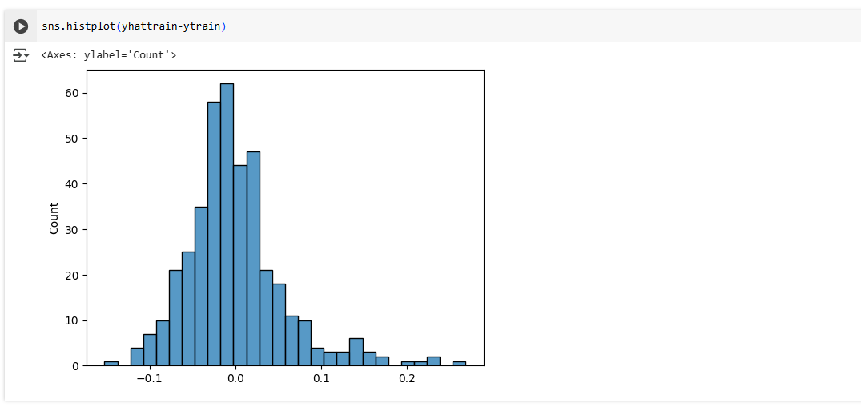

* Almost bell Shape curve can be Visualized.
* Although it is not Perfect Normal Distribution, it is Skewed Normal
* We Can Further Consolidate the Normal Distribution using Hypothesis Testing or QQ Plots

So till now Have Build Linear Regression Model using Stats Model Library, Verified all Model Metric and Checked all Linear Regression Assumptions

Now we will Explore various Other Linear Regression Modelling Techniques

##### Model Building - Linear Regression [Lasso]

Lasso Linear Regression, or Lasso (Least Absolute Shrinkage and Selection Operator), is a type of linear regression that includes a regularization term to prevent overfitting and enhance model performance. The key feature of Lasso is that it can shrink some coefficients to zero, effectively performing variable selection and simplifying the model

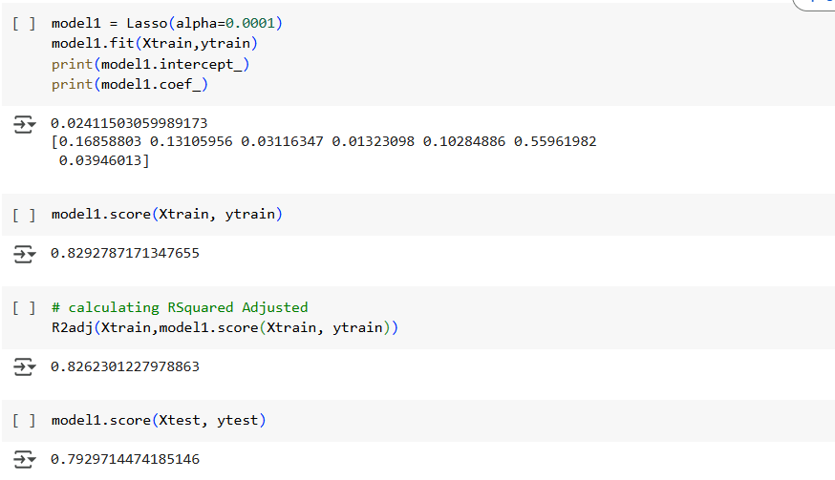

let us do L1 Regularization constant Hyperparameter Tuning

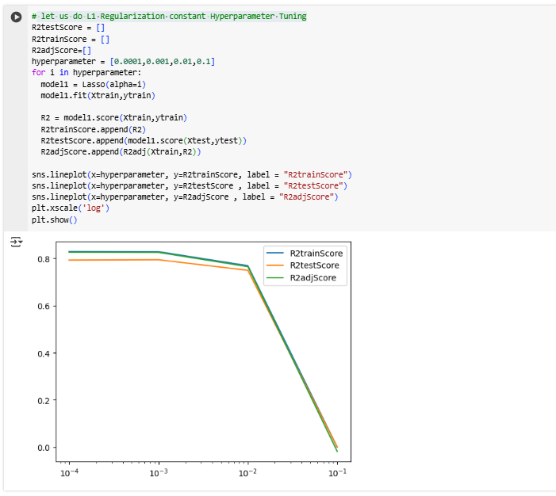

* Lasso Linear_Regression is giving slightly better results with very low L1 Regularization Constant values.
* we are getting R-Square Detoriated with increase in L1 Regularization constant.
* Meaning with our Earlier Linear Regression Model was good with Given 7 features, further by increasing Regularization we are deteriorating our model by increasing underfitting.

##### Model Building - Linear Regression [Ridge]

Ridge Regression adds a penalty equal to the square of the magnitude of coefficients to the loss function. This penalty term is controlled by a parameter, alpha. The regularization term introduces some bias but reduces variance, leading to a more stable model that generalizes better to new data. Unlike Lasso, Ridge Regression shrinks the coefficients but does not set any of them to zero, meaning it retains all features in the model.

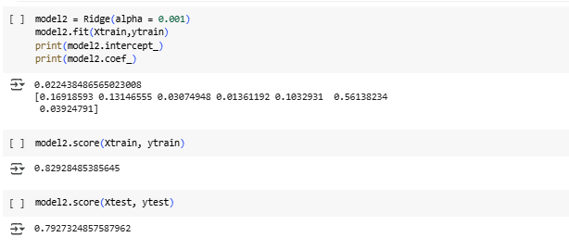

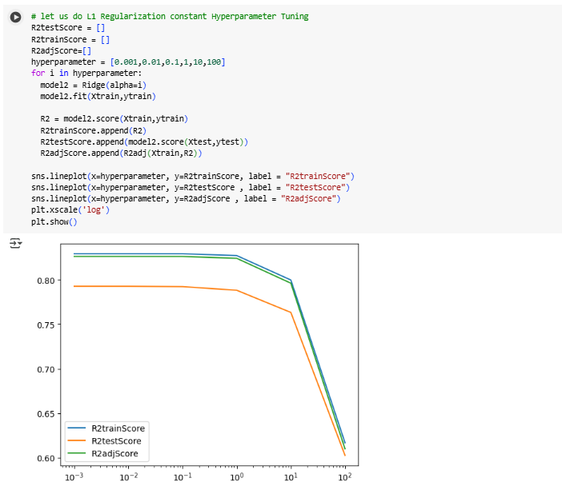

* we are are getting R-Square Detoriated with increase in L2 Regularization constant
* Meaning with our Earlier Linear Regression Model was good with Given 7 features, further by increasing Regularization we are deteriorating our model by underfitting.
* so now we will use Polynomial Feature and check if our Linear Regression Model can be further Increased.

##### Model Building - Polynomial Regression

Polynomial Regression is a type of regression analysis where the relationship between the independent variable

X and the dependent variable y is modeled as an nth degree polynomial. It extends linear regression by allowing for non-linear relationships between the variables.

Let us check if Different Polynomial will increase Rsquare & Rsquare_adj

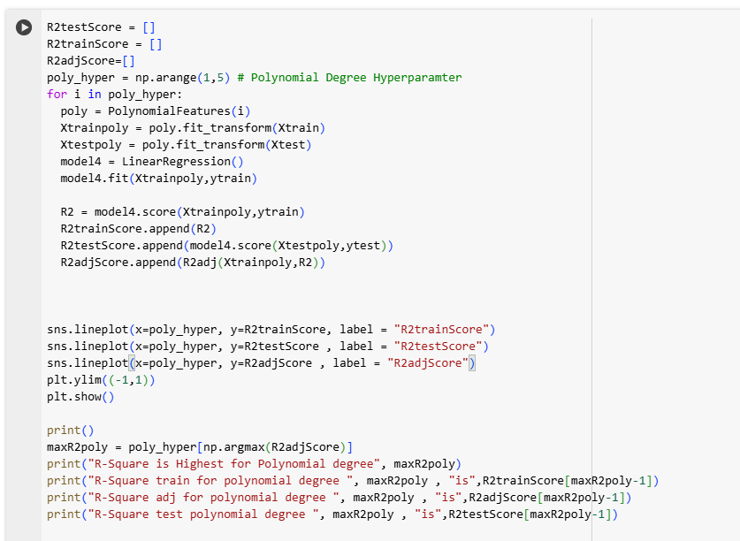

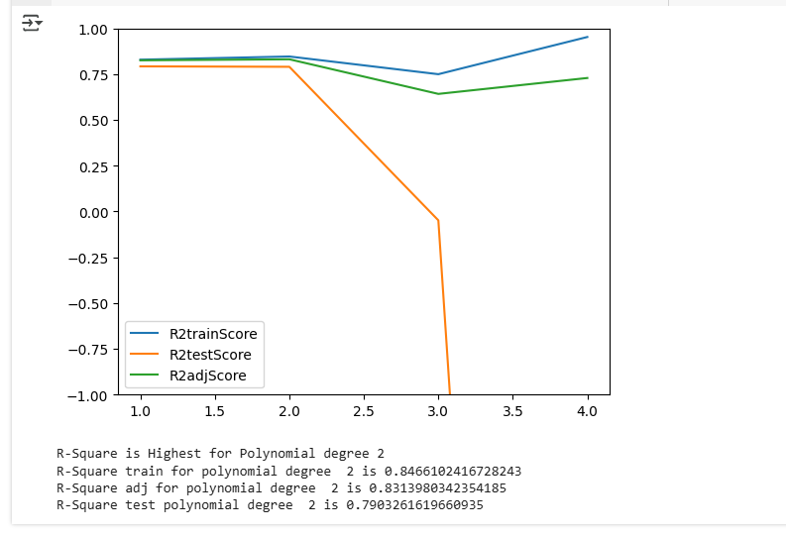

* Linear Regression Model is performing better with 2nd Degree Polynomial, further when degree increase it is leading to Overfit resulting in bad results for Testing data
* Further we will do L1 Regularization to on polynomial Features to to check if model performance can be further increased by reducing overfitting problem in higher polynomials

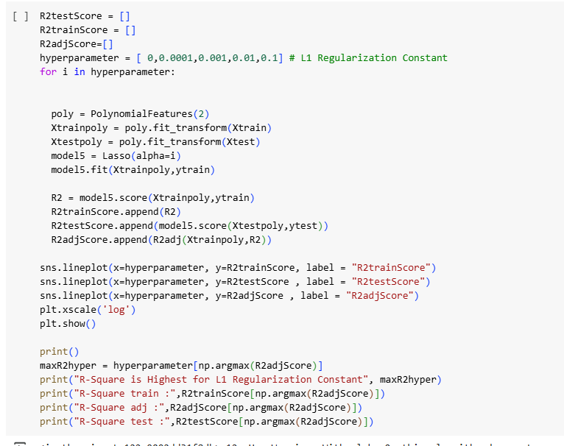

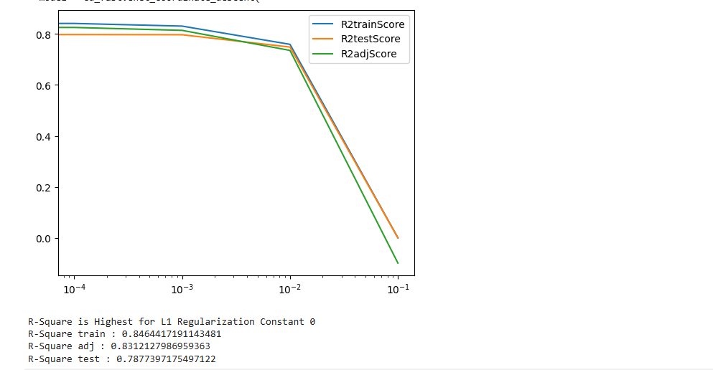

* Use of Regularization did not improve out 2nd Degree Polynomial Model

#### Business Insights:

* All the student applied are meritorious.
  + CGPA of the Student are >= 7.0
  + GRE Scores are greater than 290, More No of Data points are in that range 310 ~ 327
  + TOEFL Scores are greater than 91, More No of Data points are in that range 99~112
* All features have Positive correlation with "Chance of Admit"
  + CGPA[0.88],GRE Score[0.81],TOEFL Score[0.79] has very high correlation with "Chance of Admit"
  + Further SOP[0.68], LOR[0.65] has almost same Correlation with ""Chance of Admit"
  + Comparatively Low Correlation is found w.r.t Research & "Chance of Admit"[0.55], However is positively impactful
* From Stats OLS model Summary R- Squared is 0.829 and R-Squared Adj is 0.826, from which we can say all the features in the model are relevant
  + CGPA is the most important & Significant Feature for predicting "Chance of Admit"
  + Next significant feature in decreasing order comes: GRE Score, TOEFL Score, LOR
  + Research, University Rating & SOP are less significant for Predicting "Chance of Admit"
* From R-square Values of Train[0.829] & Test Data[0.792], we can say model is neither Overfit nor Underfit, It is Best Fit
* All Assumpitions of Linear Regression are almost Satisfied
* Further Use Regularization of Constant with Lasso and Ridge did not show much improvement as our OLS model is already Best Fit
* However, use of 2nd degree Polynomial feature very slightly improved Rsquare Adj from 0.826 --> 0.831

#### Recommendations:

* To improve the Model Following additional Features can be added
  + Under graduation College Rating
  + Extra Circular activity with an Unified Rating
  + Personal Essay Rating
  + Professional Working Experience
  + Financial Status
* further we can get actual data of Admission [yes or No] of past History records to understand the Actual Threshold for "Chance of Admit" to definitely get admitted
* With the help of above model, Jamboree can confidently guide the Students with exact course of action meaning what score/rating to improve to get admission to particular college

### Chapter 4 : Business Case Study 4

#### Problem Description

##### About Company

A leading ride-sharing platform, aiming to provide reliable, affordable, and convenient urban transportation for everyone.

##### Problem:

* The constant challenge of ride sharing platform is the churn rate of its drivers. Ensuring driver loyalty and reducing attrition are crucial to the company's operation.
* Analyzing driver data can reveal patterns in driver behavior.
* Model Building for Driver Churn using Ensemble Techniques like Boosting and Bagging

##### Dataset:

* MMMM-YY : Reporting Date (Monthly)
* Driver_ID : Unique id for drivers
* Age : Age of the driver
* Gender : Gender of the driver – Male : 0, Female: 1
* City : City Code of the driver
* Education_Level : Education level – 0 for 10+ ,1 for 12+ ,2 for graduate
* Income : Monthly average Income of the driver
* Date Of Joining : Joining date for the driver
* LastWorkingDate : Last date of working for the driver
* Joining Designation : Designation of the driver at the time of joining
* Grade : Grade of the driver at the time of reporting
* Total Business Value : The total business value acquired by the driver in a month (negative business indicates cancellation/refund or car EMI adjustments)
* Quarterly Rating : Quarterly rating of the driver: 1,2,3,4,5 (higher is better)

##### Libraries Used:

import warnings

warnings.filterwarnings("ignore")

import numpy as np

import pandas as pd

import matplotlib.pyplot as plt

import seaborn as sns

!pip install category_encoders

from category_encoders import TargetEncoder

from sklearn.preprocessing import LabelEncoder, StandardScaler, MinMaxScaler

from scipy.stats import kstest

from scipy import stats

from sklearn.model_selection import train_test_split

from sklearn.impute import KNNImputer

from imblearn.over_sampling import SMOTE

from sklearn.ensemble import RandomForestClassifier,GradientBoostingClassifier

from sklearn.model_selection import GridSearchCV,RandomizedSearchCV

from sklearn.metrics import confusion_matrix, ConfusionMatrixDisplay

from sklearn.metrics import precision_score

from sklearn.metrics import recall_score

from sklearn.metrics import f1_score

from sklearn.metrics import roc_curve,roc_auc_score

from sklearn.metrics import precision_recall_curve

from sklearn.metrics import auc

from sklearn.metrics import classification_report

##### Outcome of Analysis:

* Import the dataset and do usual exploratory analysis steps like checking the structure & characteristics of the dataset.
* Check for missing values and Prepare data for KNN Imputation, consider only numerical features for this purpose.
* Aggregate data to remove multiple occurrences of same driver data.
* Feature Engineering Steps:
  + Create a column which tells whether the quarterly rating has increased for that driver - for those whose quarterly rating has increased we assign the value 1
  + Target variable creation: Create a column called target which tells whether the driver has left the company- driver whose last working day is present will have the value 1
  + Create a column which tells whether the monthly income has increased for that driver - for those whose monthly income has increased we assign the value 1
* Statistical summary of the derived dataset
* Check correlation among independent variables and how they interact with each other.
* One hot encoding of the categorical variable
* Class Imbalance Treatment
* Standardization of training data
* Using Ensemble learning - Bagging, Boosting methods with some hyper-parameter tuning
* Results Evaluation:
  + Classification Report
  + ROC AUC curve
* Provide actionable Insights & Recommendations

#### Analysis

Let import Data and Check the Structure



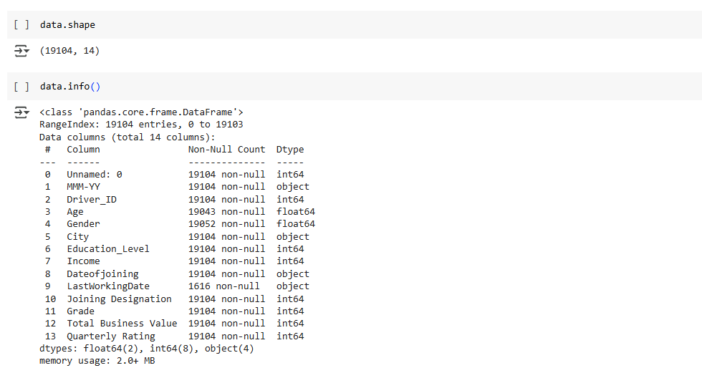

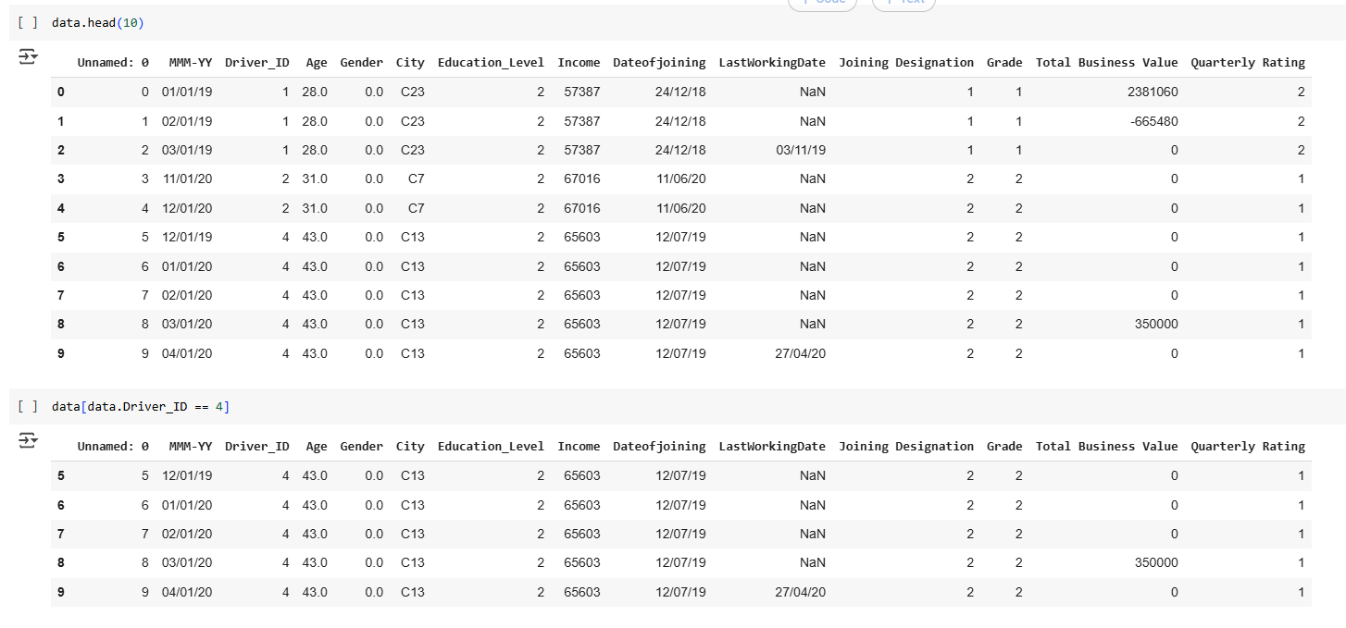

* Same Driver ID has Many Rows...we will merge all the Rows after extracting information from individual rows

##### Data Cleaning

###### Dropping Irrelevant Columns

* "Unnamed" 0" Feature is just an index , so value as a feature, So we will drop the feature



###### Datatype Conversion

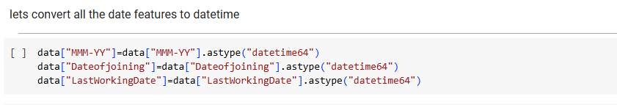

###### Missing Value Treatment

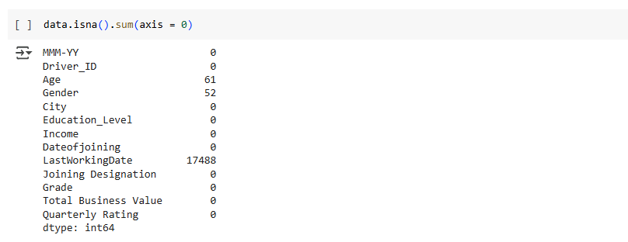

* we will impute missing values through KNN Imputation for "Age" & "Gender"
* we need not treat "LastWorkingDate" becoz if driver has not left...it will be represented as Nan Only....later we will deal it by creating new feature

Gender

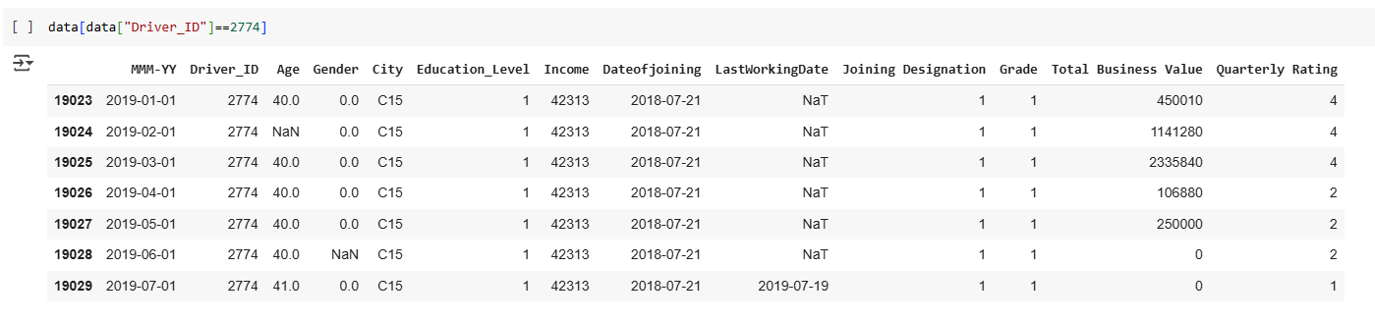

* As we can see rest of the Same Driver ID rows have Gender mentioned
* So we will use Nearest Neighbor as 1 as it is Categorical
* We will select only columns ["Driver_ID","Educational_Level","Income","Dateofjoining","Joining Designation"] for fitting of KNN Imputer

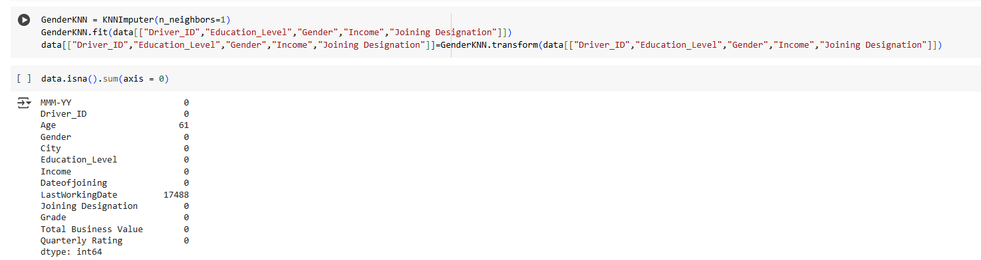

* All missing values in Gender have been imputed using KNN

Age

Like Gender, we will use Nearest Neighbor as 1

We will select only columns [Driver_ID", "Education_Level", "Age", "Gender", "Income", "Joining Designation"] for fitting of KNN Imputer

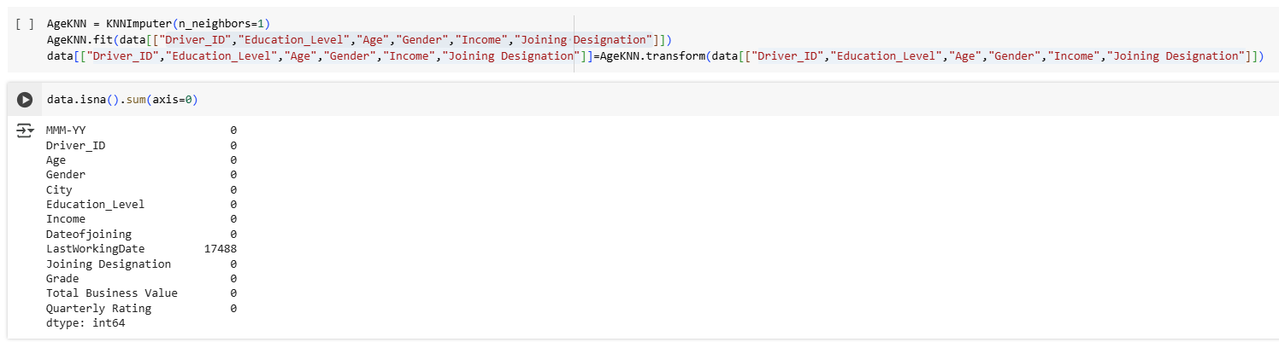

All Missing Values in the Age are Imputed using KNN imputer

###### Duplicate rows



##### Row Merging for Each Driver_ID

Let us first sort the Data as per the Driver_ID and "MMM-YY"[Reporting Month], so that when mergin we get the correct data in last and first columns.



* We will do 2 Nos Groupby on Driver ID to Collect First and Last Data for "Income",Grade","Quaterly Rating"
* Later we will merge them and use both data to create new features`

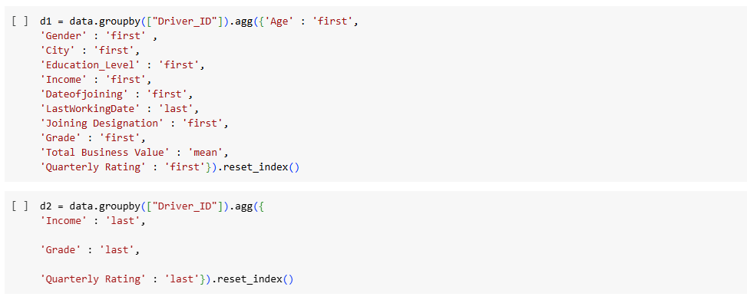

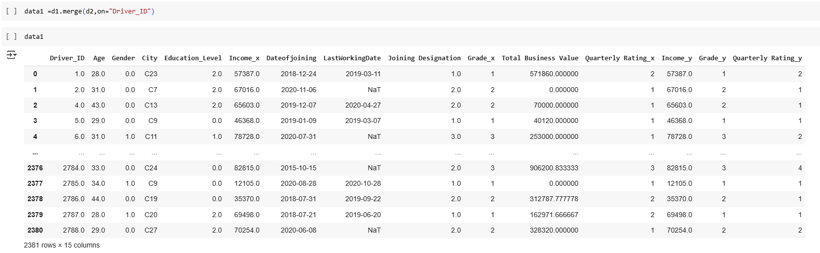

##### Feature Engineering 1

* Let us create some flag for Quarterly Rating, Monthly Income, Grade by checking if Rating has increased or decreased --> if increase we will categorize it as "1" representing growth
* Next, we will create our Target Variable for each driver ID from last working day--> if it present value will be "1" meaning driver left

###### Income

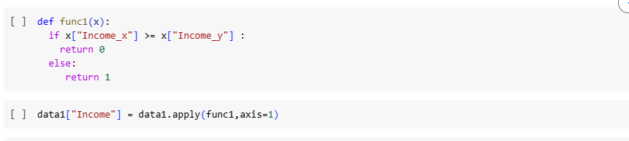

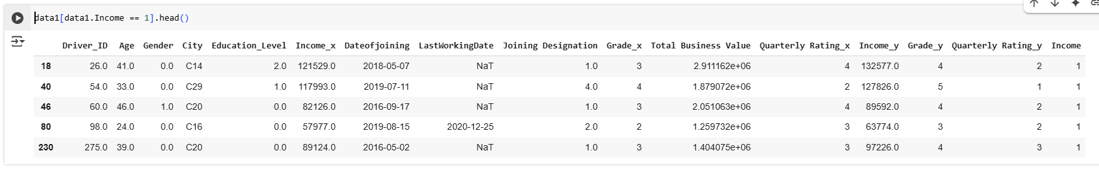

* We can see that if Income Increase --> it has be denoted as "1" in Income Column

###### Quarterly Rating

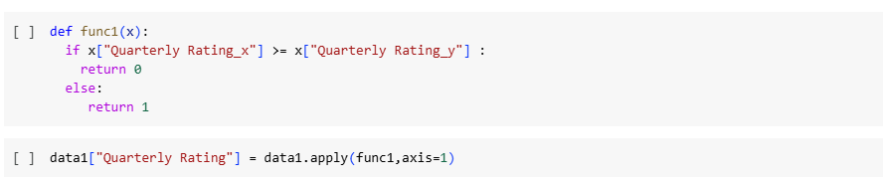

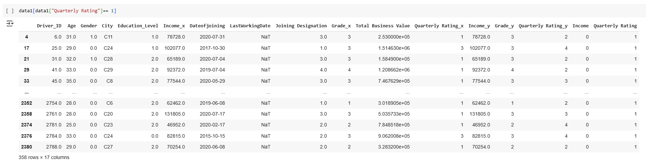

* We can see that if Quaterly Rating Increase --> it has be denoted as "1" in Quaterly Rating Column

###### Grade

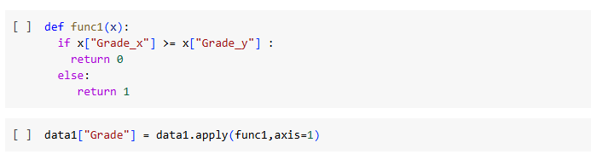

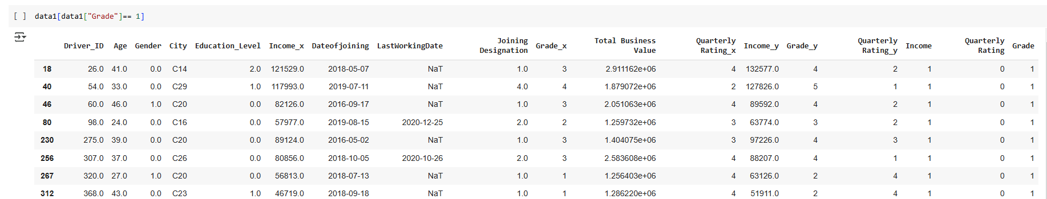

* We can see that if Grade Increase --> it has be denoted as "1" in Grade Column

###### Churn [Target Feature]



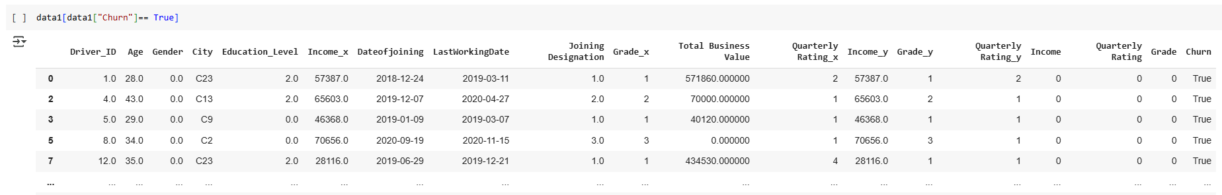

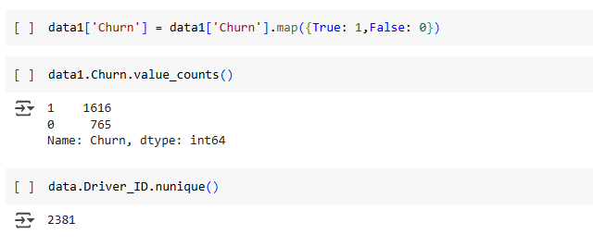

* We have created out Target Feature for all Driver ID's

As we have created our New Features, lets drop all irrelevant Columns.

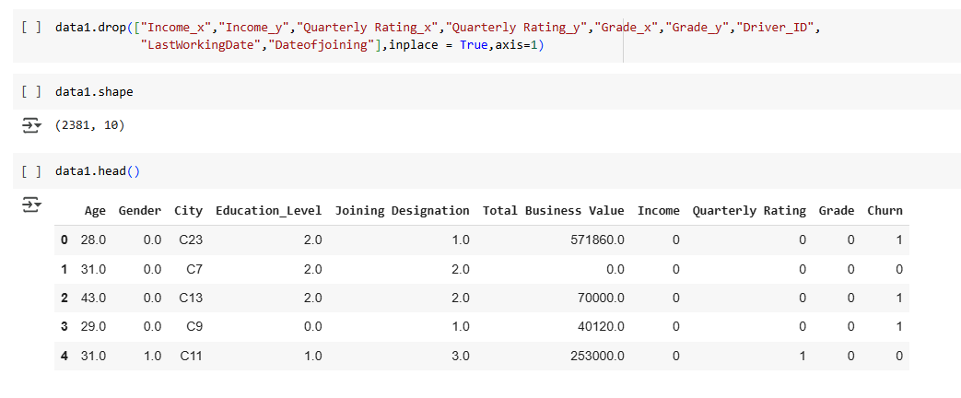

###### Feature Conversion to Categorical

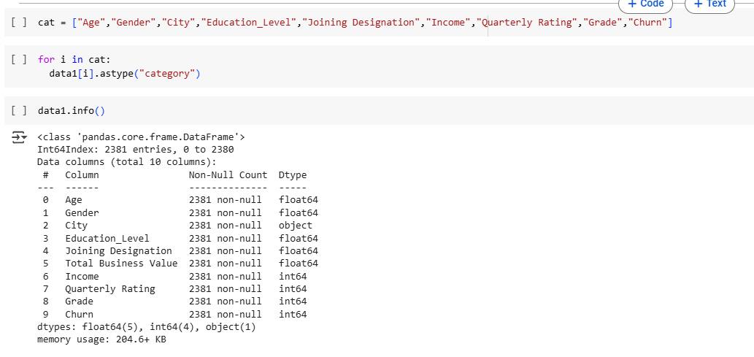

##### Univariate & Bivariate Analysis

###### Churn

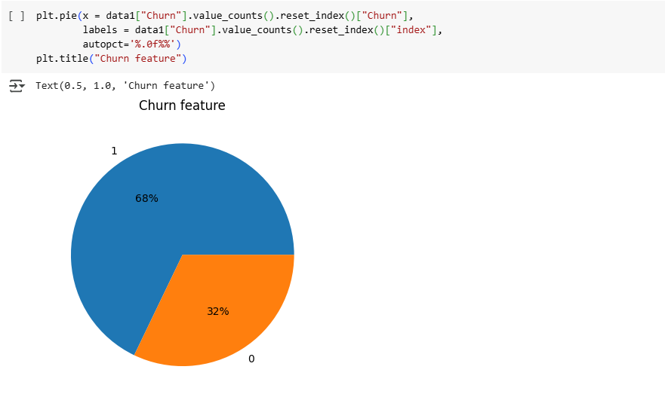

* In data Shared 68% of the Drivers have attritioned only 32% have retained
* Huge Imbalance in the Data, we have to address imbalance before model training.

###### Age

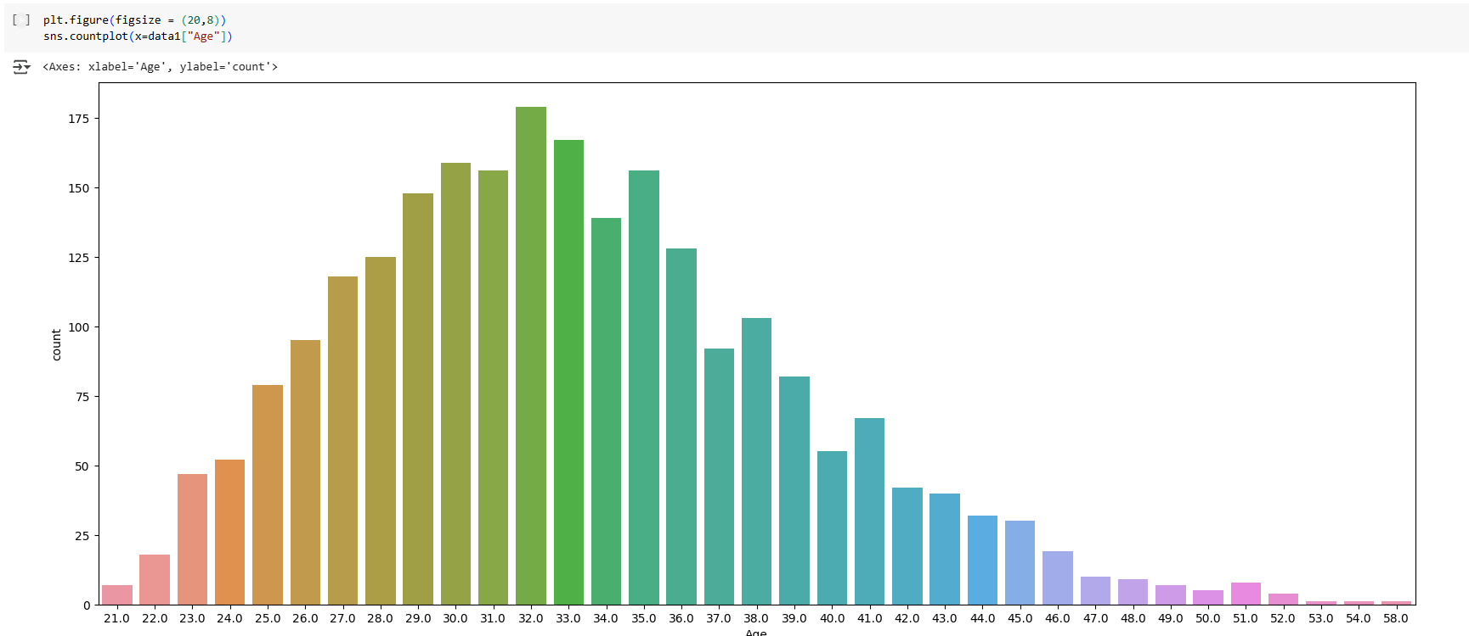

* 50% of driver have age range between 29~37
* Min age of Driver is 21 Years
* Max age of Driver is 58 Years
* Lets bin the Age ranges to Reduce the No of Categories in Age

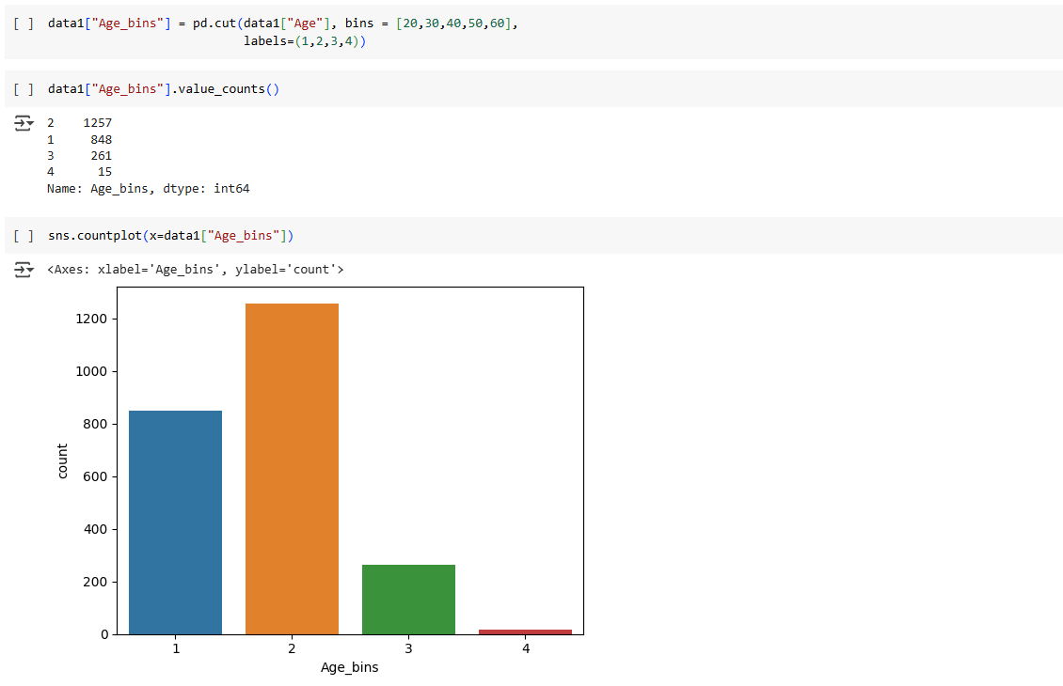

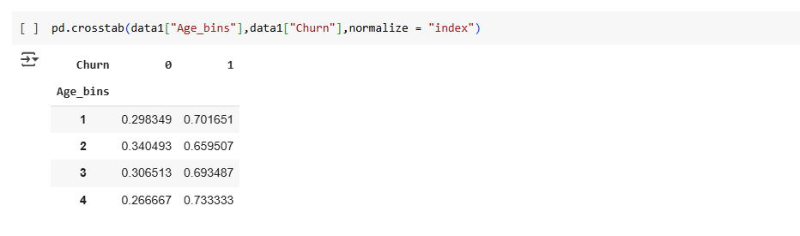

* Majority of Driver lie in the Age range 20~30
* Attrition almost same in all Age range...comparatively slightly high in 50~60 range

###### Gender

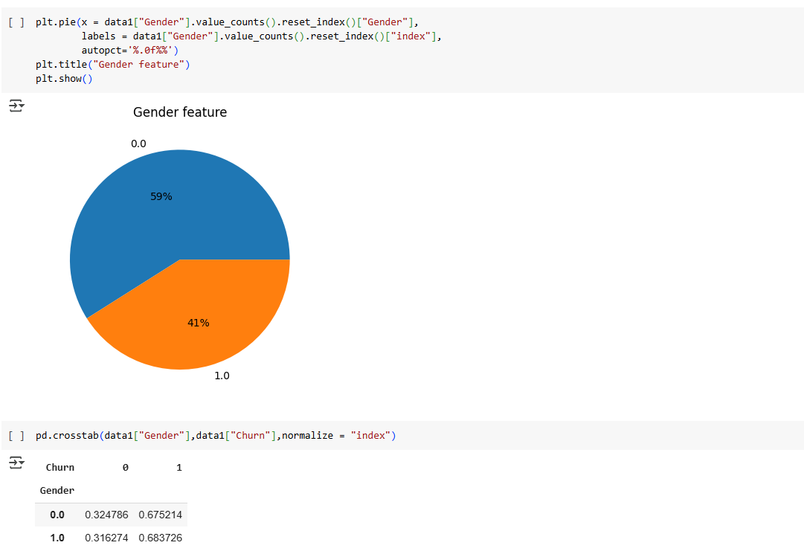

* 59% of Drivers are Male, 41% are Female.
* Attrition rate is almost same irrespective of Gender.

###### Education_level

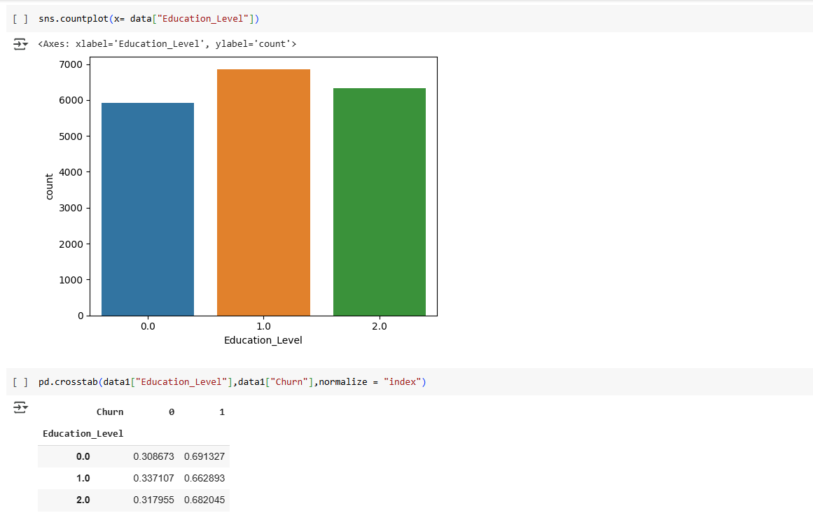

* Driver with Education 12+ are comparatively high.
* Attrition rate is almost same w.r.t Education level.

###### Joining Destination

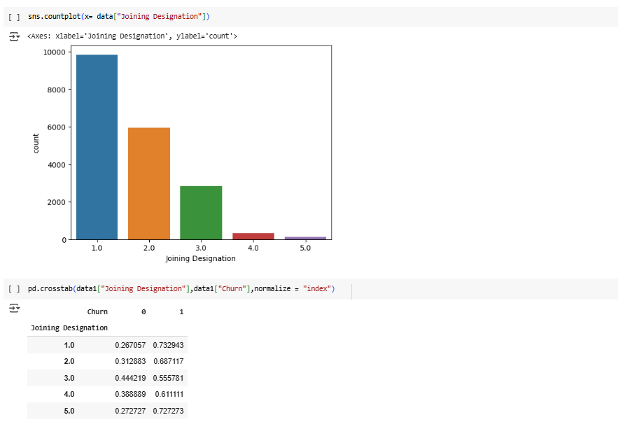

* Majority of Driver are having Joining Grade as "1"
* Attrition rate is highest with Driver having Joining Grade as "1"
* Attrition rate is least with Driver having Joining Grade as "3

###### Total Business Value

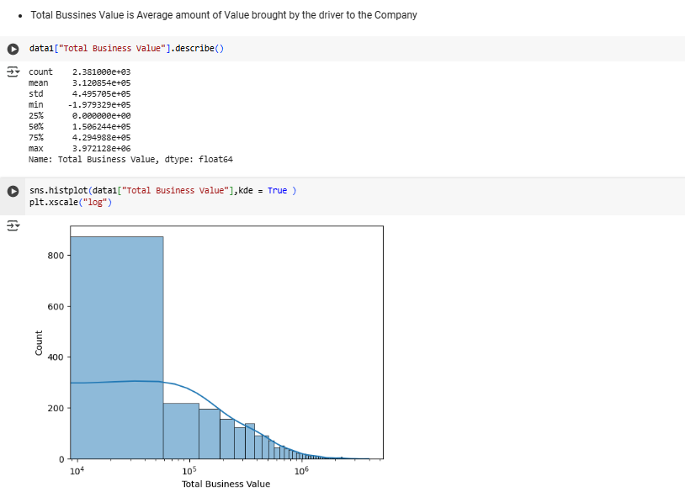

* Average Total Business values brought by the Driver range from -197,932 ~ 3,972,128
* 25% of Driver have Negative Average value to Company
* 50% of Driver have Average Values to Company < 429,498

###### Income

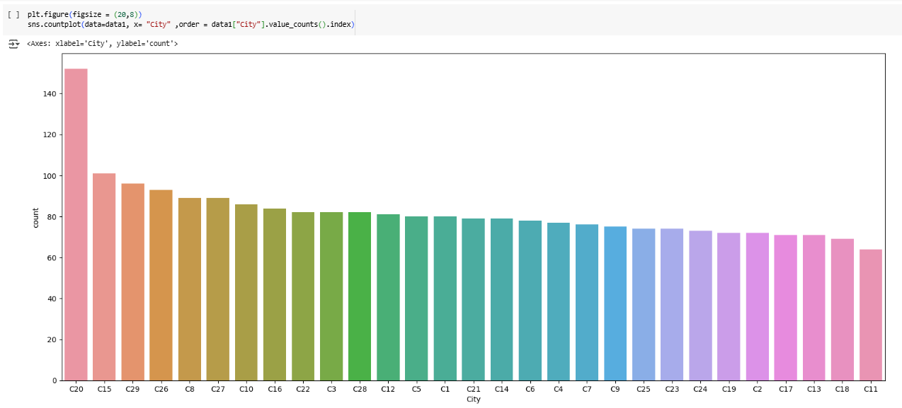

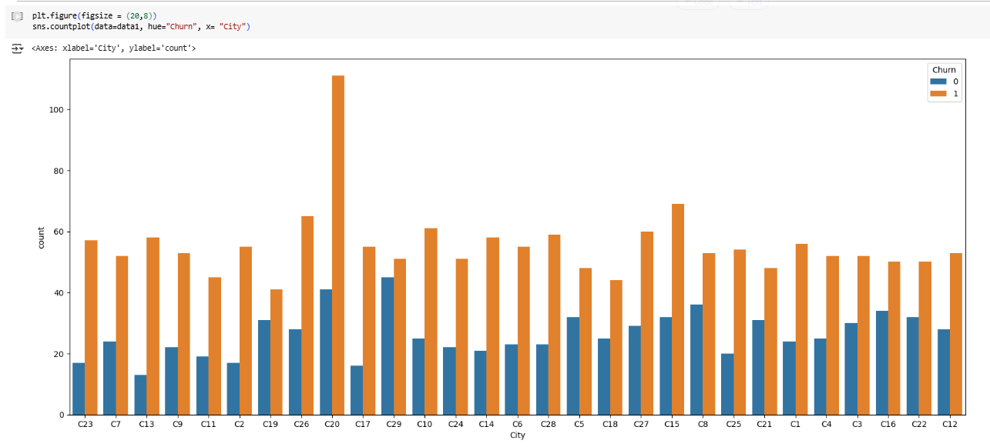

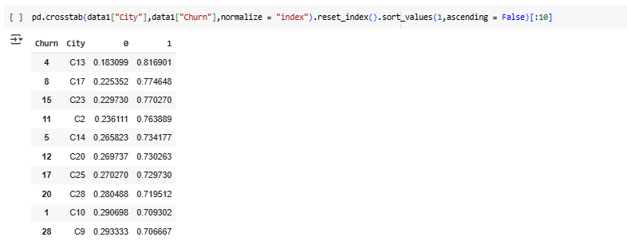

* Most no of Drivers are from city "C20"
* Least no of Driver from "C11"
* Driver Attrition rate is highest in the City "C13"

###### Income

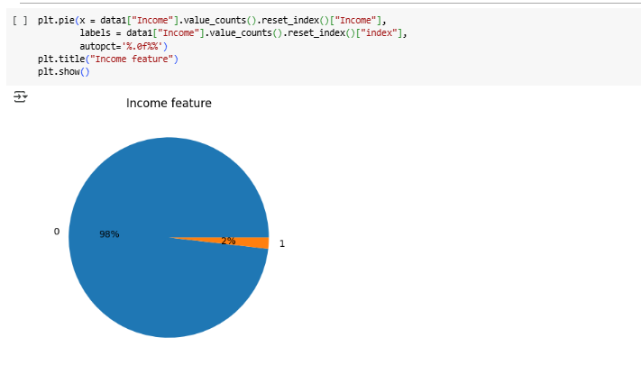

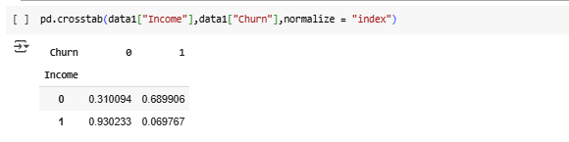

* only 2 % of Driver had their Income Growth
* Very low 6.9% Attrition rate observed with Driver of Increase Income
* 68.9% Attrition rate observed in Driver with No Income Growth

###### Quarterly Rating

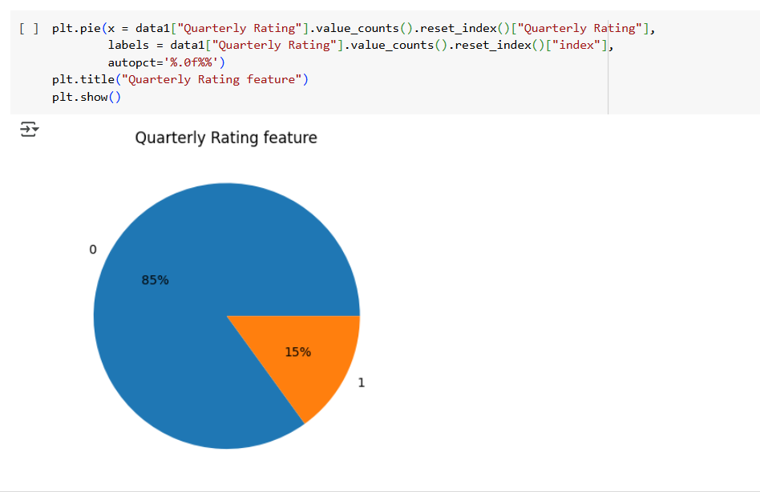

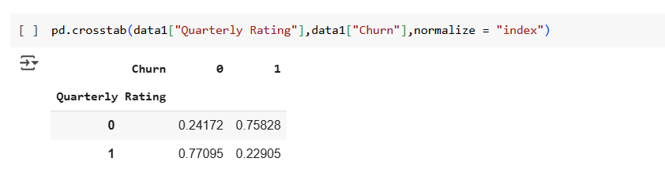

* Only 15 % of Driver had their Quaterly Rating Increase
* 23% Attrition rate observed with Driver Quaterly Rating has Increase
* whereas 77% Attrtition rate observed in Driver with Quaterly Rating Increase

###### Grade

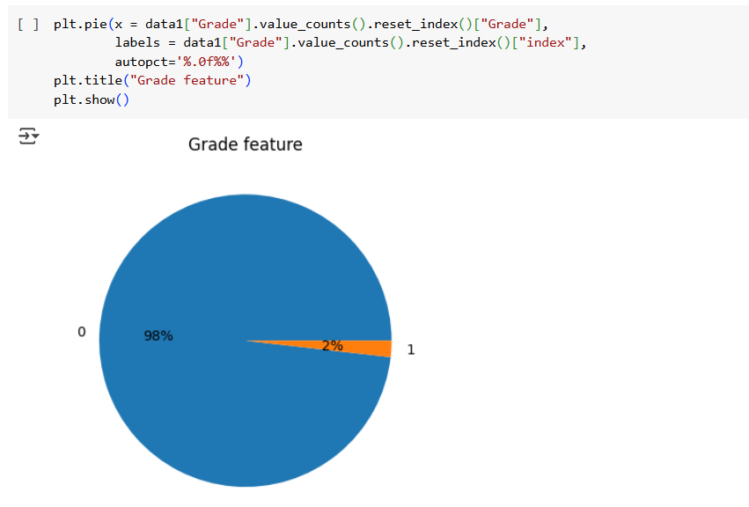

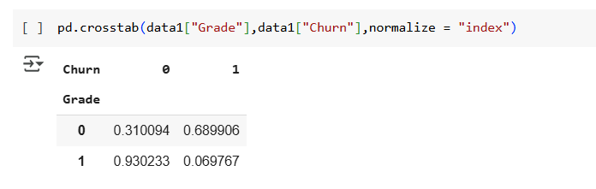

* Only 2 % of Driver had their Grade Growth
* Very low 6.9% Attrition rate observed with Driver of Increase in Grade
* 68.9% Attrition rate observed in Driver with No Grade Growth

##### Feature Engineering 2

###### Eliminate Redundant Features

###### We can drop features - "Age", "Total Business Value " as we have already created similar feature using pd.cut



###### Encoding : Non-Numerical to Numerical

* we will follow below encoding Strategy for rest of categorical features
* if Feature wise unique Value[n]
  + n<=2 --> Label Encoder
  + 3<= n <=5 --> One Hot Encoding
  + n >5 -->Target Encoding

In Feature "City", we have 29 Categories, so we will use Target Encoder

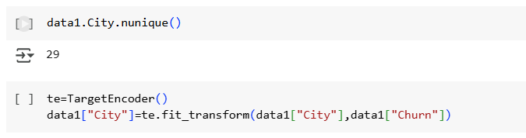

###### Scaling of Numerical Categories

We will do Normalization here as data does not have Normal Distribution

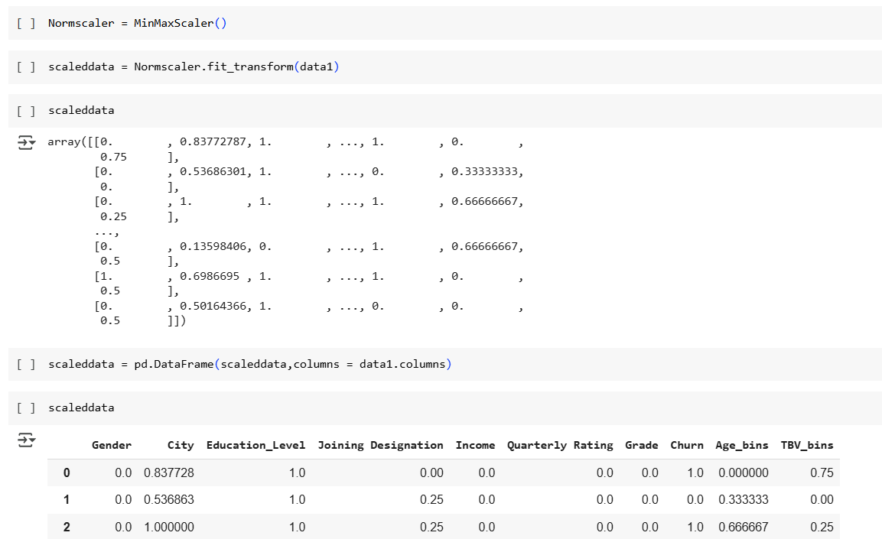

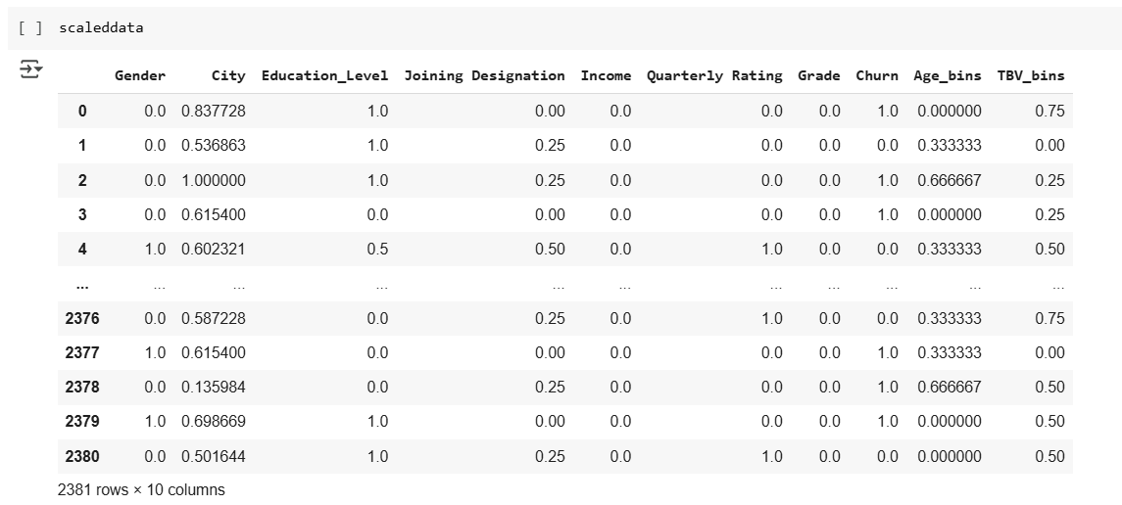

Correlation Matrix:

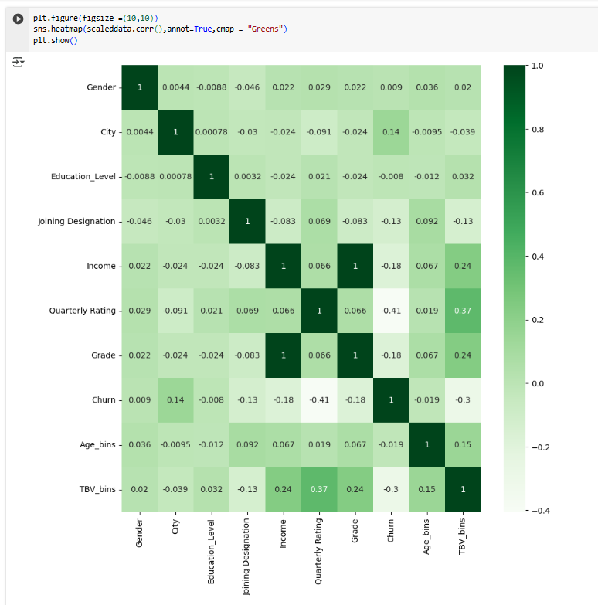

* Income and Grade Feature feature are Perfectly Correlated
* Basically these are Flag --> if "1" in Income feature means Driver Income increases similarily if "1" in Grade Feature means Driver Grade Increase
* So we will drop Grade Feature

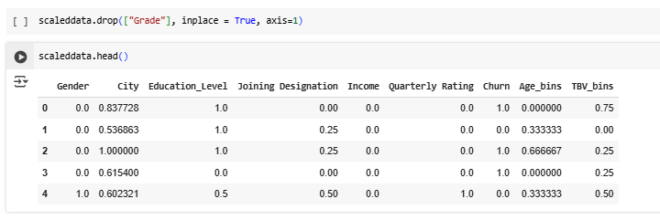

##### Data Prep for Modelling

###### Final data - Dividing Data for Training & Test

* Our desired Outcome is "Churn"
* So we will divide our scaleddata into X,y
* we will use 80:20 ratio for train & test
* Further we will Divide X & y as below data sets
  + Xtrain
  + Xtest
  + ytrain
  + ytest

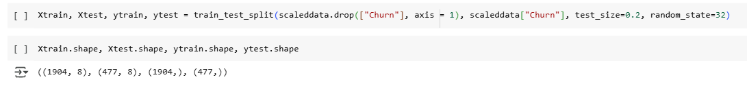

###### Data Balancing

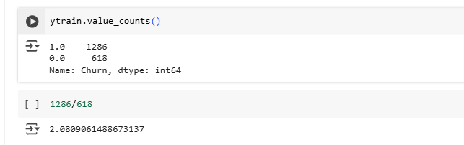

* Data is Highly Imbalance, More data points are available for Attrition Driver
* So we will use SMOTE to Balance Data

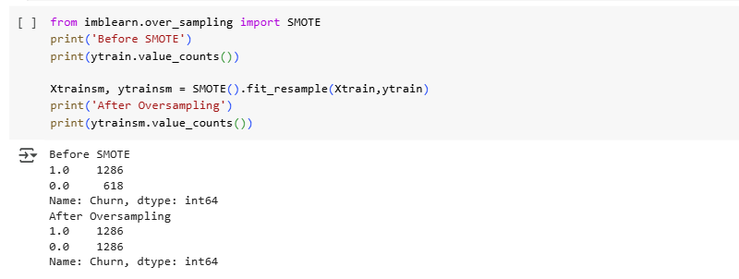

Now the Data is Balanced

##### Model Training - Random Forest [Ensemble - Bagging]

Random Forest is an ensemble learning method used for classification and regression tasks. It builds multiple decision trees during training and merges their results to improve accuracy and control overfitting. Here are the key points:

* Ensemble Method: Combines the predictions of several base estimators (decision trees) to enhance the model's performance.
* Bootstrap Aggregation (Bagging): Each tree is trained on a random subset of the data, which helps in reducing variance and improving generalization.
* Feature Randomness: At each split in the tree, a random subset of features is considered, which helps in creating diverse trees and reducing correlation among them.

One of the Important things required for good Model is **Hyperparameter Tuning**

In Random Forest Some of the important Hyperparameters are:

* 'n_estimators'
* 'max_depth'
* 'max_features'
* 'bootstrap'

But Directly We cannot do Hyperparameter in Such n Dimensional Space, it will take very long time

So First we will do Random Search Multiple time and them we will do Grid Search

###### Random Search

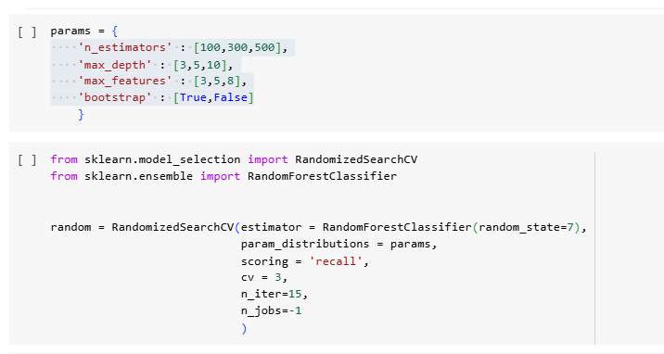

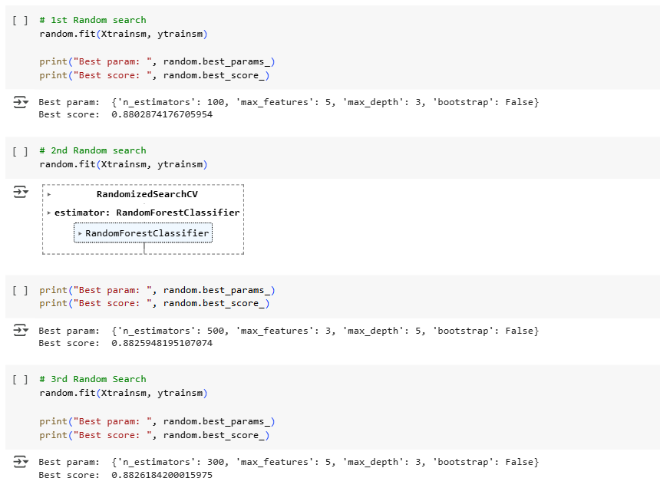

From above 3 Random Search, we can finalize Small Space in 4-dimensional Space as below

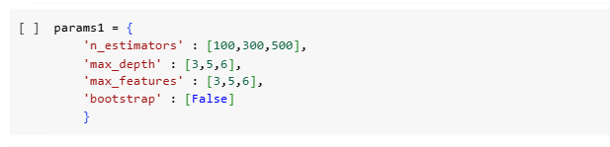

Now we will do Grid Search

###### Grid Search

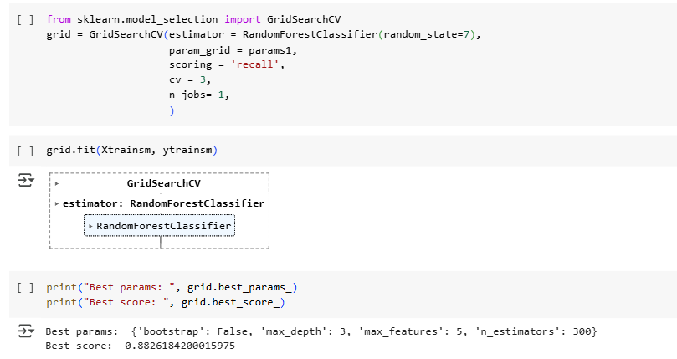

From Random and Grid Search we were able to fix out Hyper parameters

* max_depth = 3
* max_features = 5
* n_estimators = 300
* bootstrap = False

###### Model Training and Evaluation

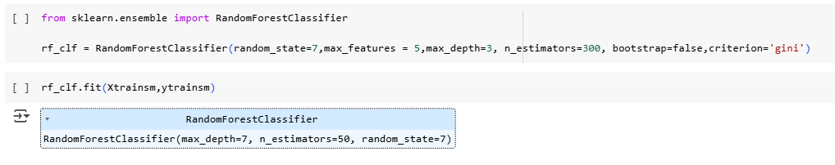

Accuracy

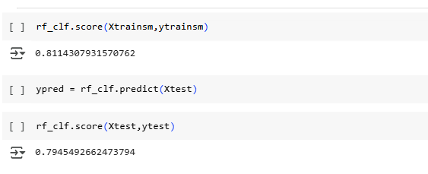

* 79% Predictions by our model are accurate.

Precision

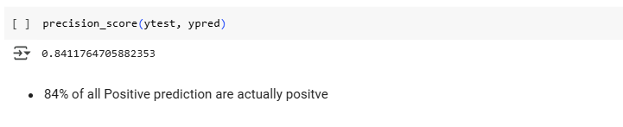

Recall

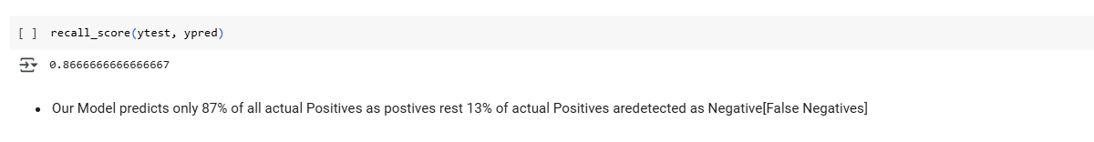

F1 Score

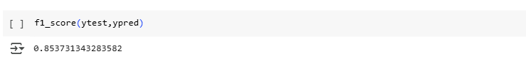

* From F1_score of 0.85, we can say Our model has almost good balance between reducing False Positives [Detect as Churner but not] and False Negative [Actually Churner but detect as not Churner]
* However, there is need to Further improve F1_Score

Confusion Matrix

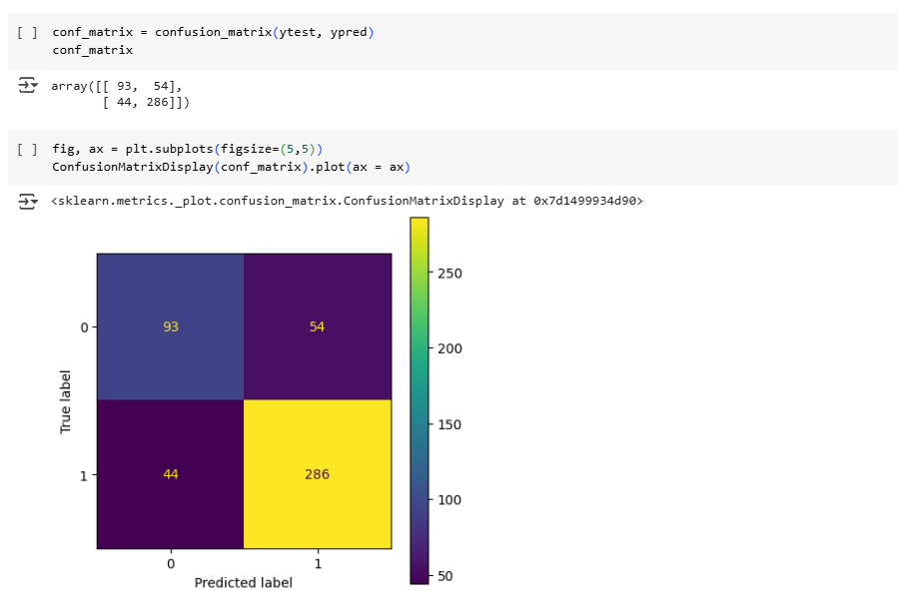

* As Seen Earlier from High Recall and Better Precision values, same is reflected in Confusion Matrix
* How ever our model is detecting FP & FN at almost same
* But as per the business problem our Focus is to identify all attrition driver as acquiring new drivers is more expensive than retaining existing ones --> So we want to reduce False Negtives
* So we will focus on Improving Recall at moderate expense of Precision by changing the threshold value for Classification

ROC

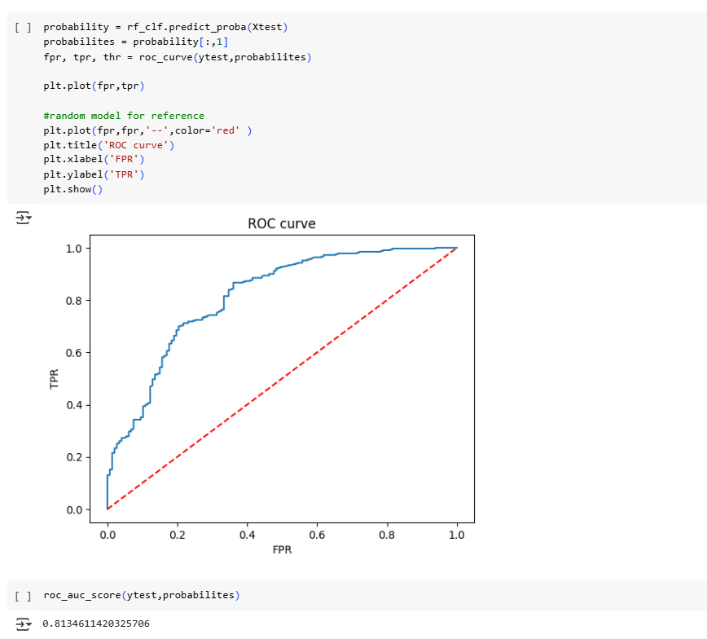

* roc_auc_score is 0.81 meaning our model can 81% efficiently Distinguish Positive and Negative Classes

Precision Recall Curve

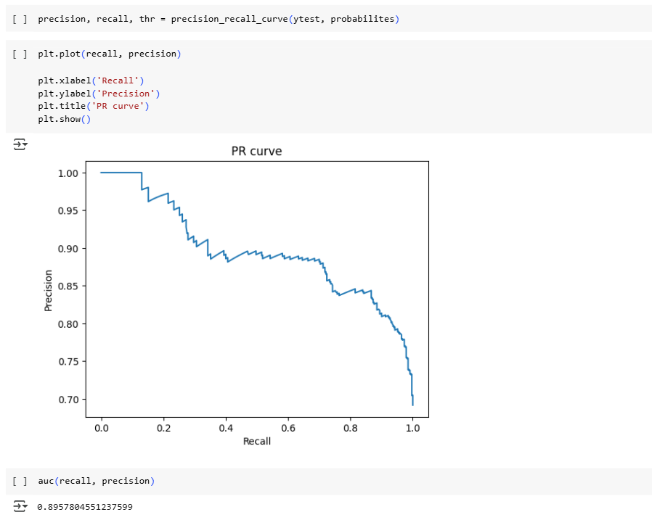

* 0.895 AUC under PR curve represents that our model has high Presicion and Recall values

Classification Report

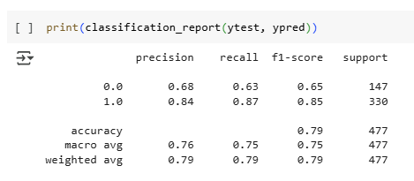

###### Optimizing Classification Threshold for Business Objective [Recall]

* As per the business problem, acquiring new drivers is more expensive than retaining existing ones
* So our focus should to predict TP and Reduce FN, so that we can correctly identify prospective Attrition Drivers
* Now let us plot Recall and Precision Variation w.r.t Different Classification Threshold values
* So that we can select best threshold for our Business Problem

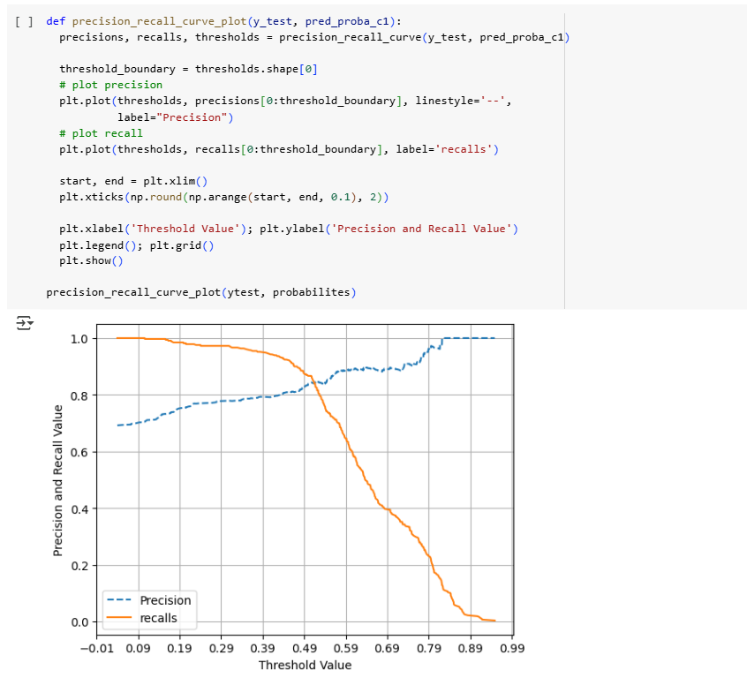

* So in order to increase Recall of our Model, we can reduce the Threshold from Default 0.5 --> 0.43 to get better Recall result at little degrading precision result[which is ok as per company assessment]
* No we will check the Model performance on test data with New threshold

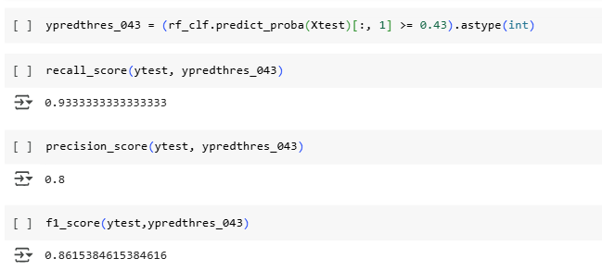

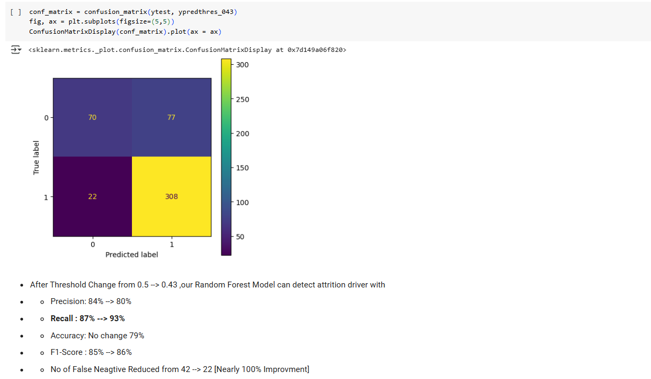

##### Model Training - Gradient Boosting DT [Ensemble - Boosting]

###### Hyperparameter Tuning

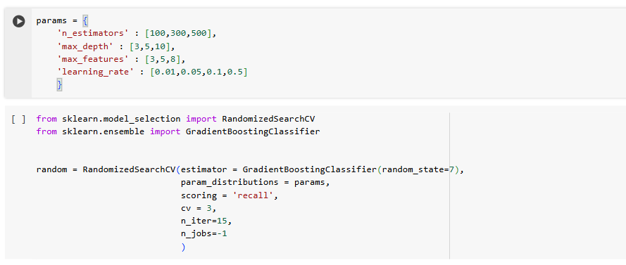

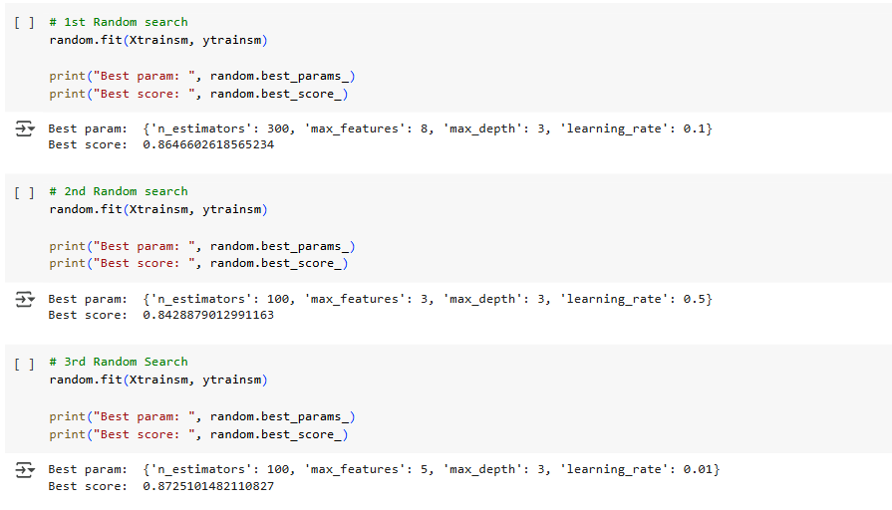

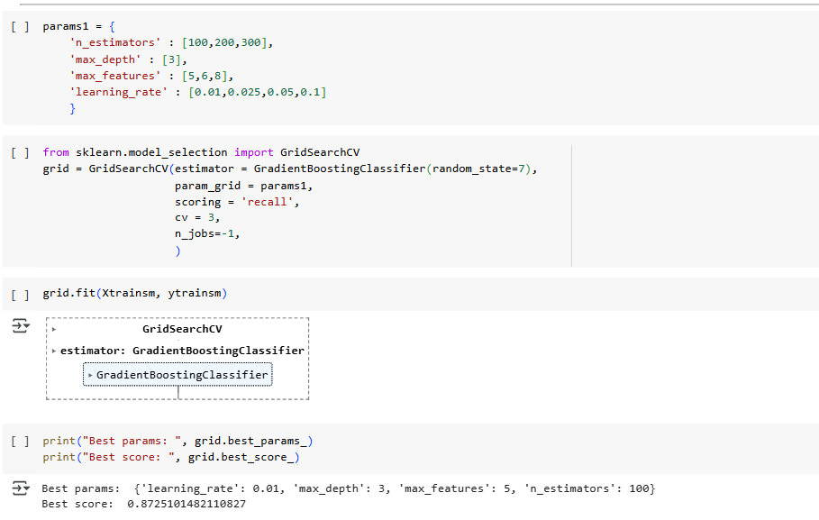

From Random and Grid Search we were able to fix out Hyper parameters for GBDT as below

* max_depth = 3
* max_features = 5
* n_estimators = 100
* learning rate = 0.01

###### Model Training and Evaluation

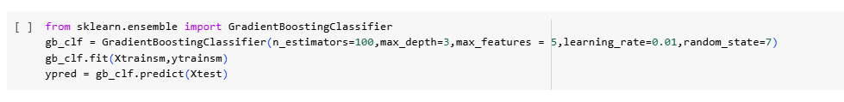

Accuracy

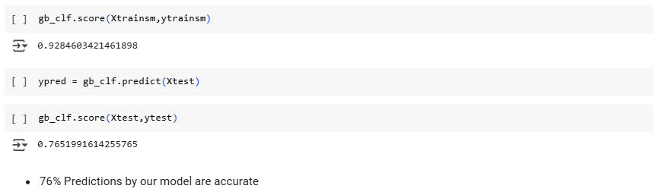

Precision

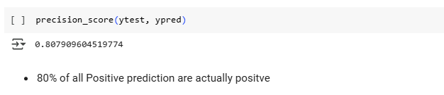

Recall

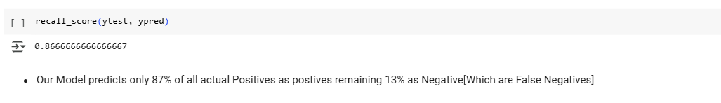

F1 Score

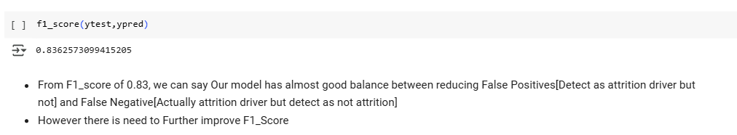

Confusion matrix

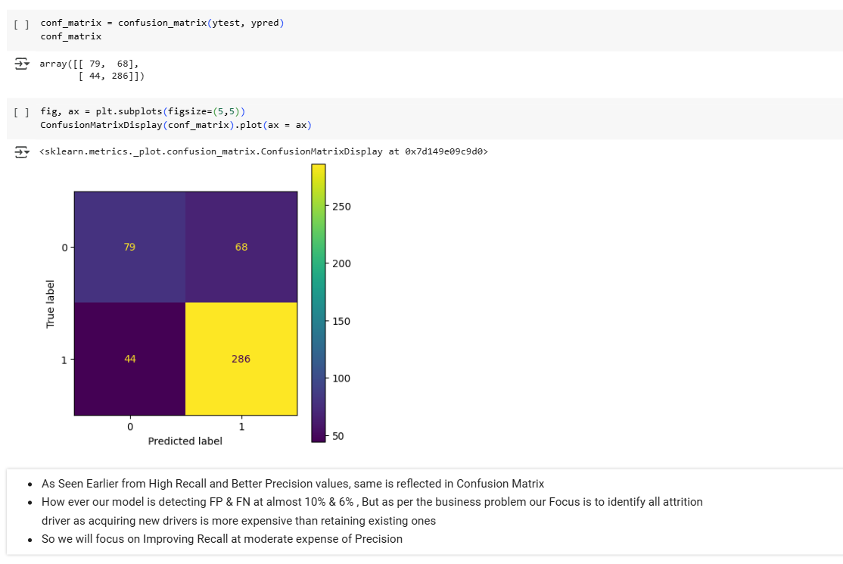

ROC

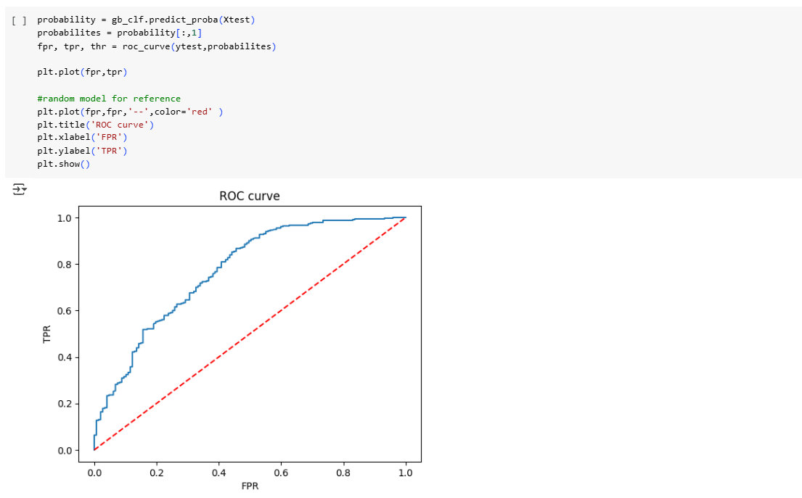

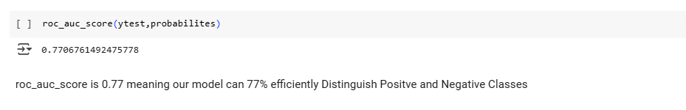

Precision Recall Curve

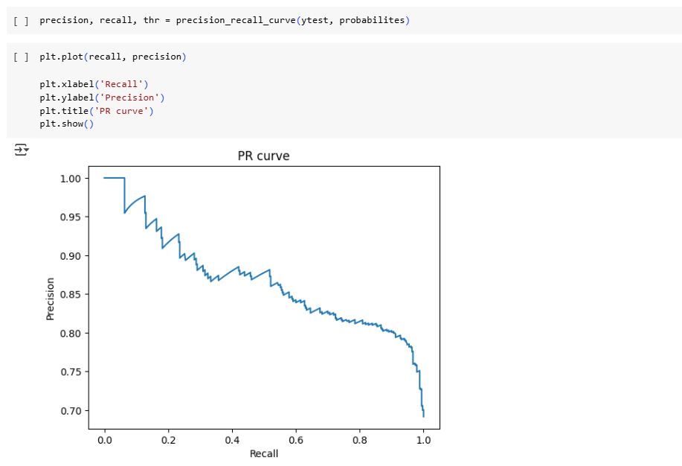

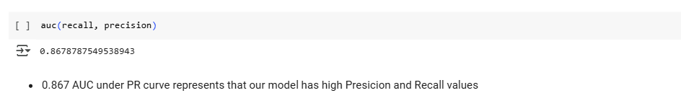

Classification Report

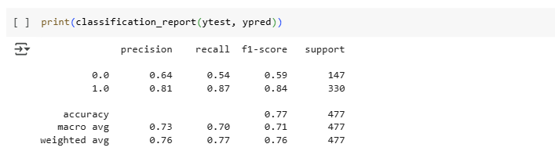

###### Optimizing Classification Threshold for Business Objective [Recall]

* As per the business problem, acquiring new drivers is more expensive than retaining existing ones
* So our focus should to predict TP and Reduce FN, so that we can correctly identify prospective Attrition Drivers
* Now let us plot Recall and Precision Variation w.r.t Different Classification Threshold values
* So that we can select best threshold for our Business Problem

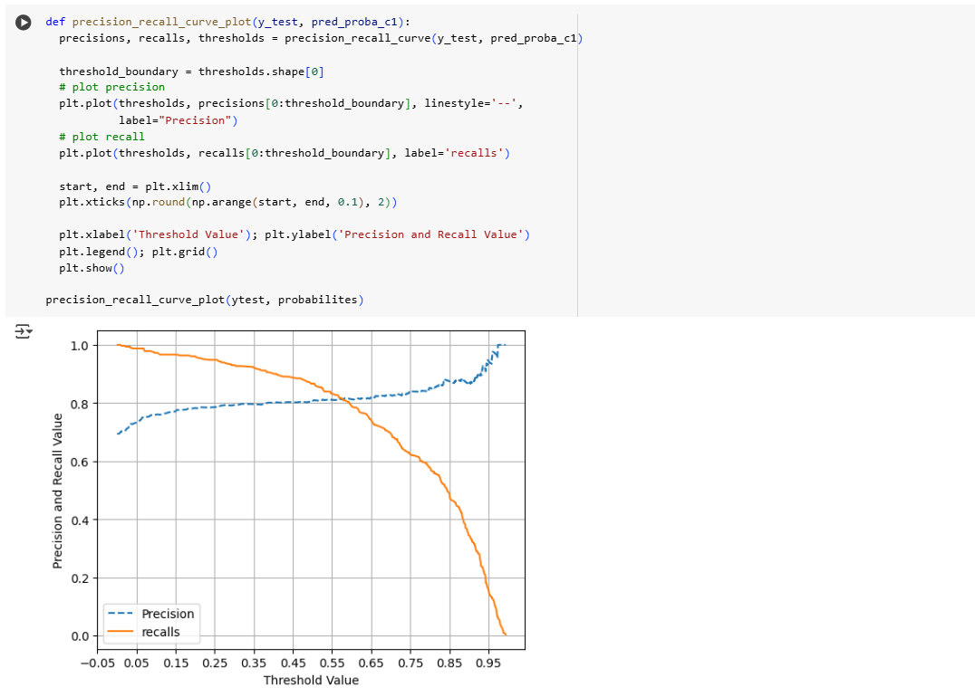

* So in order to increase Recall of our Model, we can reduce the Threshold from Default 0.5 --> 0.37 to get better Recall result at little degrading precision result [which is ok as per company assessment]
* Now we will check the Model performance on test data with New threshold

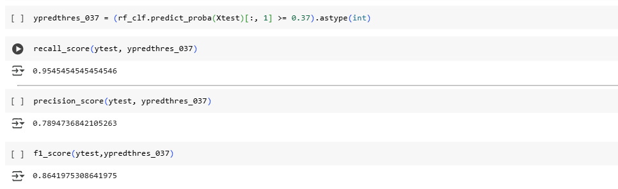

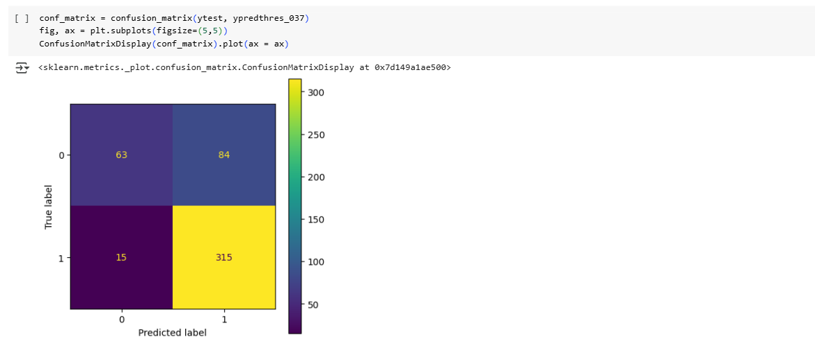

After Threshold Change from 0.5 --> 0.37 ,our GBDT Model can detect attrition driver with

* Precision: 81% --> 78%
* Recall : 87% --> 95%
* Accuracy: No change 77%
* F1-Score : 84% --> 86%
* False Negative Reduced from 44 --> 15 [approx. 150% Improvement]

#### Business Insights

Bagging:

* From Hyperparameter tuning through Random and Grid Search we were able to fix out Hyper parameters
  + max_depth = 3
  + max_features = 5
  + n_estimators = 300
  + bootstrap = False
* 79% Predictions by our model are accurate
* 84% of all Positive prediction are actually positve
* Our Model predicts only 87% of all actual Positives as postives rest 13% of actual Positives aredetected as Negative[False Negatives]
* From F1_score of 0.85, we can say Our model has almost good balance between reducing False Positives[Detect as Churner but not] and False Negative[Actually Churner but detect as not Churner]
* However there is need to Further improve F1_Score
* How ever our model is detecting FP & FN at almost same
* roc_auc_score is 0.81 meaning our model can 81% efficiently Distinguish Positve and Neagative Classes
* 0.895 AUC under PR curve represents that our model has high Presicion and Recall values
* As per the bussiness problem, acquiring new drivers is more expensive than retaining existing ones
* So our focus should to predict TP and Reduce FN, so that we can correctly idenitfy prospective Attrition Drivers
* so, From Classification Threshold Versus Presicion& Recall Curve, we Checked and changed Classification threshold from 0.5 --> 0.39 for Better Results
* After Threshold Change from 0.5 --> 0.43 ,our Random Forest Model can detect attrition driver with
  + Precision: 84% --> 80%
  + Recall : 87% --> 93%
  + Accuracy: No change 79%
  + F1-Score : 85% --> 86%
* No of False Negative Reduced from 42 --> 22 [Nearly 100% Improvement]

Boosting:

* From Hyperparameter tuning through Random and Grid Search we were able to fix out Hyper parameters for GBDT as below
  + max_depth = 3
  + max_features = 5
  + n_estimators = 100
  + learning rate = 0.01
* 76% Predictions by our model are accurate
* 80% of all Positive prediction are actually positve
* Our Model predicts only 87% of all actual Positives as postives remaining 13% as Negative[Which are False Negatives]
* From F1_score of 0.83, we can say Our model has almost good balance between reducing False Positives[Detect as attrition driver but not] and False Negative[Actually attrition driver but detect as not attrition]
* However there is need to Further improve F1_Score
* As Seen Earlier from High Recall and Better Precision values, same is reflected in Confusion Matrix
* roc_auc_score is 0.77 meaning our model can 77% efficiently Distinguish Positve and Negative Classe
* 0.867 AUC under PR curve represents that our model has high Presicion and Recall value
* How ever our model is detecting FP & FN at almost 10% & 6% , But as per the business problem our Focus is to identify all attrition driver as acquiring new drivers is more expensive than retaining existing one
* so, From Classification Threshold Versus Presicion& Recall Curve, we Checked and changed Classification threshold from 0.5 --> 0.39 for Better Results
* After Threshold Change from 0.5 --> 0.37 ,our GBDT Model can detect attrition driver with
  + Precision: 81% --> 78%
  + Recall : 87% --> 95%
  + Accuracy: No change 77%
  + F1-Score : 84% --> 86%
* False Negative Reduced from 44 --> 15 [approx 150% Improvement]

#### Recommendations

* More Information could be inputed into Model for better prediction like below
  + Average No of Hours working per Day/month
  + General working hours
  + Customer Feeback Score for the Driver
  + Regularity Discipline Parameters in working
* Further Kfold technique can be used alon with Random Forest and GBDT Model as no of data point are very less
* Intensive Random & Grid Search can be perfomred for more Hyper Parameter tuning

### Chapter 5 : Business Case Study 5

Problem Description

Analysis

Business Insights

Recommendations

### CONCLUSION

The Conclusion should include some key points as elaborated below -

* Key Takeaways: Highlight the most important points or lessons learned from the

Project

* Practical Applications : Significance of methodologies / tools with their real-world applications
* Limitations : Limitations of the methodologies / approaches / tools and suggestions for improvement

## References

Include the websites or works or the list of works referred to in a text or consulted by you for writing this report

1. Name of the Website, Date and time of referring to the Website, Name of the Author, Title/Topic
2. Author Name, Title / Topic, Research Paper Name / Book Name, Year of Publication

Format Guidelines

1. Detailed and Elaborate report of 100 pages at least is expected
2. Margins - Every page of your document must meet the margin requirements of 1.25 inches on the left and right, and 1 inch on the top and bottom.
3. Font:
   1. Style: Times New Roman,
   2. Font Size:14 (For Headings), 12 (For body text) in black colored text.
   3. All text must be the same justification, like left justified or fully justified.
4. Line Spacing:
   1. Body of the text: 1.5
   2. List of Tables/graphs/charts/bibliography: single line.
5. Alignment:
   1. Title page: Centre
   2. Chapter Heading: Centre
   3. Subheading: Left
   4. Body of the text: Justify
6. Titles: All titles and subtitles should be in bold. All tables/graphs/charts/figures should have appropriate titles.
7. Numbering of the tables, charts, graphs should be in the following fashion: Second table/graph/chart in the second chapter should be numbered as Table/graph/chart no. 2.02; where the first digit stands for chapter no. and digits after (.) stands for number of table/graph/charts in that chapter. Same numbering should be followed for all other chapters.